# Meta’s Closed-Source LLMs in Healthcare: A Critical Analysis of Risks and Benefits

### :warning: WARNING: This content was generated using Generative AI. While efforts have been made to ensure accuracy and coherence, readers should approach the material with critical thinking and verify important information from authoritative sources.

# Table of Contents

* Introduction: The Healthcare AI Revolution
  + The Evolution of AI in Healthcare
    - Historical Context and Development
    - Current State of LLMs in Healthcare
    - Meta’s Role in Healthcare AI
  + Understanding Closed-Source LLMs
    - Technical Foundations
    - Proprietary vs Open-Source Models
    - Meta’s LLM Architecture
* Risk Assessment and Security Framework
  + Security Considerations
    - Data Protection Protocols
    - Access Control Mechanisms
    - Vulnerability Assessment
  + Privacy Compliance
    - HIPAA Compliance Requirements
    - GDPR and International Standards
    - Data Governance Frameworks
  + Clinical Risk Management
    - Patient Safety Protocols
    - Clinical Validation Methods
    - Error Management Systems
* Implementation Strategy and Integration
  + Technical Integration
    - Infrastructure Requirements
    - API Integration Protocols
    - Performance Optimization
  + Organizational Change Management
    - Staff Training Programs
    - Workflow Integration
    - Resistance Management
  + Cost-Benefit Analysis
    - Implementation Costs
    - ROI Calculations
    - Long-term Value Assessment
* Ethical Considerations and Decision Framework
  + Ethical Decision Matrix
    - Stakeholder Impact Analysis
    - Bias Assessment
    - Fairness Metrics
  + Regulatory Compliance
    - Current Regulations
    - Future Regulatory Trends
    - Compliance Strategies
* Future-Proofing and Adaptation
  + Technology Evolution
    - Emerging AI Trends
    - Adaptation Strategies
    - Scalability Planning
  + Case Studies
    - Success Stories
    - Implementation Challenges
    - Lessons Learned

# Introduction: The Healthcare AI Revolution

## The Evolution of AI in Healthcare

### Historical Context and Development

The evolution of Artificial Intelligence in healthcare represents one of the most significant technological transformations in medical history. From its earliest applications in the 1960s to today’s sophisticated language models, AI has fundamentally reshaped how we approach healthcare delivery, diagnosis, and treatment planning.

The journey of AI in healthcare has been nothing short of revolutionary. What began as simple rule-based systems has evolved into sophisticated neural networks capable of processing and analysing complex medical data at unprecedented scales.

The development trajectory can be traced through several distinct phases, each marking significant technological leaps and expanding capabilities. The initial phase, characterised by expert systems and rule-based decision support tools, laid the groundwork for more sophisticated applications. The 1970s and 1980s saw the emergence of early diagnostic support systems, though these were limited by the computational power and data availability of their time.

* 1960s-1970s: Introduction of rule-based expert systems for medical diagnosis
* 1980s-1990s: Development of neural networks and machine learning applications
* 2000s-2010s: Rise of big data analytics and predictive modelling
* 2010s-Present: Emergence of deep learning and large language models

The advent of deep learning and neural networks in the 2010s marked a pivotal moment in healthcare AI. These technologies enabled more sophisticated pattern recognition and data analysis capabilities, leading to breakthroughs in medical imaging analysis, diagnostic accuracy, and treatment planning. The introduction of Large Language Models (LLMs) represents the latest frontier, offering unprecedented capabilities in natural language understanding and generation within medical contexts.

The transition from traditional machine learning to deep learning models marked a paradigm shift in healthcare AI. We’re now seeing capabilities that were once considered science fiction becoming clinical reality.

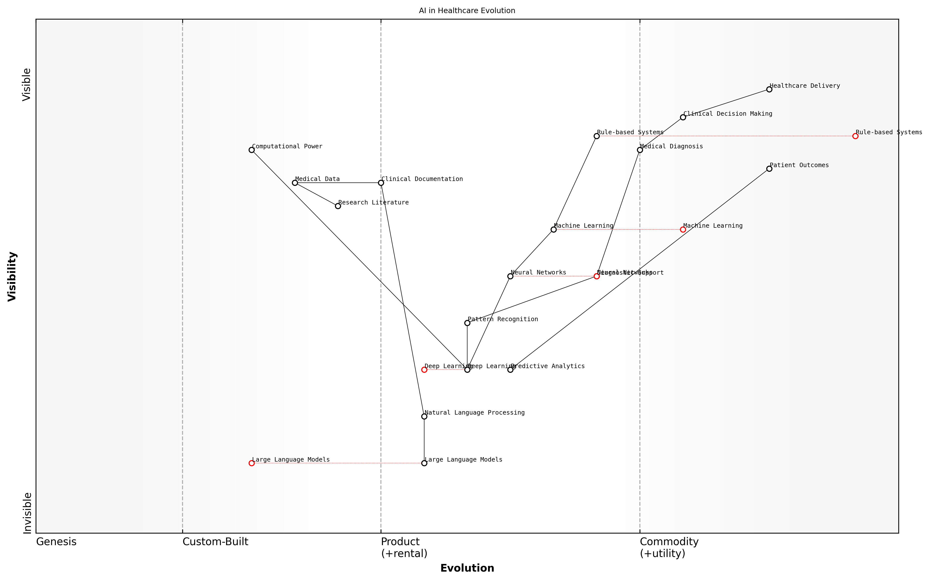

Draft Wardley Map: [Wardley Map showing the evolution of AI capabilities in healthcare, from basic rule-based systems to modern LLMs]

[Edit this draft Wardley Map](https://create.wardleymaps.ai/#clone:22240f6e73a2dda1b4)

**Wardley Map Assessment**

The map reveals a healthcare system in transition, with significant opportunities for AI-driven transformation while maintaining focus on clinical outcomes and patient care quality. Success requires balanced investment in technology, infrastructure, and human capabilities.

[View full Wardley Map report](markdown/wardley_map_reports/wardley_map_report_01_english_Historical_Context_and_Development.md)

Meta’s entry into healthcare AI builds upon this rich historical foundation, while introducing new considerations regarding the use of closed-source models in healthcare settings. The company’s approach represents a significant departure from traditional open-source medical AI development, raising important questions about transparency, accountability, and the balance between proprietary innovation and public health interests.

* Enhanced natural language processing capabilities for clinical documentation
* Advanced pattern recognition for diagnostic support
* Automated analysis of medical literature and research
* Real-time clinical decision support systems
* Predictive analytics for patient outcomes

Understanding this historical context is crucial for healthcare organisations considering the implementation of Meta’s closed-source LLMs. The evolution of AI in healthcare has consistently demonstrated that successful adoption requires careful consideration of technical capabilities, ethical implications, and practical implementation challenges. As we stand at the threshold of widespread LLM adoption in healthcare, these historical lessons become increasingly relevant to modern implementation decisions.

### Current State of LLMs in Healthcare

The current landscape of Large Language Models (LLMs) in healthcare represents a pivotal moment in the intersection of artificial intelligence and medical practice. As we navigate through 2024, healthcare organisations are increasingly exploring and implementing LLM solutions to address complex challenges in patient care, clinical documentation, and medical research.

The integration of LLMs into healthcare systems marks one of the most significant technological shifts in medical practice since the adoption of electronic health records.

Healthcare providers are currently utilising LLMs across various domains, with particular emphasis on clinical documentation assistance, medical knowledge synthesis, and decision support systems. The adoption patterns demonstrate a careful balance between innovation and the paramount importance of patient safety and data security.

* Clinical Documentation: LLMs are being deployed to assist in medical note-taking, discharge summaries, and clinical correspondence
* Medical Knowledge Access: Healthcare professionals are using LLMs to quickly access and synthesise relevant medical literature
* Decision Support: Integration of LLMs into clinical decision support systems for treatment planning and diagnosis assistance
* Administrative Efficiency: Automation of routine administrative tasks and improvement of workflow processes
* Research Applications: Analysis of medical literature and support for clinical trial design and execution

The current implementation landscape reveals a distinct divide between research applications and clinical deployment. While research institutions are actively exploring the full potential of LLMs, clinical deployments remain cautious and heavily regulated, particularly in areas directly affecting patient care.

Healthcare organisations are increasingly recognising that LLMs represent not just a technological advancement, but a fundamental shift in how we approach medical information management and clinical decision-making.

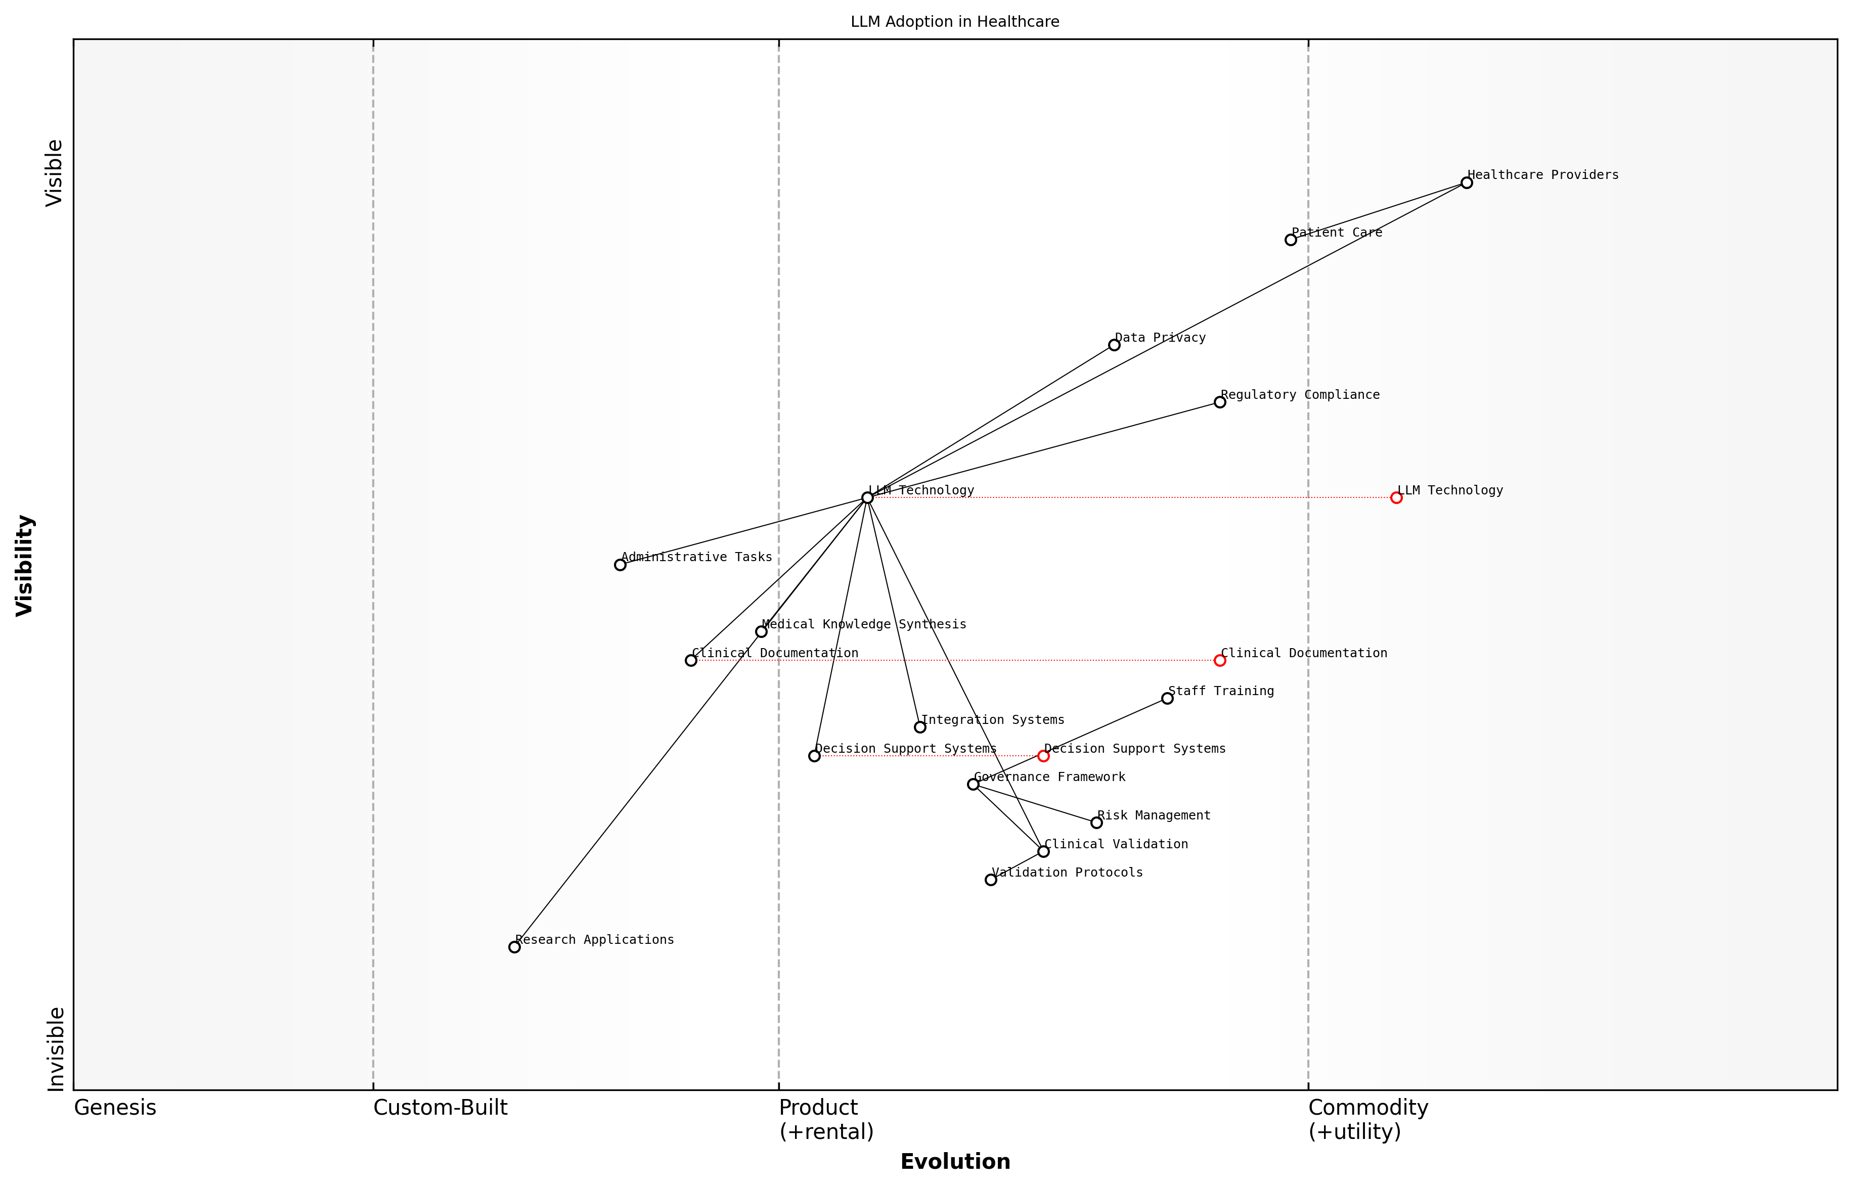

Draft Wardley Map: [Wardley Map showing the evolution of LLM adoption in healthcare, from experimental research applications to mainstream clinical use]

[Edit this draft Wardley Map](https://create.wardleymaps.ai/#clone:33a5c0d3b1771001f4)

**Wardley Map Assessment**

The map reveals a healthcare LLM system in transition, with strong foundational elements but requiring focused development in validation, integration, and governance to achieve full potential. Success depends on balancing innovation with regulatory compliance while maintaining strong clinical validation standards.

[View full Wardley Map report](markdown/wardley_map_reports/wardley_map_report_02_english_Current_State_of_LLMs_in_Healthcare.md)

Key challenges in the current state include ensuring regulatory compliance, maintaining data privacy, and validating the accuracy and reliability of LLM outputs in clinical settings. Healthcare organisations are particularly focused on establishing robust governance frameworks to manage these challenges whilst maximising the benefits of LLM technology.

* Regulatory Compliance: Ensuring adherence to healthcare-specific regulations and data protection laws
* Clinical Validation: Establishing protocols for validating LLM outputs in medical contexts
* Integration Challenges: Addressing technical and operational challenges in implementing LLMs within existing healthcare systems
* Training Requirements: Developing comprehensive training programmes for healthcare staff
* Risk Management: Creating frameworks for identifying and mitigating risks associated with LLM use

The NHS and other public healthcare providers are currently in various stages of LLM adoption, with some organisations conducting pilot programmes while others are moving towards broader implementation. These early adopters are providing valuable insights into the practical challenges and benefits of LLM integration in healthcare settings.

The success of LLM implementation in healthcare settings depends not just on the technology itself, but on our ability to create robust frameworks for its safe and effective deployment.

### Meta’s Role in Healthcare AI

Meta’s emergence as a significant player in healthcare AI represents a pivotal shift in the landscape of medical technology innovation. As a leading technology company with extensive experience in artificial intelligence and machine learning, Meta’s entry into healthcare has brought both unprecedented opportunities and unique challenges to the sector.

The integration of Meta’s advanced language models into healthcare represents one of the most significant technological shifts in medical practice since the digitisation of health records.

Meta’s approach to healthcare AI has been characterised by its development of sophisticated closed-source language models, specifically engineered to handle the complexities and sensitivities of medical data. Their strategic focus has centred on several key areas that have fundamentally influenced the healthcare sector’s adoption of AI technologies.

* Development of specialised medical language understanding capabilities
* Implementation of robust privacy-preserving mechanisms
* Creation of healthcare-specific model architectures
* Establishment of strategic partnerships with healthcare providers
* Investment in clinical validation studies

The company’s closed-source approach has sparked considerable debate within the healthcare community, particularly regarding the balance between proprietary innovation and the traditional openness of medical research. This tension has become a central consideration in healthcare organisations’ decision-making processes regarding AI adoption.

The closed-source nature of Meta’s healthcare AI solutions presents a unique paradigm in medical technology deployment, where the imperative for innovation must be balanced against the healthcare sector’s requirements for transparency and accountability.

Meta’s influence extends beyond mere technology provision, encompassing the establishment of new standards for AI deployment in clinical settings. Their approach to model development has introduced novel considerations regarding data privacy, clinical validation, and regulatory compliance, which have become benchmarks for the industry.

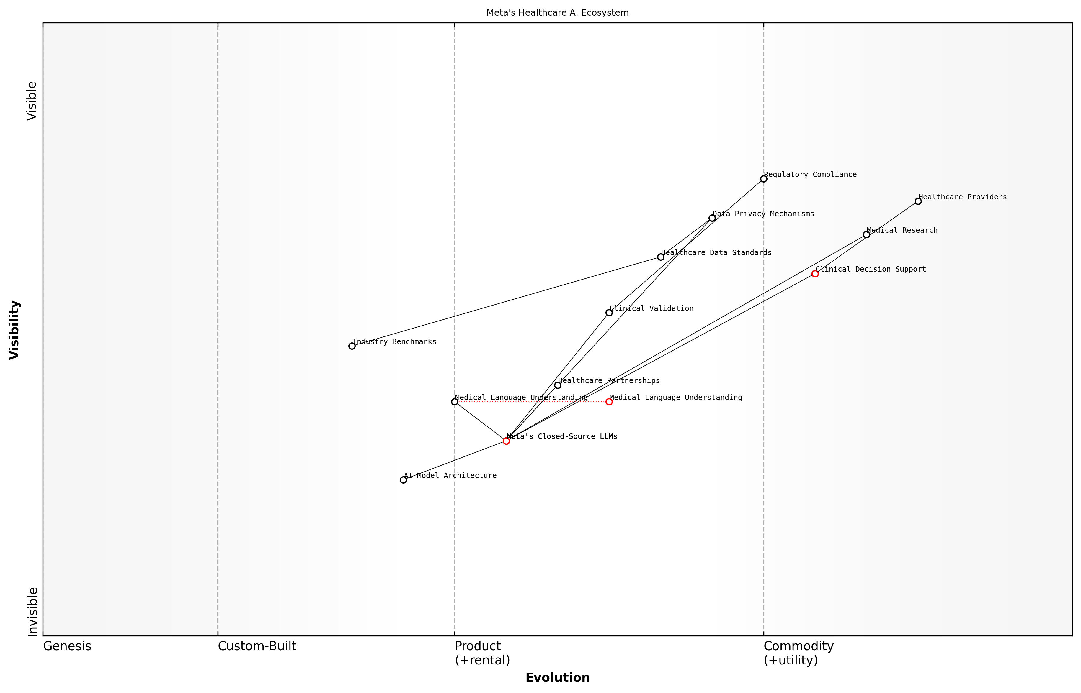

Draft Wardley Map: [Wardley Map showing Meta’s strategic positioning in the healthcare AI ecosystem, highlighting the relationship between their closed-source LLMs and various healthcare stakeholders]

[Edit this draft Wardley Map](https://create.wardleymaps.ai/#clone:e480e938cb43fc09f7)

**Wardley Map Assessment**

Meta’s healthcare AI strategy shows promise but requires careful navigation of healthcare-specific challenges and stronger integration with existing healthcare systems while maintaining technological leadership in AI

[View full Wardley Map report](markdown/wardley_map_reports/wardley_map_report_03_english_Meta's_Role_in_Healthcare_AI.md)

* Impact on clinical decision support systems
* Influence on medical research methodologies
* Contributions to healthcare data standardisation
* Role in shaping regulatory frameworks
* Effect on healthcare AI adoption patterns

The company’s strategic decisions regarding model architecture, data handling, and deployment methodologies have established precedents that continue to influence the broader healthcare AI landscape. Their emphasis on maintaining proprietary control while ensuring clinical efficacy has created a new paradigm for evaluating the implementation of AI solutions in healthcare settings.

Meta’s approach to healthcare AI development has fundamentally altered how the medical community evaluates and implements artificial intelligence solutions, establishing new benchmarks for both technical capability and clinical responsibility.

## Understanding Closed-Source LLMs

### Technical Foundations

The technical foundations of closed-source Large Language Models (LLMs) represent a crucial intersection of artificial intelligence advancement and healthcare innovation. As we examine Meta’s approach to healthcare AI, understanding the fundamental architecture and operational principles of closed-source LLMs becomes essential for healthcare organisations considering their implementation.

The complexity of healthcare data requires LLM architectures that can maintain both computational efficiency and clinical accuracy. Closed-source models offer unique advantages in terms of controlled development and systematic updates that are particularly relevant to healthcare applications.

At their core, closed-source LLMs utilise sophisticated neural network architectures, typically based on the transformer model, but with proprietary modifications and enhancements that remain undisclosed. These models undergo extensive pre-training on carefully curated datasets, followed by specific fine-tuning processes that optimise their performance for healthcare-specific tasks.

* Transformer Architecture: Proprietary implementations of attention mechanisms and neural network layers
* Training Infrastructure: Specialised hardware and software configurations for model development
* Parameter Optimisation: Sophisticated techniques for managing billions of parameters
* Healthcare-Specific Modifications: Adaptations for medical terminology and clinical reasoning
* Security Protocols: Embedded safeguards for handling sensitive medical information

The closed-source nature of these models presents both advantages and challenges for healthcare implementations. While it ensures greater control over model behaviour and security features, it also creates dependencies on the provider for updates and modifications.

Healthcare organisations must carefully consider the trade-off between the enhanced security features of closed-source models and the reduced transparency in their operational mechanics, particularly when dealing with sensitive patient data.

* Advantages of Closed-Source Architecture:
* Controlled updates and version management
* Standardised security protocols
* Consistent performance across implementations
* Professional support and maintenance
* Regular security patches and improvements

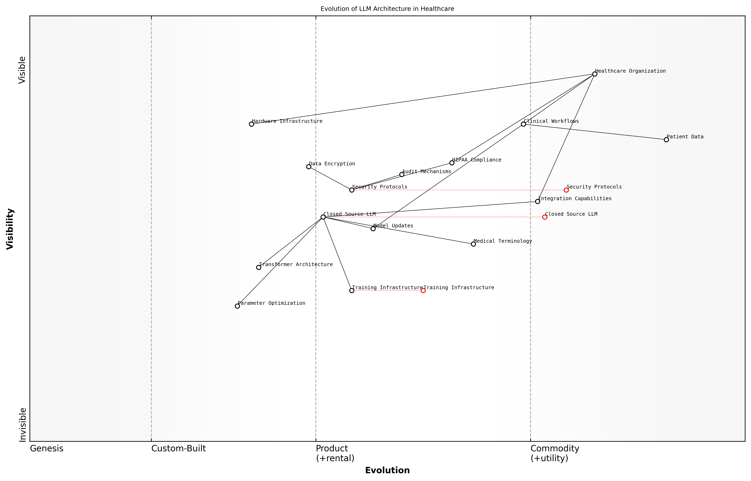

Draft Wardley Map: [Wardley Map: Evolution of LLM Architecture in Healthcare Settings]

[Edit this draft Wardley Map](https://create.wardleymaps.ai/#clone:8f01b1eed5ecf9db38)

**Wardley Map Assessment**

The map reveals a well-structured but evolving system with significant opportunities for advancement in security, integration, and automation capabilities. Success depends on maintaining balance between innovation and compliance while ensuring robust security measures.

[View full Wardley Map report](markdown/wardley_map_reports/wardley_map_report_04_english_Technical_Foundations.md)

Meta’s implementation of closed-source LLMs incorporates several technical innovations specifically designed for healthcare applications. These include enhanced privacy-preserving techniques, improved handling of medical terminology, and specialised attention mechanisms for processing clinical narratives. The architecture is designed to maintain HIPAA compliance while delivering high-performance natural language processing capabilities.

* Technical Considerations for Healthcare Implementation:
* Data encryption and security protocols
* Model inference optimisation for clinical workflows
* Integration capabilities with existing healthcare systems
* Scalability features for varying institutional needs
* Audit trail mechanisms for regulatory compliance

Understanding these technical foundations is crucial for healthcare organisations as they evaluate the potential implementation of Meta’s closed-source LLMs. The architecture’s complexity requires careful consideration of infrastructure requirements, security protocols, and integration capabilities within existing healthcare systems.

### Proprietary vs Open-Source Models

In the rapidly evolving landscape of healthcare artificial intelligence, the distinction between proprietary and open-source Large Language Models (LLMs) represents a critical decision point for healthcare organisations. This fundamental choice carries significant implications for implementation, security, accountability, and long-term sustainability of AI solutions in clinical settings.

The choice between proprietary and open-source models is not merely a technical decision, but one that fundamentally shapes the future of healthcare delivery and innovation.

Proprietary models, such as Meta’s healthcare-focused LLMs, offer distinct advantages in terms of performance optimisation, dedicated support infrastructure, and potentially more rigorous validation processes. These closed-source solutions typically undergo extensive internal testing and refinement, with dedicated teams ensuring their reliability and compliance with healthcare standards.

* Controlled Development Environment: Proprietary models benefit from centralised quality control and standardised development practices
* Dedicated Support Infrastructure: Commercial backing ensures ongoing maintenance and rapid issue resolution
* Optimised Performance: Specialised tuning for healthcare-specific tasks and workflows
* Liability and Accountability: Clear lines of responsibility and legal frameworks
* Regular Updates and Patches: Scheduled maintenance and security updates

Conversely, open-source models present their own set of advantages, particularly in terms of transparency, community-driven innovation, and customisation flexibility. The ability to inspect and modify source code allows healthcare organisations to adapt models to specific use cases and maintain greater control over their AI infrastructure.

* Complete Transparency: Full visibility into model architecture and training processes
* Community Collaboration: Benefit from collective expertise and peer review
* Customisation Freedom: Ability to modify and adapt models for specific clinical needs
* Cost Effectiveness: Reduced licensing fees and vendor lock-in
* Independent Security Auditing: Ability to conduct thorough security assessments

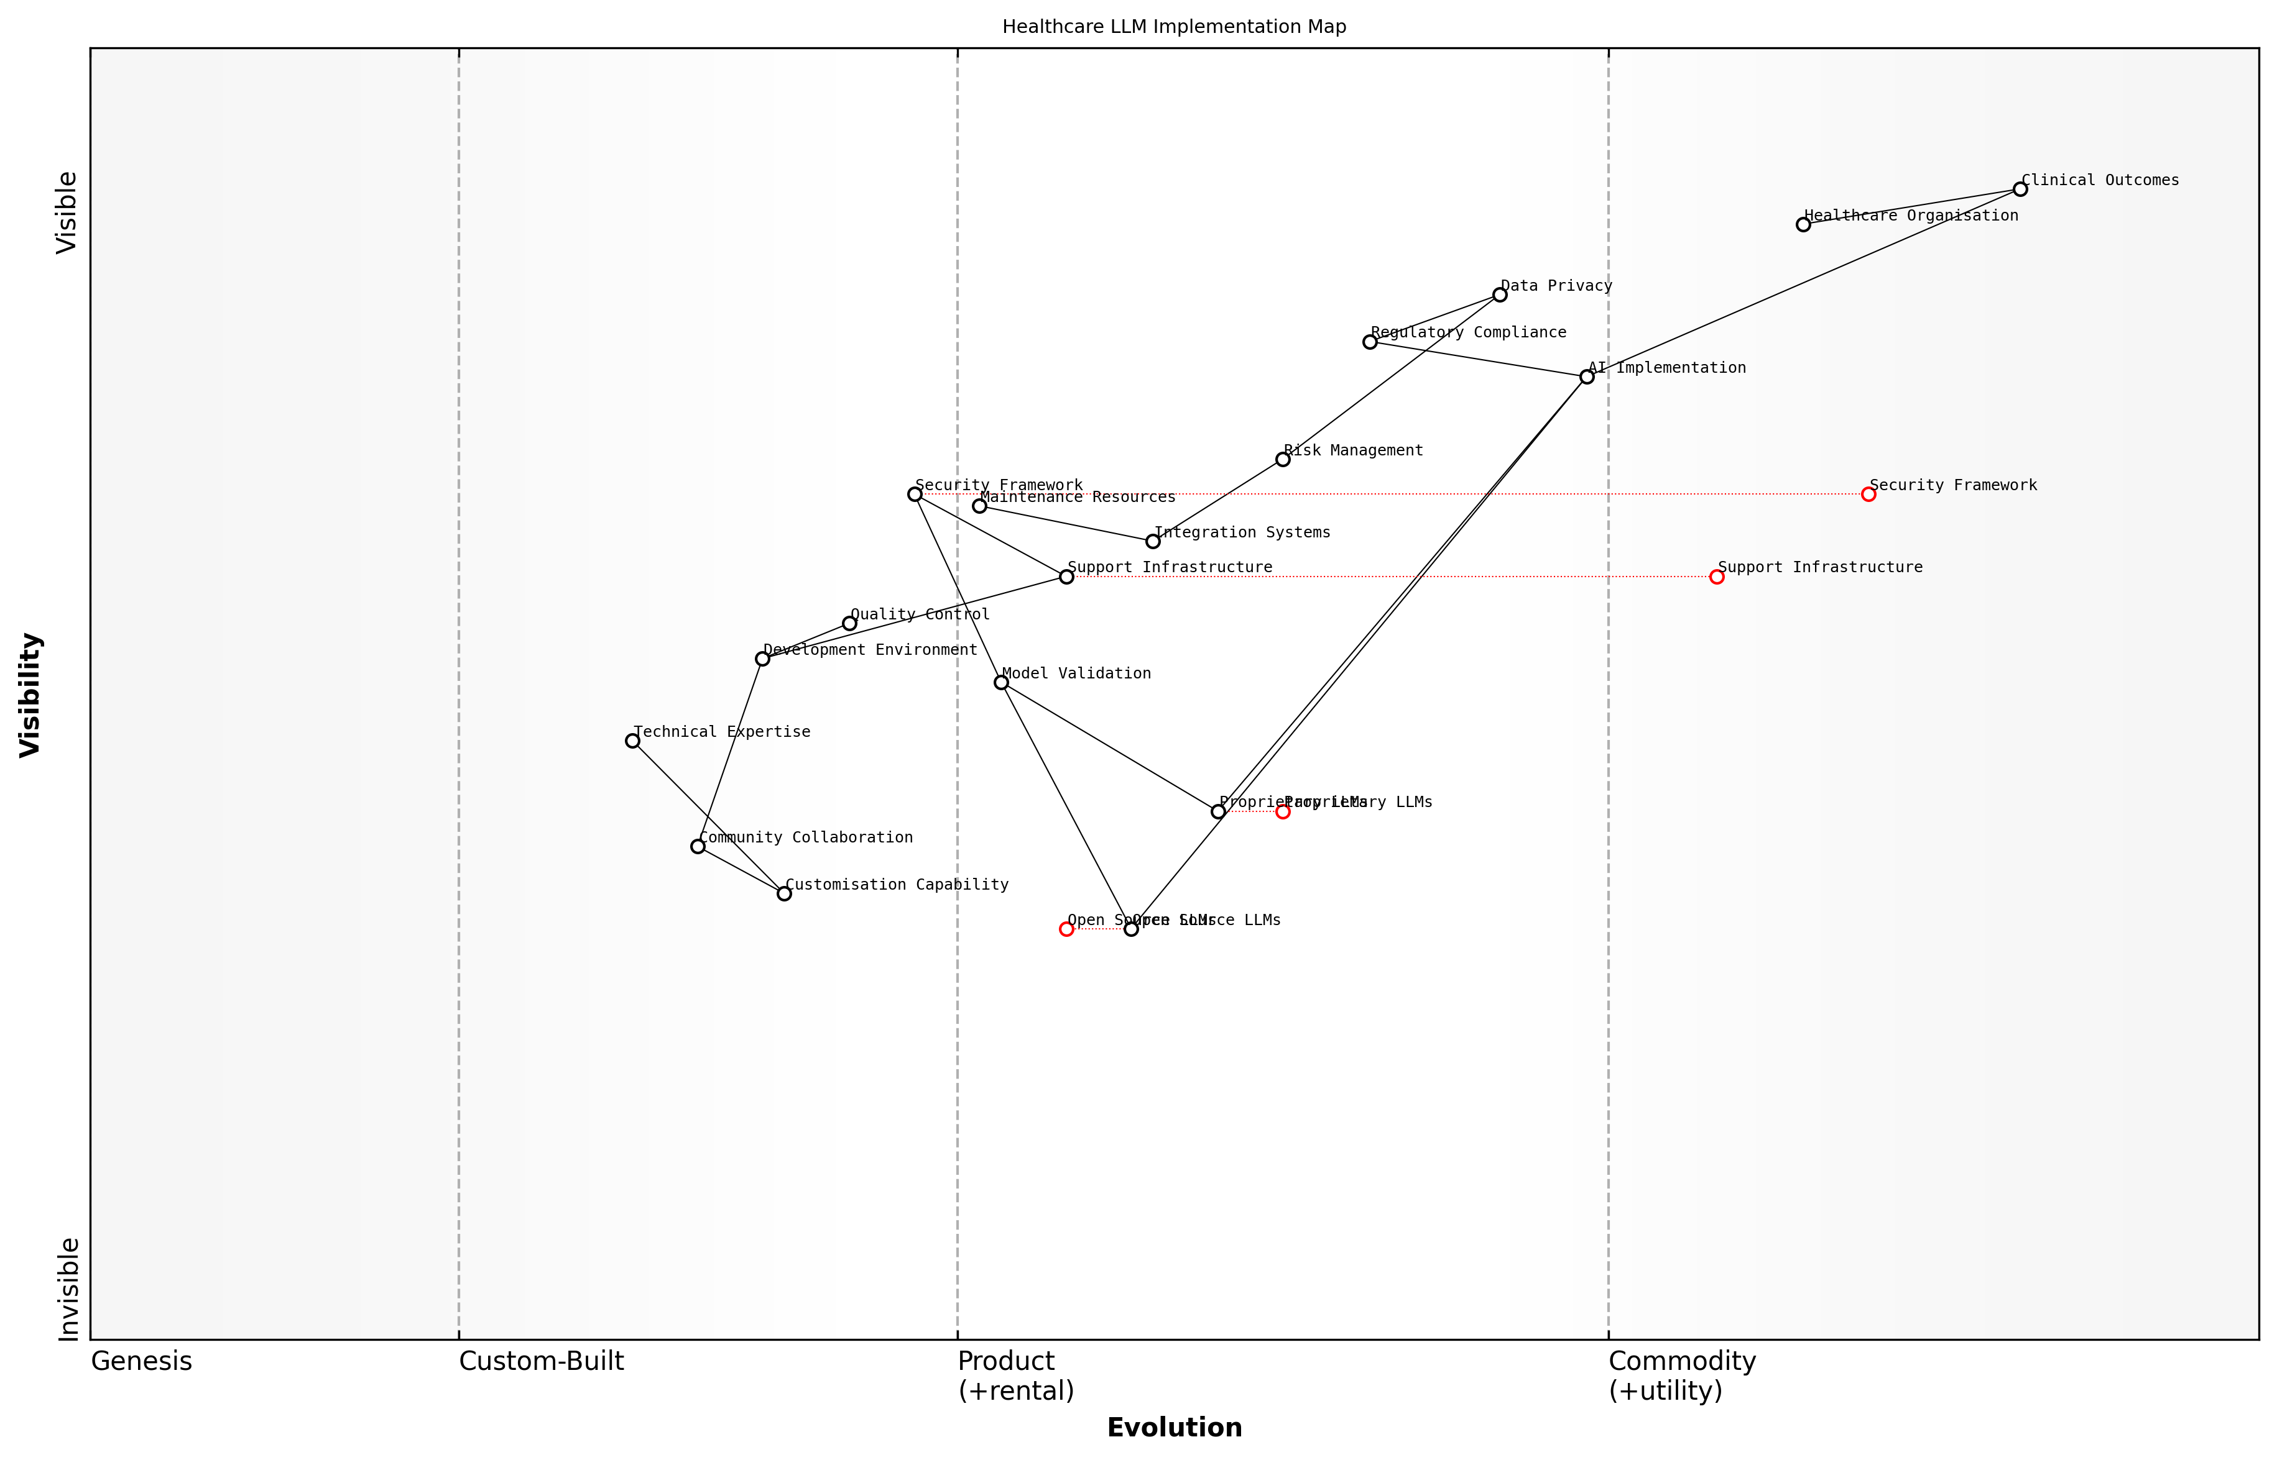

Draft Wardley Map: [Wardley Map showing the evolution and positioning of proprietary vs open-source LLMs in healthcare, highlighting key dependencies and value chain components]

[Edit this draft Wardley Map](https://create.wardleymaps.ai/#clone:231910fa561641378b)

**Wardley Map Assessment**

The map reveals a complex implementation landscape requiring careful balance between proprietary and open-source approaches, with critical focus needed on security, compliance, and technical capabilities. Success depends on building strong foundations in technical expertise while maintaining robust security and compliance frameworks.

[View full Wardley Map report](markdown/wardley_map_reports/wardley_map_report_05_english_Proprietary_vs_Open-Source_Models.md)

The healthcare sector’s unique requirements for data privacy, regulatory compliance, and clinical safety add additional layers of complexity to this decision. Proprietary models often come with pre-built compliance frameworks and documentation, while open-source solutions may require significant investment in developing these frameworks internally.

Healthcare organisations must carefully weigh the trade-offs between the controlled environment of proprietary solutions and the flexibility of open-source alternatives, considering their specific needs for security, compliance, and clinical effectiveness.

* Regulatory Compliance: Assessment of built-in vs. custom compliance frameworks
* Total Cost of Ownership: Evaluation of direct costs vs. internal development resources
* Risk Management: Analysis of vendor dependency vs. self-reliance
* Integration Capabilities: Compatibility with existing healthcare systems
* Long-term Sustainability: Consideration of future maintenance and scalability

The decision between proprietary and open-source models ultimately requires a comprehensive evaluation of an organisation’s technical capabilities, resource availability, risk tolerance, and strategic objectives. This choice will significantly influence the implementation pathway, ongoing maintenance requirements, and long-term evolution of AI capabilities within the healthcare setting.

### Meta’s LLM Architecture

Meta’s Large Language Model (LLM) architecture represents a significant advancement in artificial intelligence technology, particularly in its application to healthcare settings. As a closed-source system, it embodies a complex neural network architecture that has been specifically optimised for processing and understanding medical terminology, clinical narratives, and healthcare-specific contexts.

The architectural sophistication of Meta’s healthcare-focused LLMs demonstrates a remarkable balance between computational efficiency and clinical accuracy, setting new benchmarks for AI performance in medical applications.

The fundamental architecture comprises multiple transformer layers with self-attention mechanisms, specifically tuned to handle the nuanced vocabulary and contextual relationships present in medical documentation. This architectural design incorporates several key innovations that distinguish it from conventional LLM implementations.

* Multi-headed attention mechanisms optimised for medical terminology and clinical reasoning
* Specialised tokenisation systems designed to handle complex medical nomenclature
* Enhanced context windows capable of processing lengthy clinical narratives
* Robust parameter efficiency techniques to maintain performance while reducing computational overhead
* Integrated bias mitigation systems specific to healthcare applications

The closed-source nature of Meta’s architecture presents both advantages and challenges for healthcare implementation. While it ensures proprietary protection of sophisticated algorithms and maintains strict quality control, it also raises important considerations regarding transparency and validation in clinical settings.

* Proprietary protection mechanisms for sensitive algorithmic components
* Controlled update and deployment processes ensuring stability
* Restricted access to core architectural modifications
* Centralised quality assurance and performance monitoring
* Limited ability for third-party validation and customisation

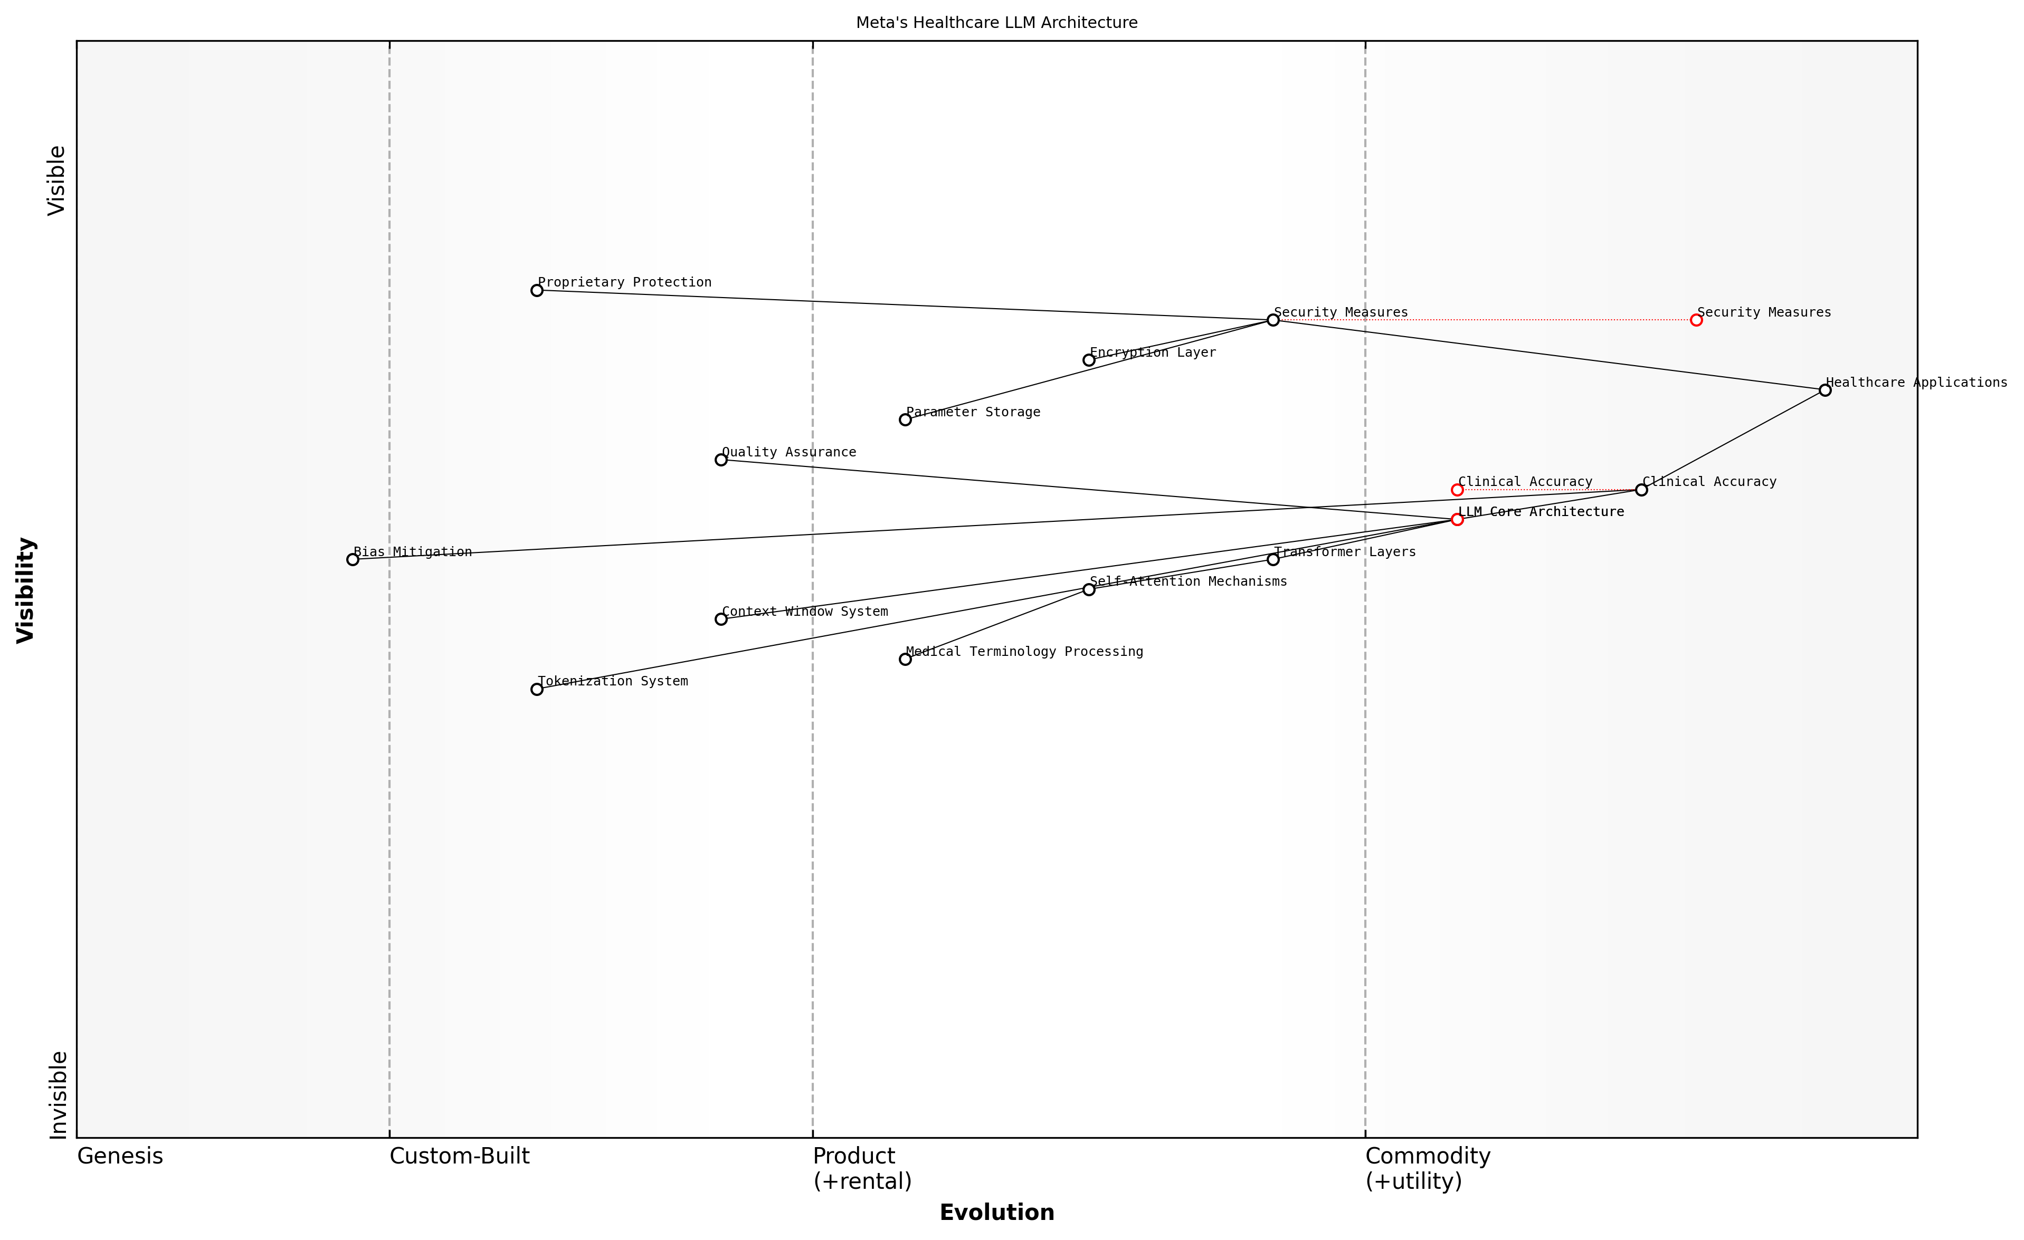

Draft Wardley Map: [Wardley Map showing the evolution and dependencies of Meta’s LLM architectural components in healthcare applications]

[Edit this draft Wardley Map](https://create.wardleymaps.ai/#clone:bc05dca3cebe9e5f0a)

**Wardley Map Assessment**

Meta’s healthcare LLM architecture shows strong foundational elements but requires focused development in healthcare-specific capabilities and security measures to maintain competitive advantage and ensure clinical reliability

[View full Wardley Map report](markdown/wardley_map_reports/wardley_map_report_06_english_Meta's_LLM_Architecture.md)

The architecture incorporates sophisticated security measures designed specifically for healthcare applications, including encrypted inference layers and secure parameter storage. These features are crucial for maintaining compliance with healthcare data protection requirements whilst enabling high-performance natural language processing capabilities.

A leading healthcare AI researcher notes that the architectural decisions in Meta’s LLMs reflect a deep understanding of the unique challenges posed by clinical applications, particularly in terms of accuracy and reliability requirements.

Understanding the implications of this architecture is crucial for healthcare organisations considering implementation. The closed-source nature, while potentially limiting in terms of customisation, provides robust safeguards and ensures consistent performance across different healthcare contexts.

# Risk Assessment and Security Framework

## Security Considerations

### Data Protection Protocols

In the context of implementing Meta’s closed-source LLMs in healthcare environments, robust data protection protocols form the cornerstone of a comprehensive security framework. These protocols must address the unique challenges presented by the intersection of advanced AI technology and sensitive healthcare data, whilst ensuring compliance with stringent regulatory requirements and maintaining the highest standards of patient confidentiality.

The implementation of closed-source LLMs in healthcare represents one of the most significant data protection challenges we’ve encountered in modern medical informatics. The complexity of securing both the training data and operational data flows requires a fundamental rethinking of traditional data protection approaches.

The primary challenge lies in establishing multi-layered protection mechanisms that safeguard patient data throughout its entire lifecycle within the LLM system. This includes securing data during input processing, model inference, and output generation, whilst maintaining the delicate balance between data utility and protection.

* End-to-end encryption protocols for all data in transit and at rest
* Secure enclaves for model deployment and inference operations
* Granular access controls with role-based authentication
* Real-time monitoring and audit logging systems
* Data anonymisation and pseudonymisation mechanisms
* Secure API endpoints with robust authentication
* Regular security assessments and penetration testing

When implementing Meta’s closed-source LLMs, organisations must establish comprehensive data classification schemes that determine appropriate protection levels for different types of healthcare information. This includes implementing sophisticated tokenisation methods for personally identifiable information (PII) and protected health information (PHI).

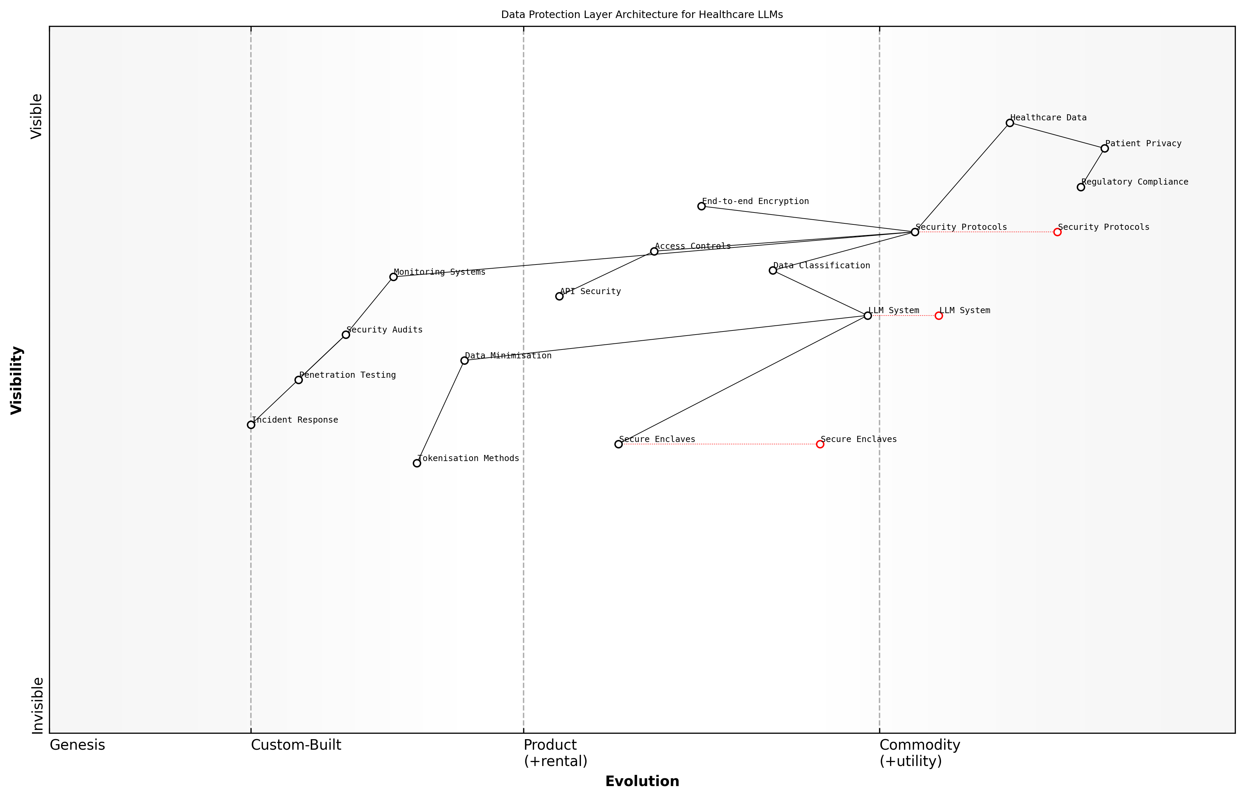

Draft Wardley Map: [Wardley Map: Data Protection Layer Architecture showing the evolution from raw data protection to sophisticated LLM-specific security measures]

[Edit this draft Wardley Map](https://create.wardleymaps.ai/#clone:db4795bbce28d665a7)

**Wardley Map Assessment**

The architecture provides a solid foundation for healthcare LLM security but requires continuous evolution to address emerging threats and technological advances while maintaining strict compliance and patient privacy protection

[View full Wardley Map report](markdown/wardley_map_reports/wardley_map_report_07_english_Data_Protection_Protocols.md)

* Patient demographic data protection protocols
* Clinical data security measures
* Genomic data protection frameworks
* Imaging data security protocols
* Laboratory results protection mechanisms
* Prescription data security measures
* Administrative data protection protocols

A crucial consideration is the implementation of robust data minimisation principles, ensuring that only essential information is processed by the LLM system. This approach not only reduces potential security risks but also aligns with regulatory requirements and best practices in healthcare data protection.

Our experience with implementing closed-source LLMs in healthcare environments has shown that successful data protection isn’t just about technology—it’s about creating a comprehensive ecosystem of security measures that work in harmony with clinical workflows whilst maintaining the highest standards of patient privacy.

Regular security audits and assessments must be conducted to ensure the ongoing effectiveness of data protection protocols. These should include penetration testing, vulnerability assessments, and compliance reviews, with particular attention paid to the unique challenges posed by Meta’s closed-source architecture.

* Monthly security assessment schedules
* Quarterly compliance audits
* Bi-annual penetration testing
* Annual comprehensive security reviews
* Continuous monitoring and threat detection
* Regular protocol updates and refinements
* Incident response planning and testing

### Access Control Mechanisms

Access control mechanisms form a critical cornerstone in the security architecture for implementing Meta’s closed-source LLMs within healthcare environments. These mechanisms must be robust enough to protect sensitive patient data whilst enabling authorised healthcare professionals to leverage the full capabilities of the LLM system. The complexity of healthcare operations, combined with the sensitive nature of patient data, necessitates a sophisticated multi-layered approach to access control.

The implementation of access controls for AI systems in healthcare requires a delicate balance between security and usability. We’ve found that overly restrictive controls can impede clinical workflows, while insufficient measures can expose organisations to significant risks.

When implementing Meta’s closed-source LLMs, organisations must establish comprehensive access control frameworks that align with existing healthcare security protocols whilst addressing the unique challenges posed by AI systems. This includes consideration of both traditional access control elements and AI-specific requirements.

* Role-Based Access Control (RBAC): Defining specific roles and permissions based on clinical responsibilities and need-to-know principles
* Attribute-Based Access Control (ABAC): Implementing dynamic access rules based on user attributes, context, and data sensitivity
* Multi-Factor Authentication (MFA): Requiring multiple forms of verification for accessing LLM systems
* Session Management: Implementing automatic timeouts and activity monitoring
* Audit Trails: Maintaining comprehensive logs of all system access and interactions

A particularly crucial aspect of access control for Meta’s LLMs is the management of API access tokens and service accounts. These must be carefully controlled and regularly rotated to prevent unauthorised access to the LLM’s capabilities. Furthermore, organisations must implement robust monitoring systems to detect and respond to any unusual access patterns or potential security breaches.

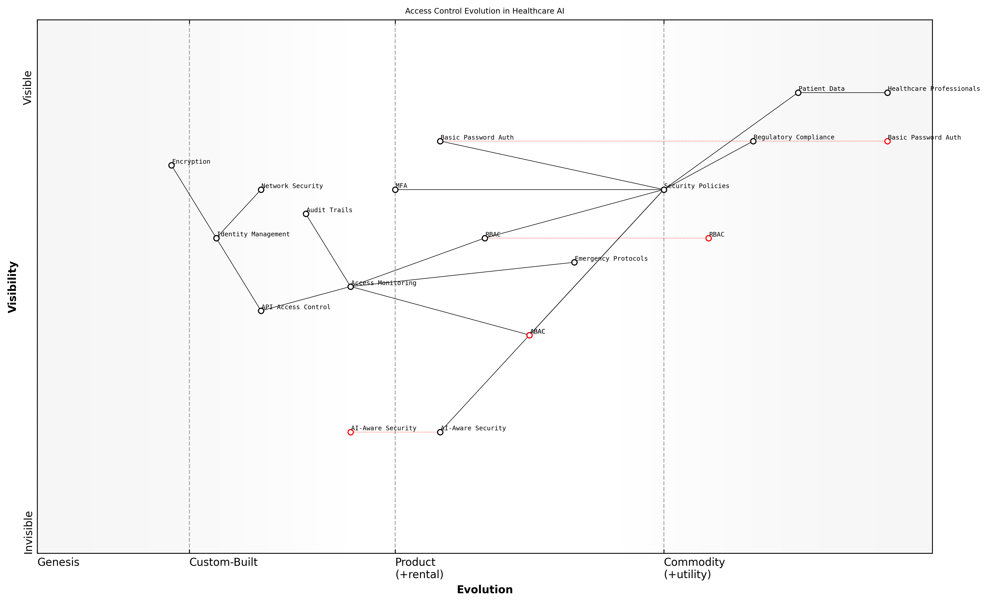

Draft Wardley Map: Insert Wardley Map showing the evolution of access control mechanisms from basic password protection to advanced AI-aware security systems

[Edit this draft Wardley Map](https://create.wardleymaps.ai/#clone:8ec84fb7decb3bc08c)

**Wardley Map Assessment**

The map reveals a system in transition from traditional to AI-integrated security, requiring careful balance of innovation and stability while maintaining strict healthcare compliance requirements. Success depends on strategic implementation of AI-aware security while managing legacy system transitions.

[View full Wardley Map report](markdown/wardley_map_reports/wardley_map_report_08_english_Access_Control_Mechanisms.md)

* Technical Controls: Encryption of data in transit and at rest, secure API endpoints, and network segmentation
* Administrative Controls: Policies, procedures, and training programmes for proper access management
* Physical Controls: Secure data centres and restricted access to critical infrastructure
* Compliance Controls: Regular audits, documentation, and alignment with healthcare regulations

The implementation of access controls must also consider the unique challenges posed by AI models, such as potential model extraction attacks or attempts to probe the system for sensitive information. This requires additional layers of protection beyond traditional access control mechanisms.

Our experience with healthcare AI implementations has shown that successful access control strategies must evolve continuously, adapting to new threats while maintaining the delicate balance between security and clinical efficiency.

* Regular access reviews and user permission audits
* Continuous monitoring and alerting systems
* Integration with existing identity management systems
* Emergency access protocols for critical care situations
* Version control and change management for access policies

Healthcare organisations must also consider the implications of third-party access, particularly when implementing Meta’s closed-source LLMs. This includes establishing clear protocols for vendor access, maintenance procedures, and emergency support scenarios, while ensuring all such access adheres to regulatory requirements and internal security policies.

### Vulnerability Assessment

In the context of implementing Meta’s closed-source LLMs in healthcare settings, vulnerability assessment represents a critical component of the security framework. As an integral part of risk management, it requires a systematic approach to identifying, quantifying, and prioritising potential security weaknesses that could compromise patient data or system integrity.

The implementation of closed-source LLMs in healthcare environments presents unique challenges that traditional vulnerability assessment frameworks may not fully address. We must evolve our approach to consider both the AI-specific attack vectors and the sensitive nature of healthcare data.

The vulnerability assessment process for Meta’s closed-source LLMs must consider multiple layers of potential exposure, from the underlying infrastructure to the application layer and the specific implementations within healthcare workflows. This comprehensive approach ensures no potential weakness goes unexamined.

* Model-specific vulnerabilities (prompt injection, model extraction, adversarial attacks)
* Infrastructure vulnerabilities (network security, API endpoints, authentication mechanisms)
* Integration points with existing healthcare systems
* Data pipeline vulnerabilities
* Access control and user privilege escalation risks
* Third-party dependency risks
* Compliance-related vulnerabilities

A particular challenge in assessing vulnerabilities of closed-source LLMs lies in the limited visibility into the model’s internal workings. Healthcare organisations must develop robust testing frameworks that can effectively evaluate security without full access to the model’s architecture.

* Regular penetration testing protocols
* Automated vulnerability scanning
* Manual security reviews
* Red team exercises
* Compliance audits
* Third-party security assessments
* Continuous monitoring systems

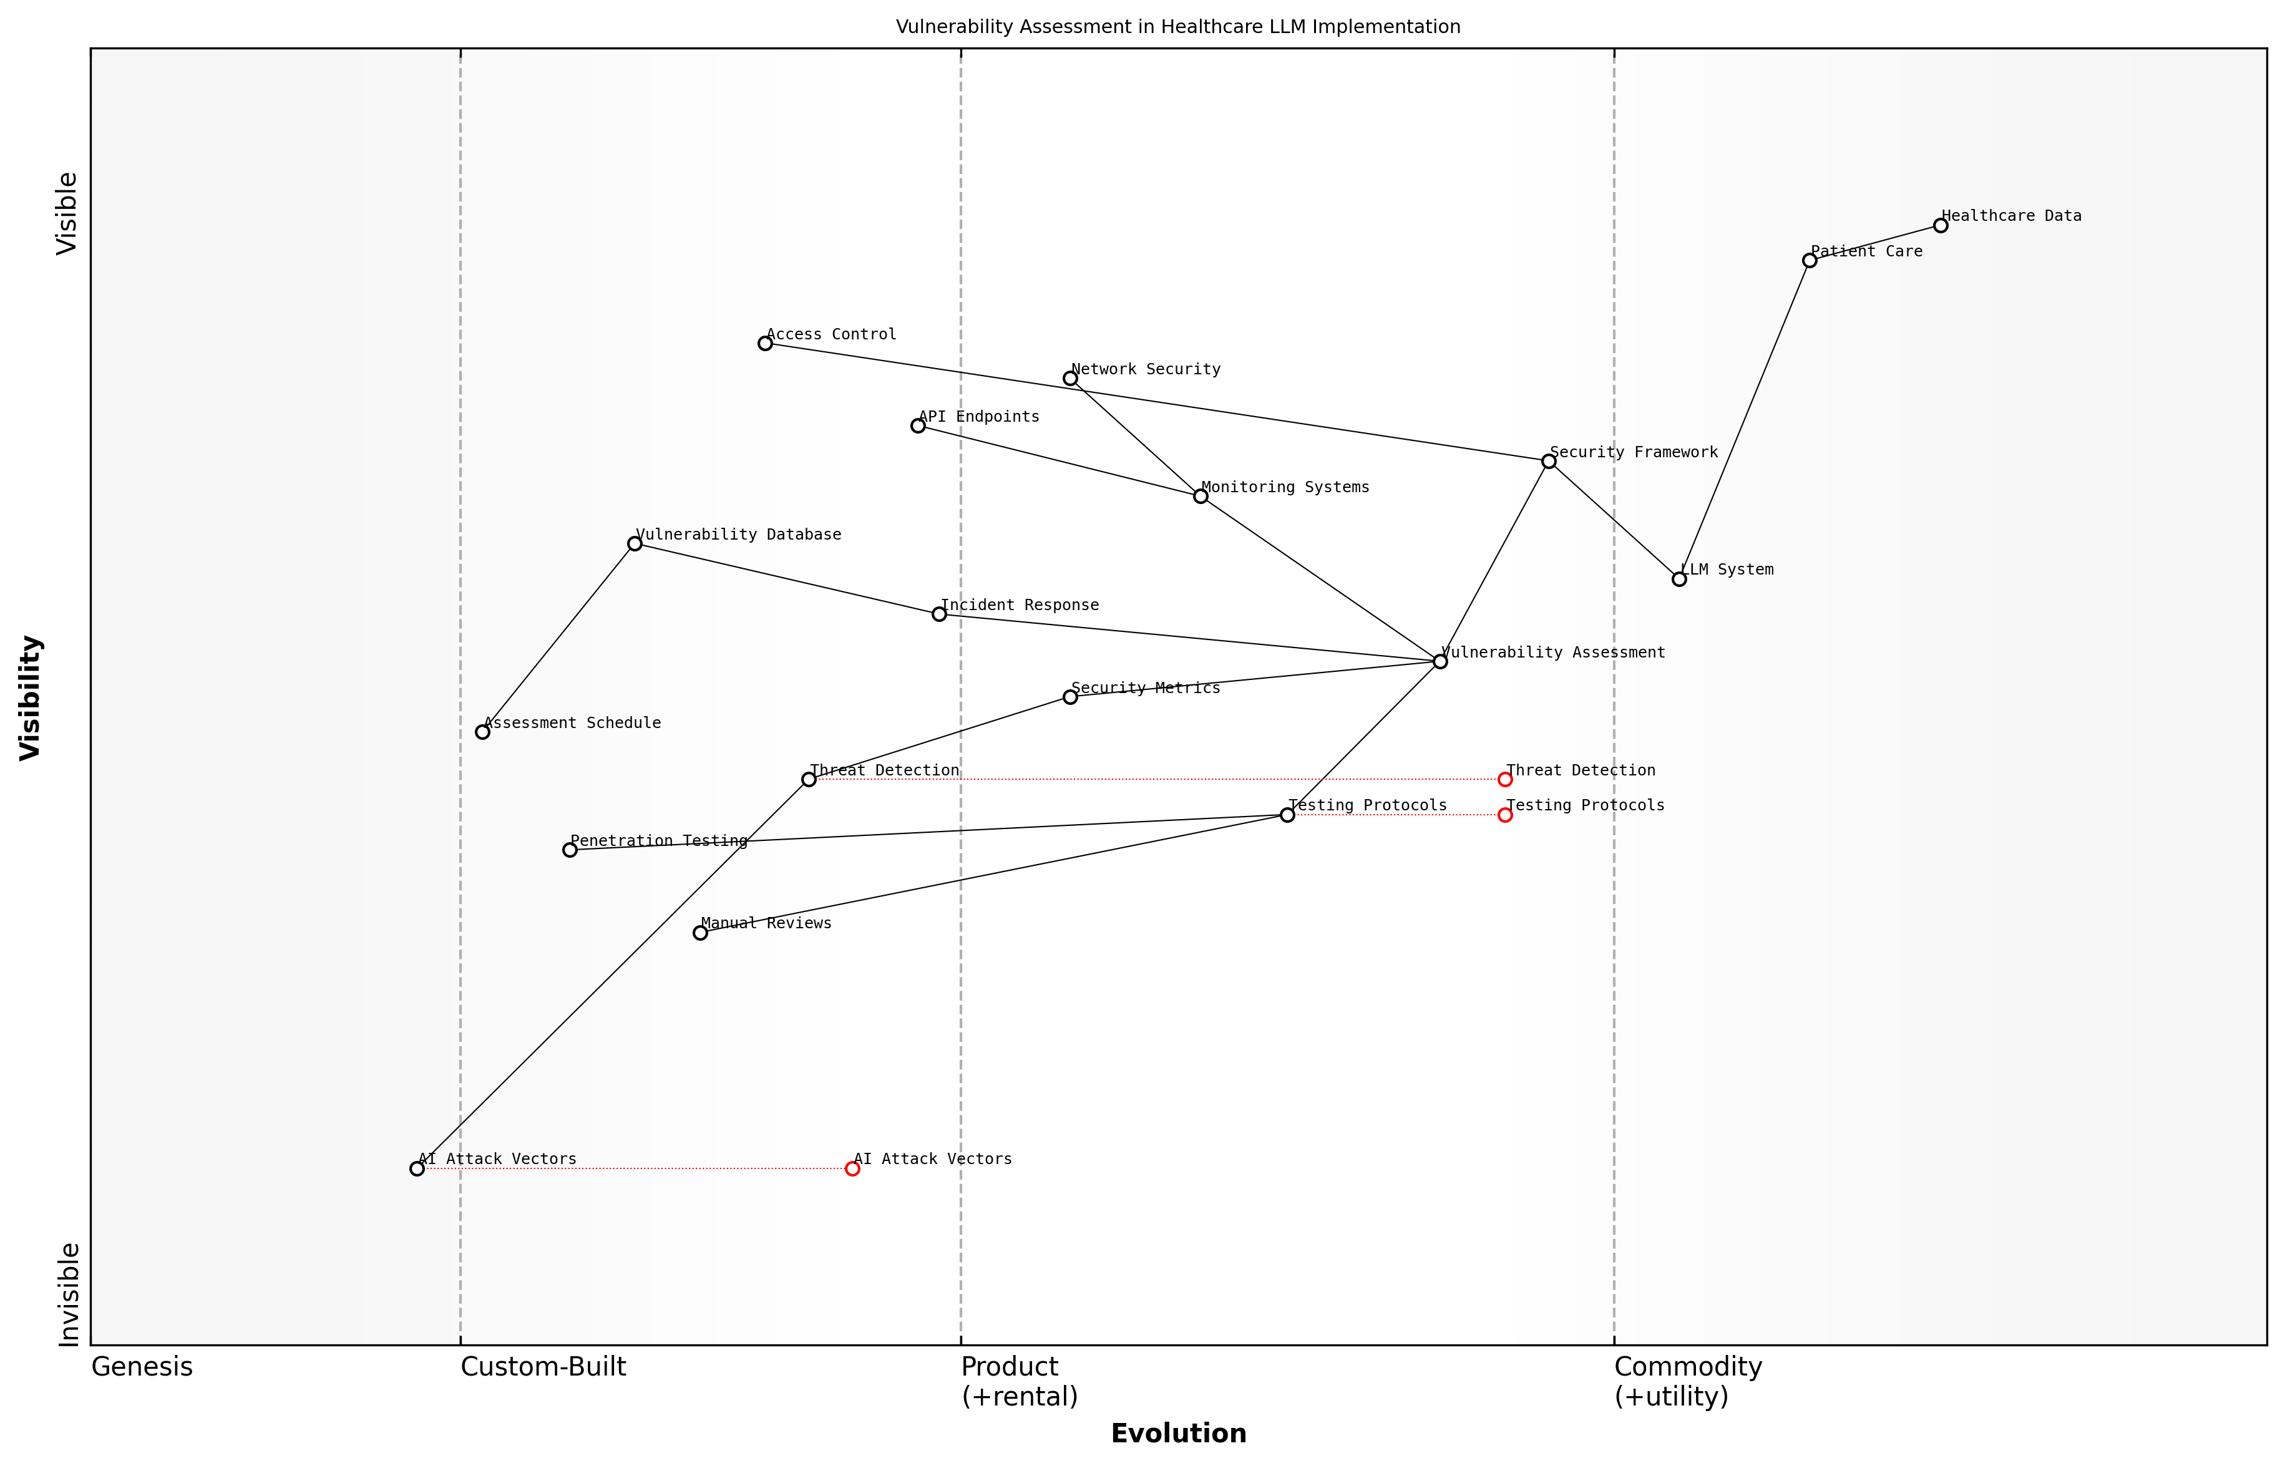

Draft Wardley Map: [Wardley Map: Vulnerability Assessment Components in Healthcare LLM Implementation]

[Edit this draft Wardley Map](https://create.wardleymaps.ai/#clone:f20da57af0bcc68997)

**Wardley Map Assessment**

The map reveals a security framework in transition, moving from traditional approaches to AI-aware security measures. Success requires balancing robust protection of healthcare data with enabling innovative LLM implementation, while actively addressing emerging AI-specific security challenges.

[View full Wardley Map report](markdown/wardley_map_reports/wardley_map_report_09_english_Vulnerability_Assessment.md)

The assessment process must be continuous rather than a one-time exercise, particularly given the dynamic nature of both healthcare environments and AI technology. Regular reassessment ensures that new vulnerabilities are identified and addressed promptly.

Our experience in implementing AI systems in healthcare environments has shown that vulnerability assessment must be viewed as a living process, constantly evolving to address new threats and attack vectors as they emerge.

* Establish baseline security metrics
* Define vulnerability severity classification
* Implement automated detection systems
* Develop incident response procedures
* Create vulnerability management workflows
* Set up regular assessment schedules
* Maintain detailed vulnerability databases

Healthcare organisations must also consider the unique implications of vulnerabilities in AI systems that directly impact patient care. This includes assessing not only technical vulnerabilities but also the potential for AI-specific issues such as data poisoning or model manipulation that could lead to incorrect medical recommendations or compromised patient privacy.

## Privacy Compliance

### HIPAA Compliance Requirements

The implementation of Meta’s closed-source Large Language Models (LLMs) in healthcare settings necessitates rigorous adherence to the Health Insurance Portability and Accountability Act (HIPAA) requirements. As these AI systems interact with Protected Health Information (PHI), understanding and implementing HIPAA compliance measures becomes paramount for healthcare organisations considering their adoption.

The integration of closed-source LLMs represents one of the most significant compliance challenges we’ve faced in healthcare technology adoption. The black-box nature of these systems requires unprecedented levels of scrutiny and safeguarding.

The closed-source nature of Meta’s LLMs presents unique challenges in demonstrating HIPAA compliance, particularly in terms of transparency and audit requirements. Healthcare organisations must establish comprehensive frameworks that address both technical and administrative safeguards whilst maintaining the confidentiality, integrity, and availability of PHI.

* Technical Safeguards: Implementation of encryption protocols, access controls, and audit trails specific to LLM interactions with PHI
* Administrative Safeguards: Development of policies, procedures, and training programmes for staff handling LLM-processed health data
* Physical Safeguards: Ensuring secure physical access to systems hosting Meta’s LLMs and associated PHI
* Risk Analysis: Regular assessment of potential vulnerabilities in LLM implementation
* Documentation: Maintaining detailed records of compliance measures and system configurations
* Business Associate Agreements: Establishing clear contractual obligations with Meta regarding PHI handling

Healthcare organisations must implement specific technical controls to ensure HIPAA compliance when utilising Meta’s LLMs. These include robust authentication mechanisms, encryption of data both in transit and at rest, and comprehensive audit logging capabilities that track all LLM interactions with PHI.

* Privacy Impact Assessments specific to LLM implementation
* Security risk analysis and management plans
* Incident response procedures for potential data breaches
* Training materials for staff working with LLM systems
* Access control policies and procedures
* System configuration documentation
* Audit logs and monitoring protocols

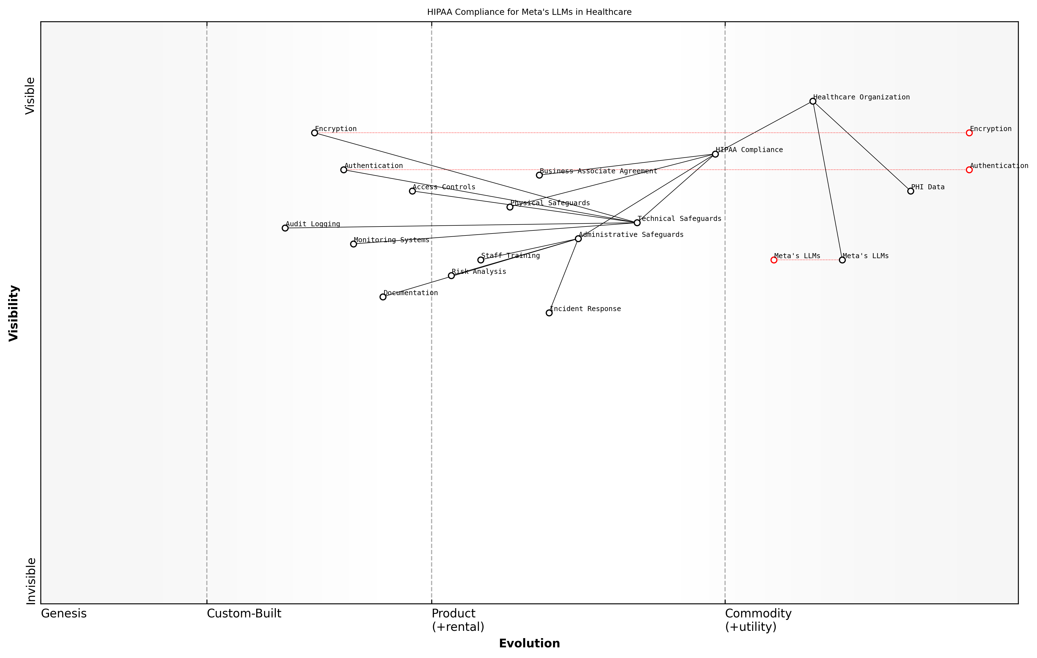

Draft Wardley Map: [Wardley Map: HIPAA Compliance Components for Meta’s LLMs in Healthcare]

[Edit this draft Wardley Map](https://create.wardleymaps.ai/#clone:57a7d99c12b5bc3325)

**Wardley Map Assessment**

The map reveals a well-structured but evolving system that requires focused investment in automation and integration while maintaining strict compliance standards. Key opportunities lie in automation and AI-driven solutions, while main risks centre around documentation and training consistency.

[View full Wardley Map report](markdown/wardley_map_reports/wardley_map_report_10_english_HIPAA_Compliance_Requirements.md)

The implementation of Meta’s closed-source LLMs requires careful consideration of the minimum necessary principle under HIPAA. Organisations must establish protocols to ensure that LLMs only access and process the minimum amount of PHI required for their intended purpose, implementing strict data access controls and monitoring mechanisms.

The challenge lies not just in achieving HIPAA compliance, but in maintaining it whilst leveraging the full potential of these advanced AI systems. Healthcare organisations must strike a delicate balance between innovation and regulatory adherence.

* Regular security assessments and penetration testing
* Continuous monitoring of LLM access patterns and usage
* Periodic review of access controls and user privileges
* Regular updates to policies and procedures
* Ongoing staff training and awareness programmes
* Routine compliance audits and documentation reviews

Healthcare organisations must also establish clear procedures for handling HIPAA-related incidents involving Meta’s LLMs, including breach notification protocols and corrective action plans. This includes maintaining detailed documentation of any incidents, their resolution, and preventive measures implemented to avoid future occurrences.

### GDPR and International Standards

The implementation of Meta’s closed-source Large Language Models (LLMs) in healthcare settings presents unique challenges when considering compliance with the General Data Protection Regulation (GDPR) and various international data protection standards. As healthcare organisations increasingly adopt AI technologies, understanding and adhering to these regulatory frameworks becomes paramount for ensuring legal compliance and maintaining patient trust.

The complexity of implementing AI systems in healthcare cannot be understated. When dealing with closed-source LLMs, we must ensure unprecedented levels of transparency and compliance across multiple jurisdictional frameworks whilst maintaining the utility of the technology.

The GDPR’s requirements for data processing in healthcare contexts are particularly stringent, requiring careful consideration when implementing Meta’s closed-source LLMs. Healthcare organisations must ensure their use of these systems aligns with core GDPR principles, including lawfulness, fairness, and transparency in data processing.

* Data Minimisation: Ensuring only necessary patient data is processed by the LLM
* Purpose Limitation: Clearly defining and limiting the purposes for which the LLM processes health data
* Storage Limitation: Implementing appropriate data retention policies
* Accuracy: Maintaining data quality and providing mechanisms for data correction
* Integrity and Confidentiality: Implementing robust security measures
* Accountability: Demonstrating compliance through documentation and auditing

International standards beyond GDPR must also be considered, particularly when implementing Meta’s LLMs across different jurisdictions. These include ISO 27701 for privacy information management, HIPAA compliance for US-based interactions, and various national healthcare data protection regulations.

* ISO 27701 Privacy Information Management System requirements
* APEC Cross-Border Privacy Rules
* National Healthcare Data Protection Laws
* Industry-specific standards and certifications
* Cross-border data transfer mechanisms
* Local data residency requirements

A particular challenge with Meta’s closed-source LLMs lies in demonstrating compliance with the GDPR’s requirements for transparency and data subject rights. Healthcare organisations must establish clear processes for handling subject access requests, right to erasure, and data portability requirements, even when dealing with a closed-source system.

The challenge isn’t just about compliance on paper - it’s about implementing practical, workable solutions that maintain the utility of AI while respecting fundamental privacy rights and meeting regulatory requirements across multiple jurisdictions.

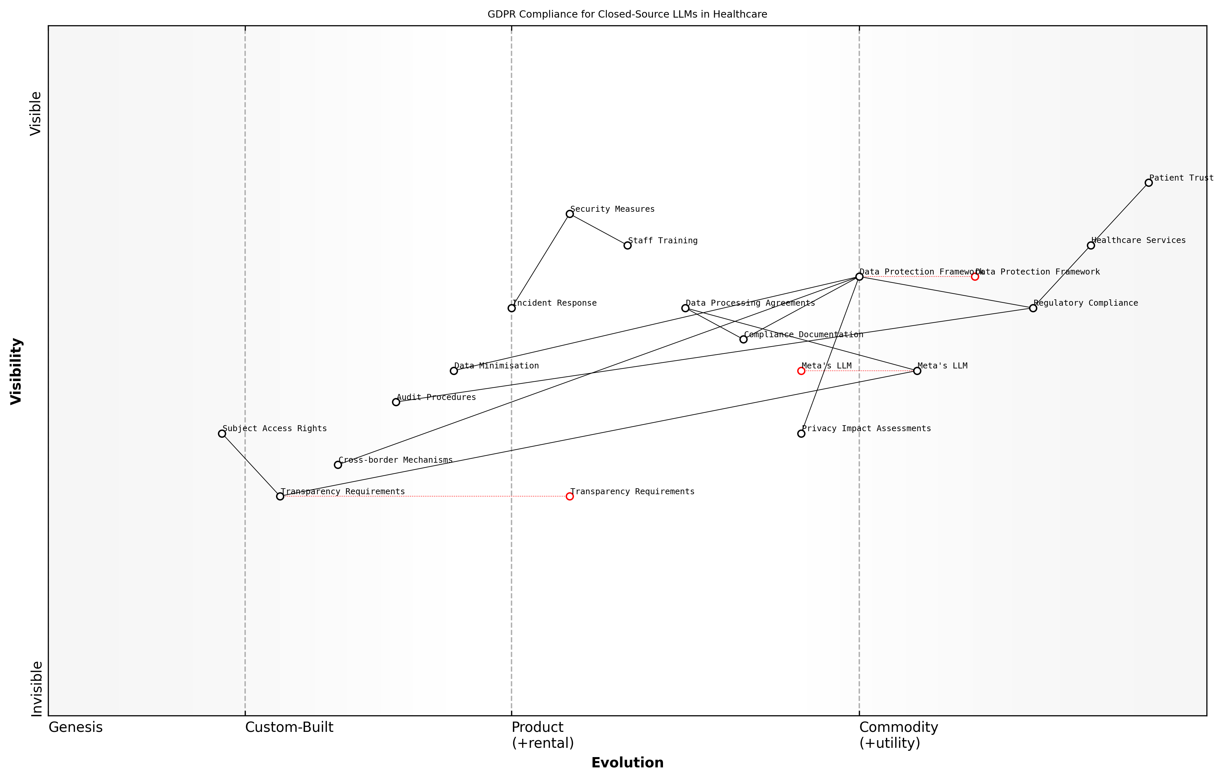

Draft Wardley Map: [Wardley Map: GDPR Compliance Requirements for Closed-Source LLMs in Healthcare]

[Edit this draft Wardley Map](https://create.wardleymaps.ai/#clone:05b8133fed339dce09)

**Wardley Map Assessment**

The map reveals a well-structured but evolving compliance framework that requires significant investment in automation and privacy-preserving technologies to maintain effectiveness while supporting innovation in healthcare AI applications

[View full Wardley Map report](markdown/wardley_map_reports/wardley_map_report_11_english_GDPR_and_International_Standards.md)

Healthcare organisations must implement specific technical and organisational measures to ensure compliance. These include conducting Data Protection Impact Assessments (DPIAs) before implementing Meta’s LLMs, establishing data processing agreements, and maintaining detailed records of processing activities.

* Regular privacy impact assessments
* Documentation of processing activities
* Implementation of privacy by design principles
* Staff training on data protection requirements
* Incident response procedures
* Regular compliance audits and reviews

The closed-source nature of Meta’s LLMs requires additional consideration regarding transparency obligations under GDPR Article 22, particularly concerning automated decision-making. Healthcare organisations must ensure they can provide meaningful information about the logic involved in any automated processing while respecting Meta’s intellectual property rights.

### Data Governance Frameworks

Data governance frameworks form the cornerstone of responsible and compliant implementation of Meta’s closed-source LLMs in healthcare settings. These frameworks must address the unique challenges posed by the intersection of artificial intelligence, sensitive health data, and proprietary technology whilst ensuring adherence to regulatory requirements and ethical standards.

The implementation of closed-source LLMs in healthcare requires a paradigm shift in how we approach data governance. Traditional frameworks must evolve to accommodate the complexity of AI systems whilst maintaining the stringent privacy standards expected in healthcare environments.

When implementing Meta’s closed-source LLMs, healthcare organisations must establish robust data governance frameworks that address three critical dimensions: data lifecycle management, access control hierarchies, and audit mechanisms. These frameworks must be designed to maintain compliance whilst enabling the effective utilisation of AI capabilities.

* Data Classification and Categorisation Protocols
* Access Control and Authentication Mechanisms
* Data Quality Management Standards
* Audit Trail Requirements
* Incident Response Procedures
* Data Retention and Disposal Policies
* Privacy Impact Assessment Frameworks
* Third-party Risk Management Protocols

A crucial consideration in developing these frameworks is the need to balance innovation with protection. The closed-source nature of Meta’s LLMs presents unique challenges in terms of transparency and accountability, requiring additional governance measures to ensure appropriate oversight and control.

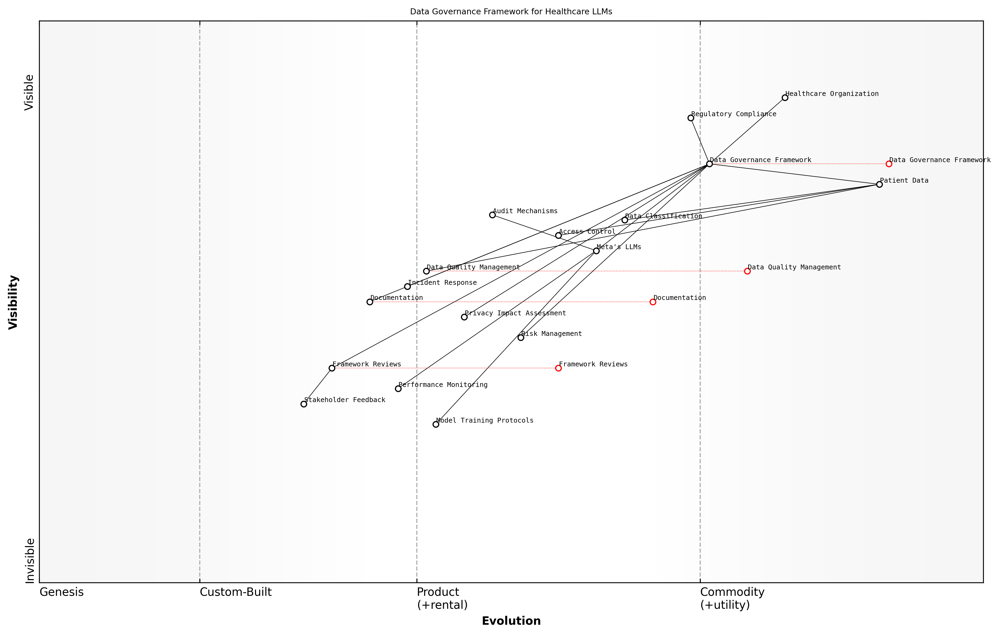

Draft Wardley Map: [Wardley Map: Data Governance Framework Components showing evolution from unstructured to structured governance approaches]

[Edit this draft Wardley Map](https://create.wardleymaps.ai/#clone:52f467dddec1ec52fd)

**Wardley Map Assessment**

The map reveals a well-structured but evolving governance framework that requires continuous adaptation and enhancement to meet the challenges of implementing LLMs in healthcare while maintaining strict compliance and security standards

[View full Wardley Map report](markdown/wardley_map_reports/wardley_map_report_12_english_Data_Governance_Frameworks.md)

* Establish clear roles and responsibilities for data stewardship
* Implement robust data quality monitoring mechanisms
* Define clear procedures for data access and sharing
* Create comprehensive audit trails for all data interactions
* Develop incident response and breach notification protocols
* Maintain detailed documentation of all governance processes

The framework must also address the specific challenges posed by AI model training and deployment. This includes establishing clear protocols for data used in model training, validation data sets, and ongoing model performance monitoring. Healthcare organisations must maintain detailed records of how patient data interacts with the LLM system, ensuring transparency and accountability throughout the AI lifecycle.

The success of AI implementation in healthcare hinges not just on the technology itself, but on our ability to govern it effectively. A robust data governance framework is not just a compliance requirement - it’s a fundamental enabler of trust and adoption.

Regular framework reviews and updates are essential to ensure continued effectiveness and relevance. Healthcare organisations must establish mechanisms for continuous monitoring and improvement of their governance frameworks, incorporating lessons learned and adapting to evolving regulatory requirements and technological capabilities.

* Quarterly framework effectiveness reviews
* Annual comprehensive governance audits
* Regular stakeholder feedback sessions
* Continuous compliance monitoring
* Periodic risk reassessment
* Technology impact evaluations

## Clinical Risk Management

### Patient Safety Protocols

Patient safety protocols represent a critical cornerstone in the implementation of Meta’s closed-source LLMs within healthcare environments. As we navigate the integration of these sophisticated AI systems, establishing robust safety mechanisms becomes paramount to protect patient welfare and maintain the integrity of healthcare delivery.

The implementation of AI systems in healthcare requires a paradigm shift in how we approach patient safety. Traditional protocols must evolve to encompass the unique challenges presented by closed-source LLMs while maintaining the rigorous standards our patients expect and deserve.

When implementing Meta’s closed-source LLMs, healthcare organisations must establish a comprehensive framework of patient safety protocols that address both traditional clinical risks and AI-specific challenges. These protocols must be designed to prevent, detect, and mitigate potential harm while ensuring the technology enhances rather than compromises patient care.

* Real-time monitoring systems for LLM outputs and recommendations
* Automated safety checks and validation protocols
* Clear escalation pathways for AI-related safety concerns
* Regular safety audits and performance assessments
* Incident reporting mechanisms specific to LLM-related events
* Clinical override protocols and human-in-the-loop safeguards
* Emergency shutdown procedures for critical situations

A crucial aspect of patient safety protocols involves the establishment of clear boundaries for LLM usage. Healthcare organisations must explicitly define which clinical decisions can be supported by the LLM and which must remain entirely under human control. This delineation helps prevent over-reliance on AI systems and maintains appropriate clinical oversight.

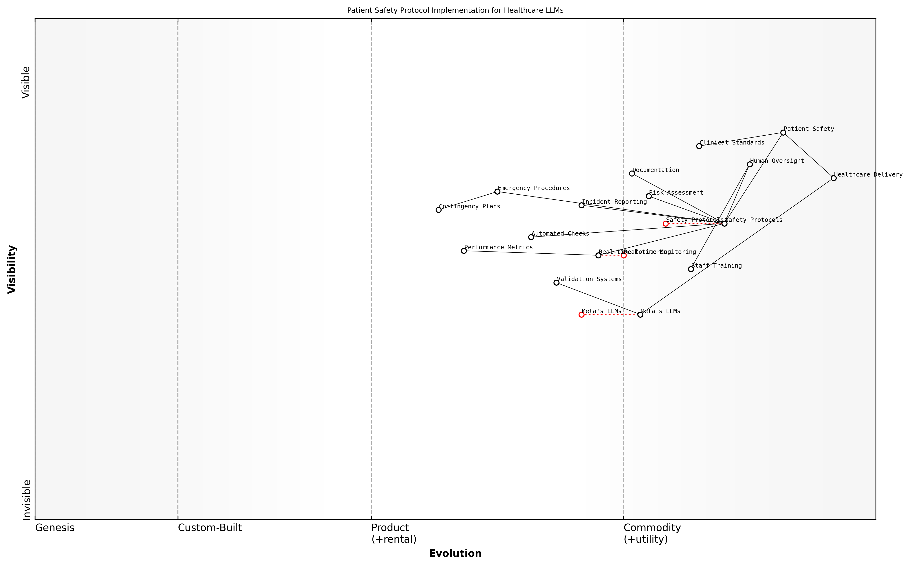

Draft Wardley Map: Insert Wardley Map: Patient Safety Protocol Implementation Stages

[Edit this draft Wardley Map](https://create.wardleymaps.ai/#clone:d0e4b9f79fa83f2e98)

**Wardley Map Assessment**

The map reveals a well-structured but evolving system that effectively balances technological innovation with patient safety requirements. Key opportunities lie in strengthening validation systems and developing more integrated monitoring capabilities while maintaining strong human oversight.

[View full Wardley Map report](markdown/wardley_map_reports/wardley_map_report_13_english_Patient_Safety_Protocols.md)

* Pre-implementation safety assessment and risk stratification
* Continuous monitoring of LLM performance and safety metrics
* Regular validation of LLM outputs against established clinical standards
* Documentation and tracking of all LLM-supported decisions
* Patient consent and information protocols
* Staff training on safety procedures and override mechanisms
* Regular safety protocol reviews and updates

Our experience implementing closed-source LLMs in major healthcare institutions has shown that robust patient safety protocols are not just regulatory requirements - they are fundamental enablers of successful AI adoption and clinical acceptance.

The implementation of safety protocols must also consider the unique challenges posed by Meta’s closed-source nature. Without access to the underlying model architecture, healthcare organisations must establish additional safeguards and validation mechanisms to ensure patient safety. This includes comprehensive testing protocols, enhanced monitoring systems, and robust backup procedures.

* Development of safety benchmarks specific to closed-source LLMs
* Implementation of independent validation mechanisms
* Establishment of clear accountability frameworks
* Creation of transparent incident investigation procedures
* Regular safety performance reviews and assessments
* Development of contingency plans for system failures
* Integration with existing clinical risk management systems

Healthcare organisations must also establish clear protocols for handling edge cases and unexpected scenarios. This includes developing comprehensive documentation requirements, establishing clear lines of responsibility, and ensuring appropriate clinical oversight at all times. Regular reviews and updates of these protocols ensure they remain effective and relevant as the technology evolves.

### Clinical Validation Methods

Clinical validation methods form a critical cornerstone in evaluating the safety and efficacy of Meta’s closed-source LLMs within healthcare settings. As an integral component of clinical risk management, these methods must be rigorously designed and implemented to ensure that AI systems meet the exacting standards required for patient care whilst addressing the unique challenges posed by closed-source architectures.

The validation of closed-source LLMs represents one of the most significant challenges in modern healthcare AI implementation. Without access to the underlying model architecture, we must develop robust external validation frameworks that can ensure patient safety and clinical efficacy.

The clinical validation process for Meta’s closed-source LLMs requires a multi-layered approach that combines traditional clinical validation methodologies with specialised techniques designed specifically for black-box AI systems. This comprehensive framework must address both the technical performance aspects and the clinical utility of the system.

* Prospective Clinical Testing: Controlled trials comparing LLM performance against established clinical standards
* Retrospective Analysis: Evaluation of LLM outputs against historical patient data and outcomes
* Real-world Performance Monitoring: Continuous assessment of system performance in live clinical settings
* Edge Case Testing: Systematic evaluation of system behaviour in rare or complex clinical scenarios
* Bias Detection: Regular assessment of potential biases in system outputs across different patient demographics

A crucial aspect of clinical validation for closed-source LLMs is the establishment of performance benchmarks. These must be carefully calibrated to reflect the specific healthcare contexts in which the system will be deployed, taking into account both the technical limitations of closed-source systems and the practical requirements of clinical care.

* Accuracy Metrics: Sensitivity, specificity, and positive/negative predictive values
* Clinical Relevance Assessments: Evaluation of practical utility in clinical decision-making
* Safety Thresholds: Defined acceptable margins of error for different use cases
* Performance Stability: Monitoring for drift and degradation over time
* Integration Impact: Assessment of effects on existing clinical workflows

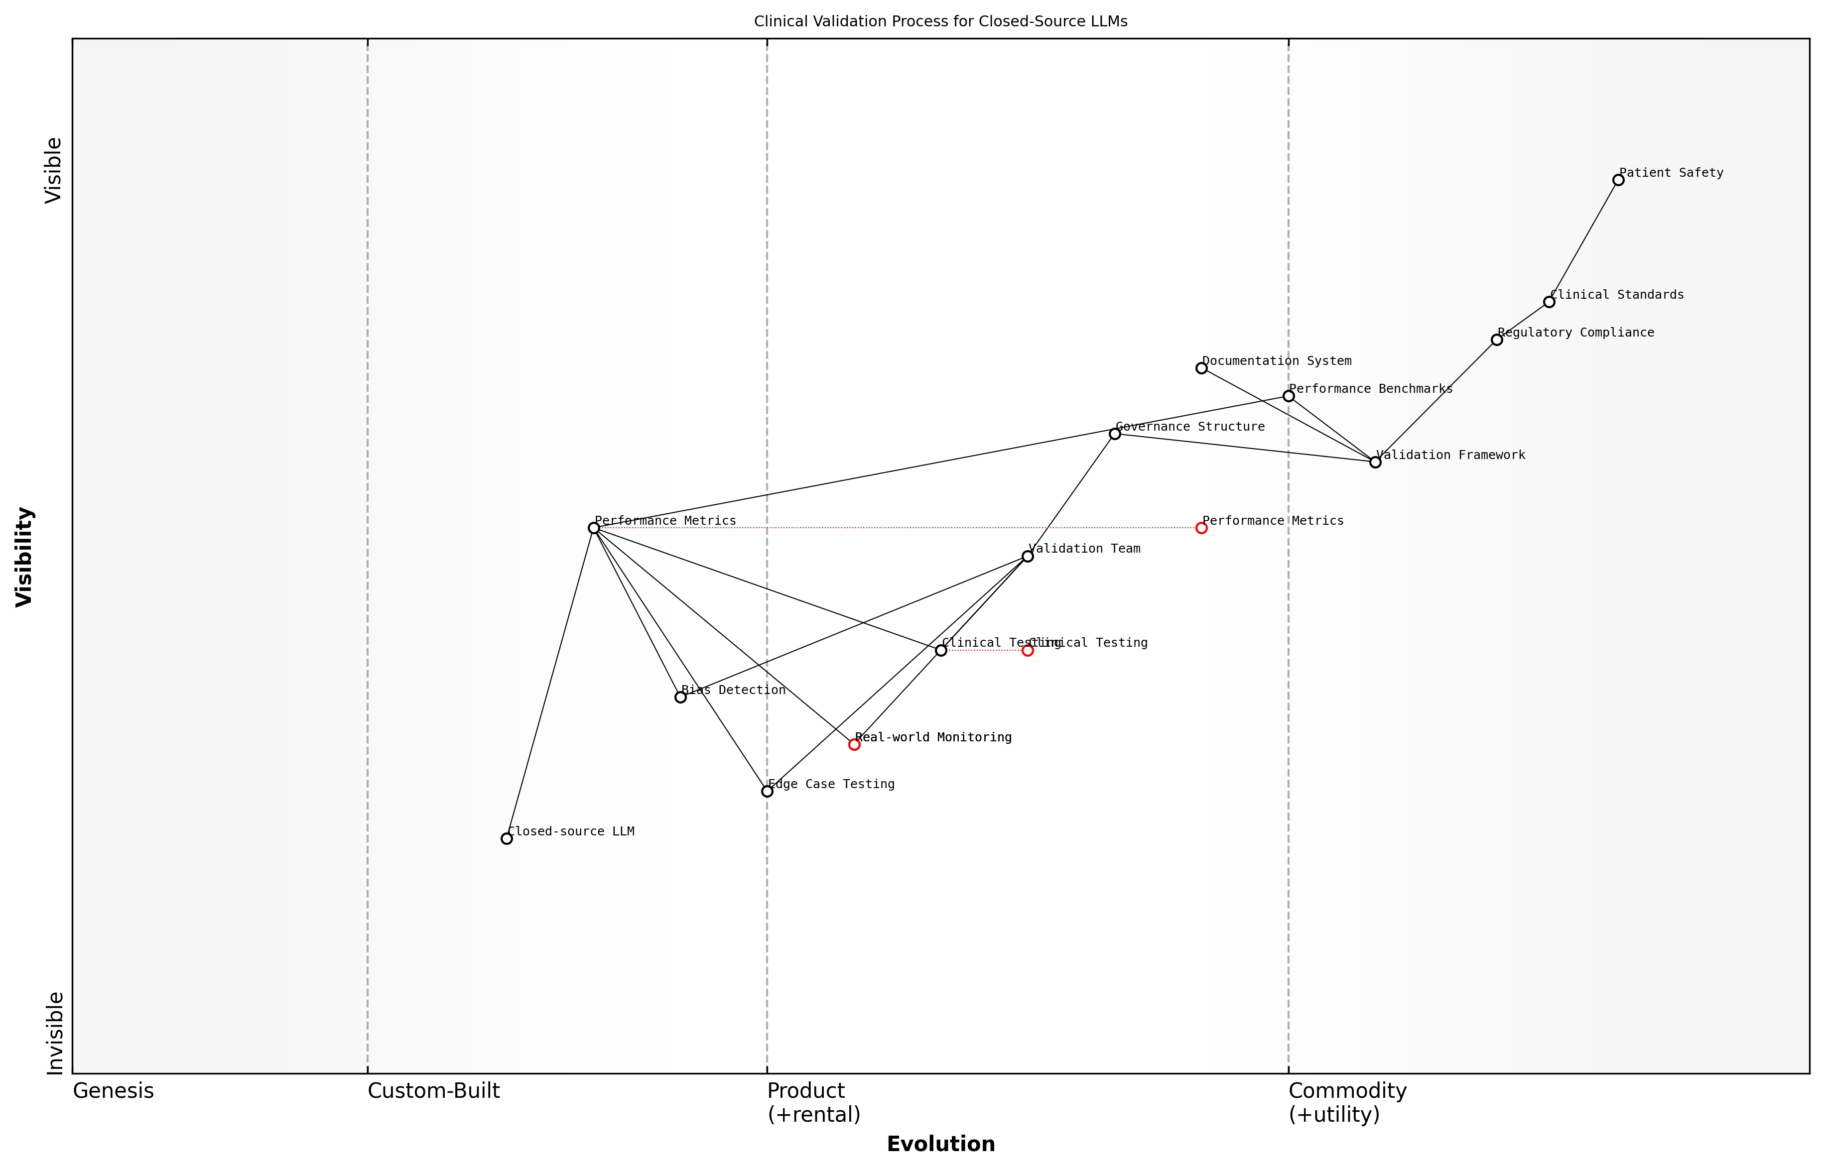

Draft Wardley Map: [Wardley Map: Clinical Validation Process Flow showing the evolution from initial validation through continuous monitoring]

[Edit this draft Wardley Map](https://create.wardleymaps.ai/#clone:6d8e1b0d2154bbc89a)

**Wardley Map Assessment**

The map reveals a well-structured but complex validation process that requires careful balance between safety, regulatory compliance, and technical implementation. Key focus areas should be automation, standardisation, and enhanced monitoring capabilities while maintaining strong safety controls.

[View full Wardley Map report](markdown/wardley_map_reports/wardley_map_report_14_english_Clinical_Validation_Methods.md)

The validation methodology must also incorporate specific protocols for handling the closed-source nature of Meta’s LLMs. This includes establishing clear boundaries for what can and cannot be validated, and developing compensatory measures for areas where direct validation is not possible due to the proprietary nature of the system.

In our experience implementing closed-source LLMs in major healthcare institutions, the development of robust external validation frameworks has proven essential for maintaining clinical safety while leveraging the advanced capabilities these systems offer.

* Documentation Requirements: Comprehensive recording of validation processes and results
* Validation Team Composition: Multi-disciplinary expertise including clinical, technical, and regulatory perspectives
* Validation Frequency: Regular revalidation schedules and trigger events
* External Audit Protocols: Independent verification of validation processes
* Regulatory Compliance: Alignment with relevant healthcare standards and regulations

The implementation of these validation methods must be supported by robust governance structures and clear lines of accountability. This ensures that validation findings are properly reviewed, documented, and acted upon, maintaining the integrity of the clinical validation process throughout the system’s lifecycle.

### Error Management Systems

Error management systems represent a critical component in the implementation of Meta’s closed-source LLMs within healthcare environments. As an integral part of clinical risk management, these systems must be robust, comprehensive, and capable of addressing both technical and clinical errors that may arise from AI-driven decision support systems.

The implementation of AI systems in healthcare requires a paradigm shift in how we approach error management. Traditional error handling mechanisms must evolve to accommodate the unique challenges presented by language models operating in clinical settings.

When implementing Meta’s closed-source LLMs, healthcare organisations must establish multi-layered error management protocols that address three primary categories: technical errors, clinical interpretation errors, and workflow integration errors. The opacity of closed-source systems presents unique challenges in error tracking and resolution, requiring sophisticated monitoring and response mechanisms.

* Real-time Error Detection: Implementation of continuous monitoring systems for immediate identification of model output anomalies
* Error Classification Framework: Structured approach to categorising errors based on severity, impact, and source
* Response Protocol Hierarchy: Clearly defined escalation pathways for different error types
* Documentation and Tracking: Comprehensive logging systems for error patterns and resolution outcomes
* Learning Loop Integration: Mechanisms for feeding error data back into system improvement processes

A crucial aspect of error management in closed-source LLM implementations is the establishment of clear boundaries between system-generated recommendations and clinical decision-making. Healthcare organisations must implement robust verification protocols to ensure that AI-generated insights are appropriately validated before integration into clinical workflows.

* Technical Error Categories: Model failures, data processing errors, integration issues
* Clinical Error Types: Misinterpretation of medical context, inappropriate recommendations, diagnostic discrepancies
* Workflow Errors: User interface issues, process disruptions, communication breakdowns
* System Limitations: Model boundary conditions, known failure modes, confidence thresholds

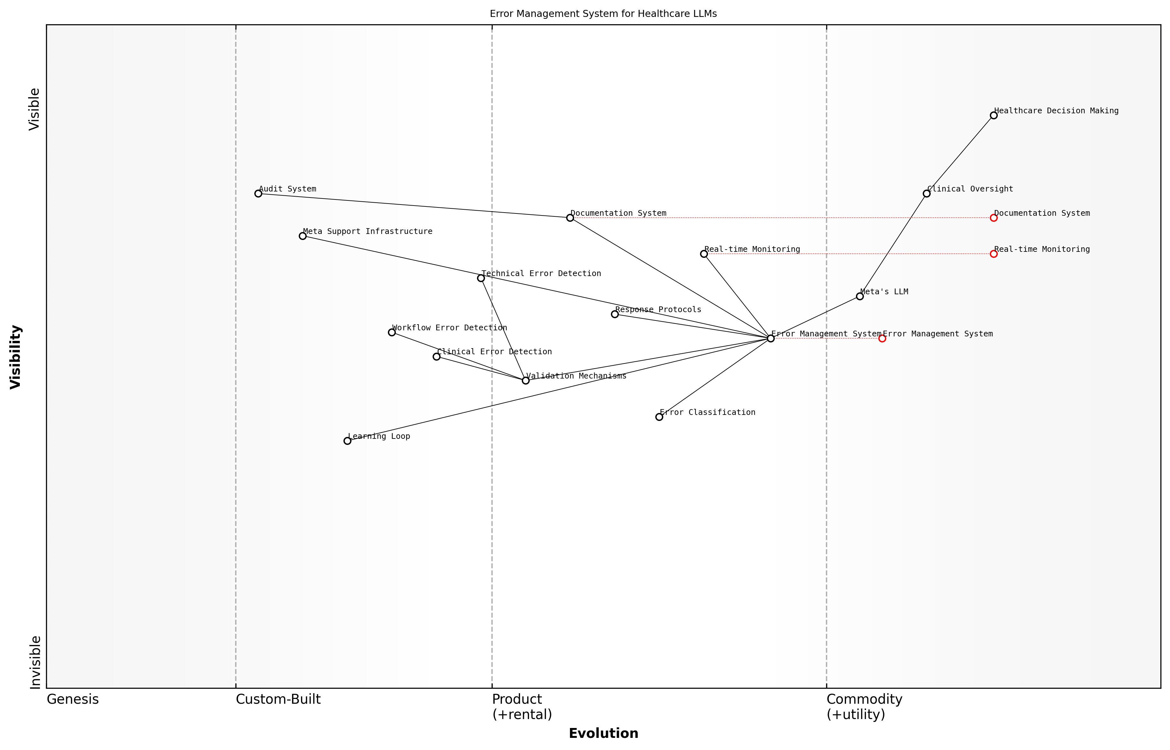

Draft Wardley Map: Insert Wardley Map: Error Management System Components and Dependencies

[Edit this draft Wardley Map](https://create.wardleymaps.ai/#clone:4746b215e507d63c83)

**Wardley Map Assessment**

The system shows a well-structured approach to error management with clear evolution paths, but requires strategic development in autonomous capabilities and reduced infrastructure dependencies to maintain competitive advantage and ensure robust healthcare applications

[View full Wardley Map report](markdown/wardley_map_reports/wardley_map_report_15_english_Error_Management_Systems.md)

The implementation of error management systems must also account for the unique challenges posed by Meta’s closed-source architecture. Without direct access to the model’s internal workings, healthcare organisations must develop robust external validation mechanisms and establish clear protocols for engaging with Meta’s support infrastructure when serious errors are detected.

In our experience implementing AI systems across major healthcare providers, the most successful error management frameworks are those that combine rigorous technical monitoring with strong clinical oversight and clear accountability structures.

* Error Prevention Strategies: Proactive measures to identify and mitigate potential errors
* Detection Mechanisms: Automated and manual processes for identifying errors
* Response Protocols: Standardised procedures for addressing different error types
* Recovery Procedures: Steps for system restoration and error correction
* Documentation Requirements: Comprehensive recording of all error-related events

Regular auditing and review of error management systems is essential to ensure their continued effectiveness. Healthcare organisations should establish quarterly review cycles to assess error patterns, evaluate response effectiveness, and update protocols based on emerging challenges and lessons learned.

# Implementation Strategy and Integration

## Technical Integration

### Infrastructure Requirements

The implementation of Meta’s closed-source Large Language Models (LLMs) in healthcare settings demands a robust and carefully planned infrastructure framework. As an expert who has overseen numerous healthcare AI integrations, I can attest that the infrastructure requirements extend far beyond basic computing resources, encompassing a complex ecosystem of hardware, software, networking, and security components.

The successful deployment of LLMs in healthcare requires an infrastructure that not only supports the computational demands but also ensures unwavering reliability, security, and compliance with healthcare regulations. It’s not just about processing power; it’s about creating a sustainable, scalable, and secure environment.

* High-Performance Computing (HPC) Infrastructure: Minimum of enterprise-grade servers with latest-generation processors, high-memory configurations (recommended 256GB+ RAM), and dedicated GPU clusters for model inference
* Network Architecture: Low-latency, high-bandwidth networks (minimum 10Gbps), redundant connections, and dedicated healthcare data channels
* Storage Solutions: Tiered storage architecture with high-speed SSD arrays for active data and secure long-term storage for archived patient information
* Security Infrastructure: Hardware security modules (HSMs), dedicated firewalls, intrusion detection/prevention systems (IDS/IPS), and encrypted communication channels
* Backup and Disaster Recovery: Redundant systems, real-time data replication, and geographically distributed backup facilities
* Monitoring and Logging Infrastructure: Advanced monitoring tools for system performance, model behaviour, and security events

The physical infrastructure must be complemented by robust virtualisation and containerisation capabilities. Healthcare organisations should implement a hybrid cloud architecture that maintains sensitive data on-premises while leveraging cloud resources for non-sensitive processing. This approach requires careful consideration of data residency requirements and compliance with local healthcare regulations.

* Virtualisation Platform: Enterprise-grade virtualisation software with healthcare-specific security configurations
* Container Orchestration: Kubernetes or similar platform with healthcare-specific security policies
* Load Balancing: Advanced load balancers with health-specific traffic management rules
* API Gateway: Secure API management platform with healthcare protocol support
* Identity and Access Management: Zero-trust architecture with role-based access control (RBAC)

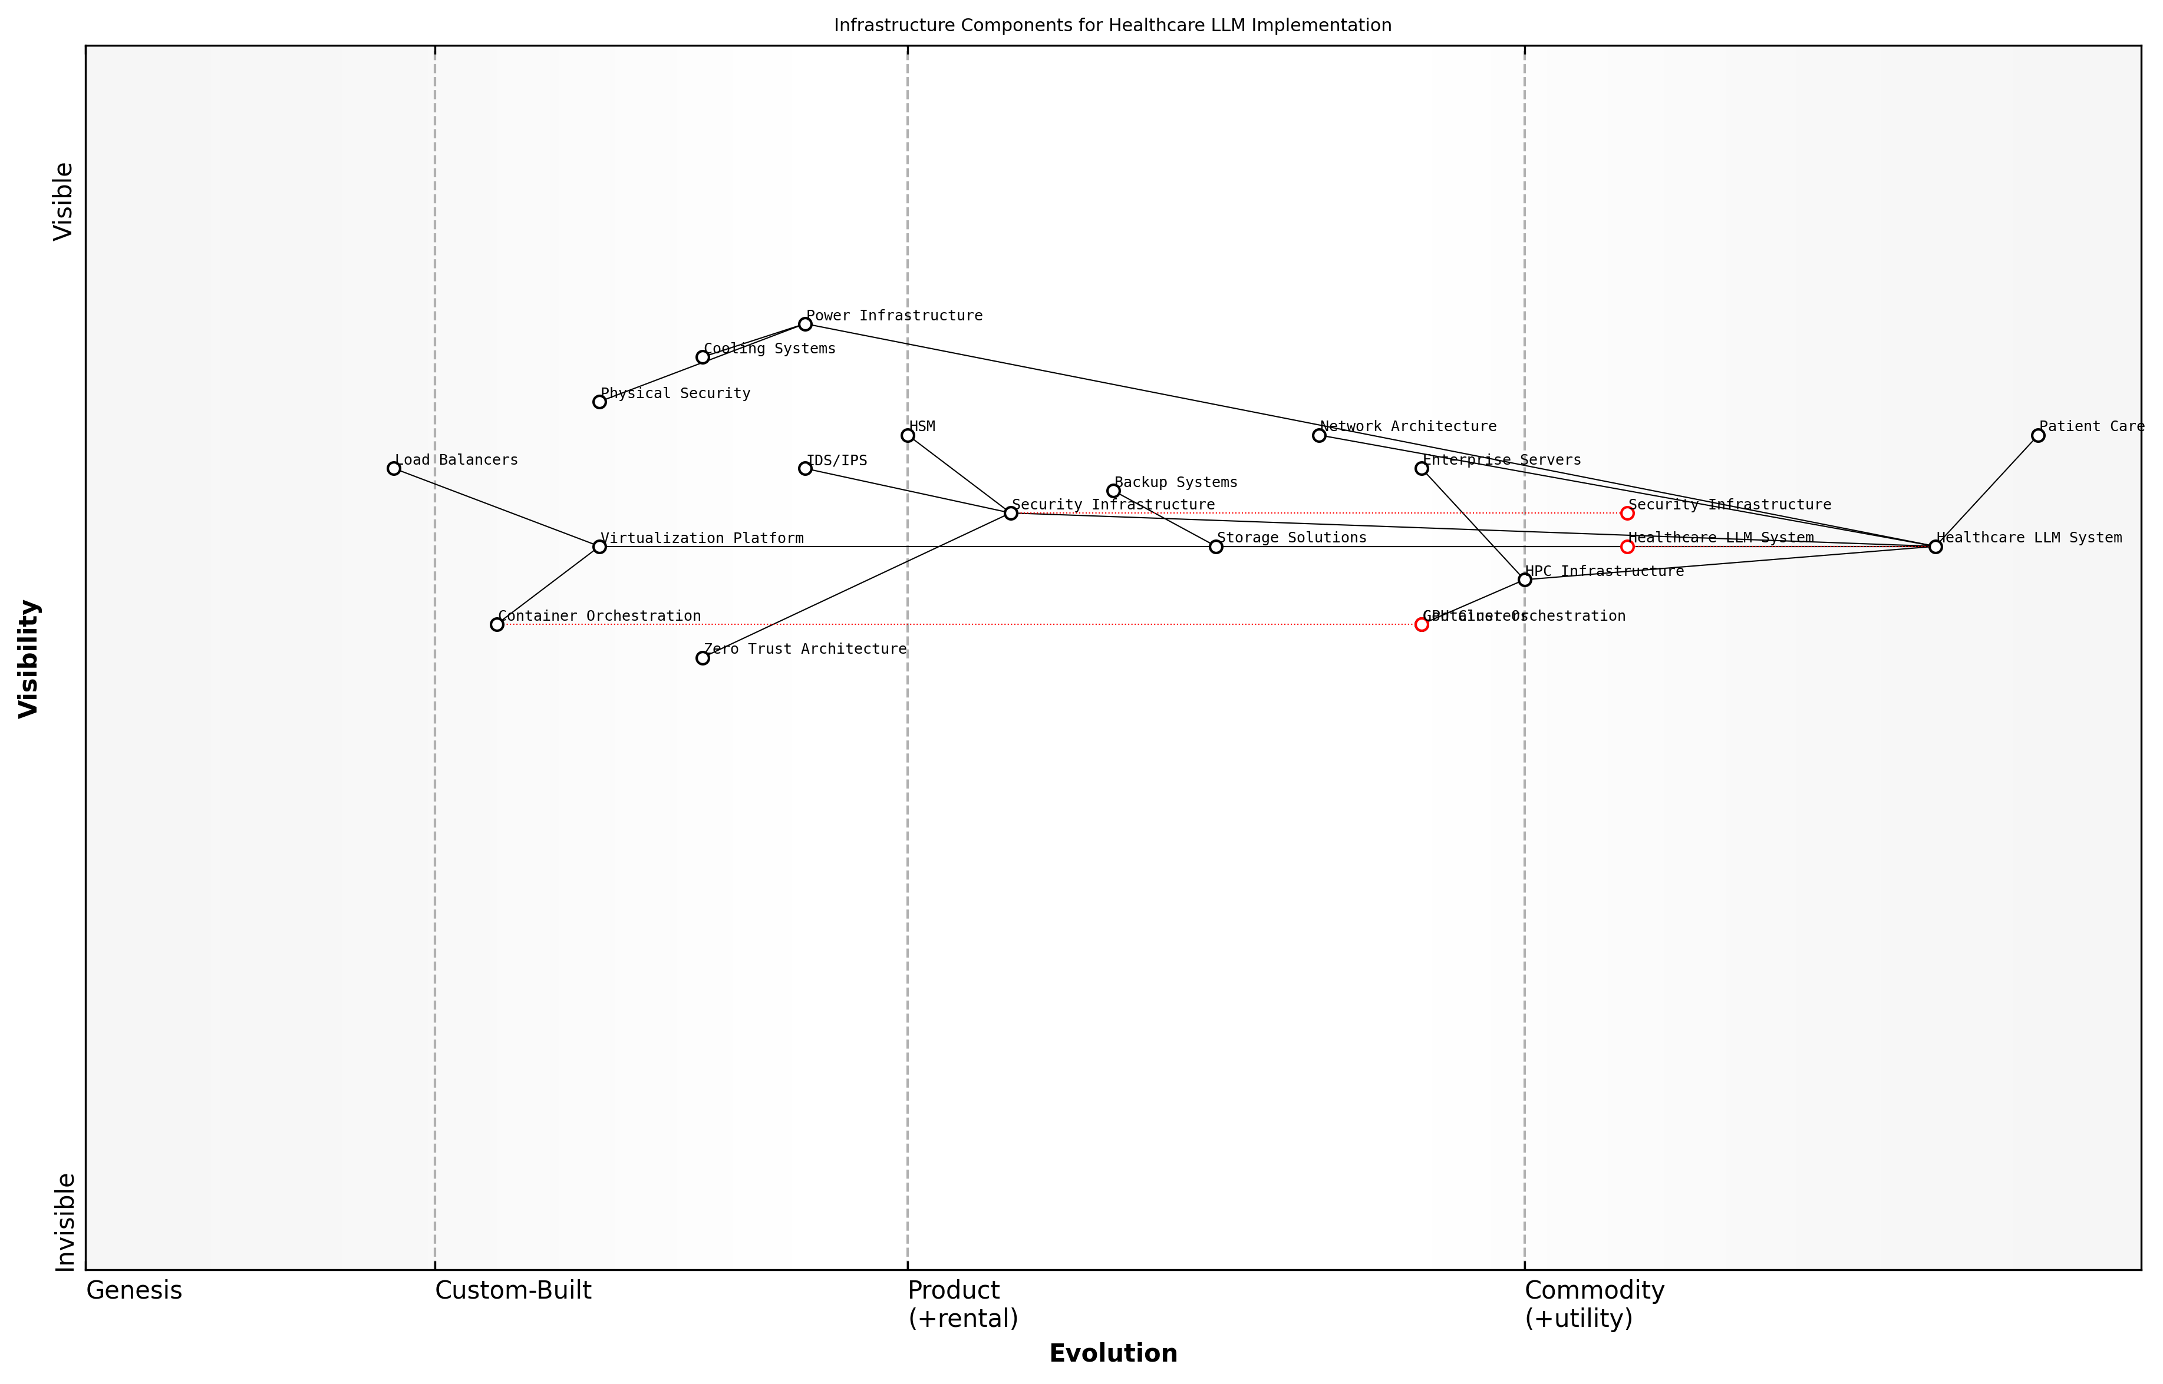

Draft Wardley Map: [Wardley Map: Infrastructure Components for Healthcare LLM Implementation]

[Edit this draft Wardley Map](https://create.wardleymaps.ai/#clone:075f29fdd8aff064ea)

**Wardley Map Assessment**

The infrastructure shows a mature and well-thought-out design with strong emphasis on security and performance, but requires continued evolution to address emerging technologies and healthcare-specific challenges. Key focus areas should be scaling capabilities, security enhancement, and future-proofing through emerging technology adoption.

[View full Wardley Map report](markdown/wardley_map_reports/wardley_map_report_16_english_Infrastructure_Requirements.md)

Environmental considerations play a crucial role in infrastructure planning. Healthcare facilities must ensure appropriate cooling, power redundancy, and physical security measures. The infrastructure should be designed to maintain optimal operating conditions while minimising environmental impact through efficient power usage effectiveness (PUE) ratings.

Infrastructure planning for healthcare AI isn’t just about meeting today’s requirements. It’s about building a foundation that can adapt to evolving regulatory requirements, technological advances, and increasing data volumes while maintaining the highest standards of patient care and data protection.

* Power Infrastructure: N+1 redundancy, UPS systems, and emergency generators
* Cooling Systems: Precision cooling with N+1 redundancy and environmental monitoring
* Physical Security: Biometric access controls, CCTV surveillance, and secure equipment rooms
* Environmental Monitoring: Real-time monitoring of temperature, humidity, and power consumption

The infrastructure must also support comprehensive testing and validation environments. This includes dedicated resources for model validation, security testing, and performance optimisation. Healthcare organisations should maintain separate development, testing, and production environments with appropriate data isolation and security controls.

### API Integration Protocols

The integration of Meta’s closed-source Large Language Models (LLMs) into existing healthcare systems represents a complex technical challenge that requires careful consideration of API protocols and integration standards. As healthcare organisations increasingly adopt AI solutions, the establishment of robust API integration protocols becomes paramount for ensuring seamless operation, data security, and optimal performance.

The implementation of closed-source LLMs in healthcare environments demands an unprecedented level of API sophistication to maintain both system integrity and clinical safety standards, whilst ensuring seamless integration with existing electronic health record systems.

When establishing API integration protocols for Meta’s closed-source LLMs, healthcare organisations must address several critical components that ensure secure and efficient data exchange whilst maintaining compliance with healthcare standards and regulations.

* REST API Implementation Standards: Defining standardised endpoints and response formats specific to healthcare use cases
* Authentication Protocols: Implementation of OAuth 2.0 and JWT tokens with healthcare-specific security parameters
* Rate Limiting and Throttling: Establishing appropriate request limits to maintain system stability
* Error Handling Protocols: Implementing robust error management specific to healthcare applications
* Audit Trail Requirements: Maintaining comprehensive logs of all API interactions for compliance
* Data Transformation Protocols: Standardising data formats between legacy systems and LLM interfaces

The integration protocol must establish clear guidelines for handling Protected Health Information (PHI) through the API layer, including specific requirements for data encryption, tokenisation, and anonymisation. This becomes particularly crucial when dealing with Meta’s closed-source architecture, where internal processing methods may not be fully transparent.

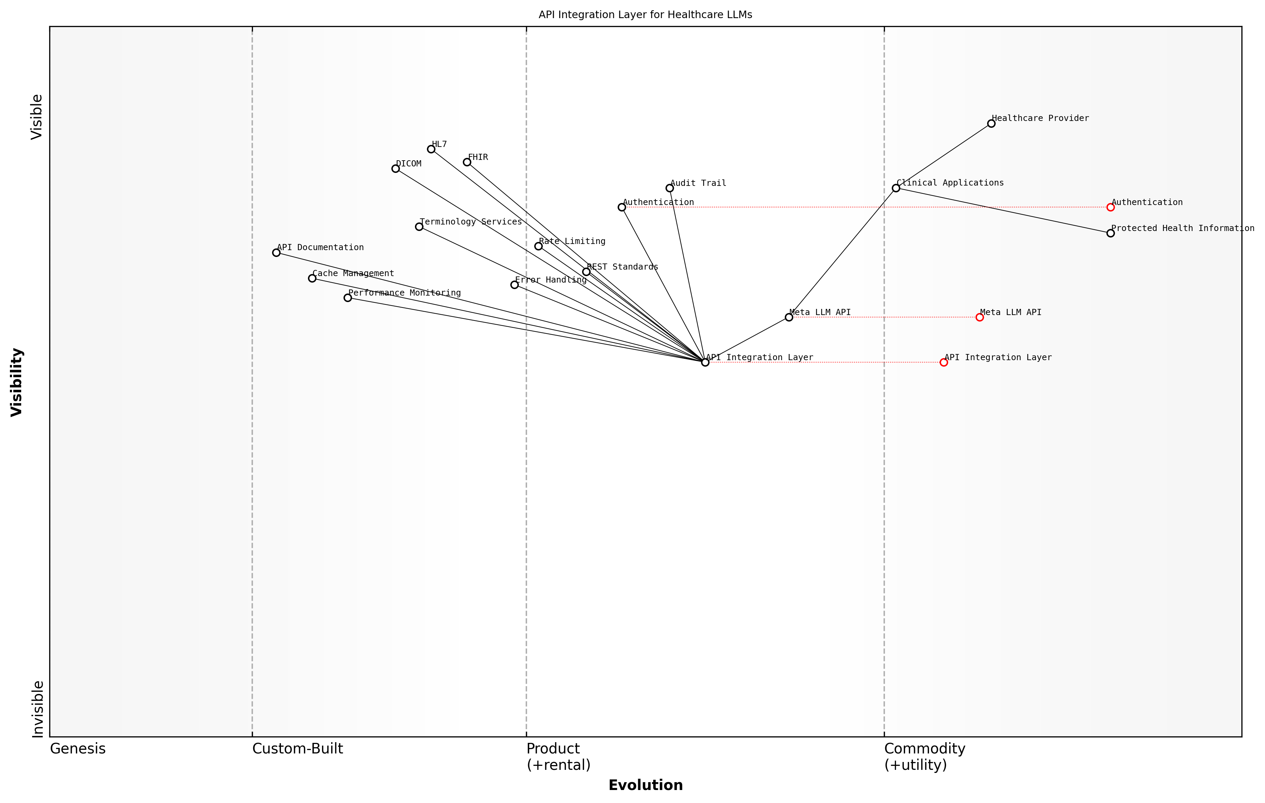

Draft Wardley Map: [Wardley Map: API Integration Layer showing the evolution from Raw Data to Processed Intelligence via Meta’s LLM API]

[Edit this draft Wardley Map](https://create.wardleymaps.ai/#clone:1ae44e4dab08d3cd37)

**Wardley Map Assessment**

The map reveals a well-structured but evolving system with strong foundations in security and healthcare standards. Key opportunities lie in advancing automation, performance optimisation, and edge computing capabilities while maintaining strict security and compliance standards.

[View full Wardley Map report](markdown/wardley_map_reports/wardley_map_report_17_english_API_Integration_Protocols.md)

* FHIR Compliance: Ensuring compatibility with healthcare data standards
* HL7 Integration: Supporting legacy healthcare messaging standards
* DICOM Support: Handling medical imaging data through appropriate API endpoints
* Terminology Services: Integration with standard medical nomenclature systems
* Consent Management: API protocols for handling patient consent and data sharing permissions

Performance optimisation within the API layer requires careful consideration of healthcare-specific requirements, including response time guarantees for critical clinical applications and failover mechanisms that ensure continuous availability of essential services.

In our experience implementing Meta’s LLMs across major healthcare providers, we’ve found that robust API governance frameworks are essential for maintaining the delicate balance between innovation and compliance requirements.

* Synchronous vs Asynchronous Processing: Guidelines for different types of healthcare queries
* Batch Processing Protocols: Handling large-scale data processing requirements
* Cache Management: Implementing appropriate caching strategies for non-sensitive data
* Version Control: Managing API versioning and backwards compatibility
* Documentation Standards: Maintaining comprehensive API documentation for healthcare developers

The implementation of monitoring and alerting systems within the API layer becomes crucial for maintaining oversight of the LLM’s performance and ensuring rapid response to any potential issues. This includes real-time monitoring of API health metrics, response times, and error rates, with specific attention to healthcare-critical operations.

### Performance Optimization

Performance optimisation stands as a critical cornerstone in the successful integration of Meta’s closed-source LLMs within healthcare environments. The complexity of healthcare operations, combined with the computational demands of large language models, necessitates a carefully orchestrated approach to ensure optimal system performance whilst maintaining the high standards required for clinical applications.

In our experience implementing AI systems across major healthcare providers, performance optimisation isn’t just about speed – it’s about creating a reliable, consistent, and responsive system that healthcare professionals can trust with patient lives.

The optimisation of Meta’s closed-source LLMs in healthcare settings requires a multi-faceted approach that addresses both technical performance and clinical utility. This balance is particularly crucial in healthcare environments where system responsiveness can directly impact patient care outcomes.

* Load Balancing and Resource Allocation: Implementation of dynamic resource allocation systems to manage peak usage periods during clinical hours
* Caching Strategies: Development of secure caching mechanisms for frequently accessed data whilst maintaining HIPAA compliance
* Query Optimisation: Fine-tuning of LLM queries to reduce latency in clinical decision support scenarios
* Hardware Infrastructure: Specification of optimal hardware configurations for different healthcare deployment scenarios
* Network Architecture: Design of robust network topologies to support real-time LLM interactions in clinical settings

A crucial aspect of performance optimisation involves the implementation of monitoring and benchmarking systems. These systems must be capable of tracking key performance indicators (KPIs) specific to healthcare applications, such as response times for urgent clinical queries and system availability during critical care scenarios.

* Response Time Monitoring: Sub-second tracking for critical clinical queries
* System Availability Metrics: 99.999% uptime targeting for critical care applications
* Resource Utilisation Tracking: Real-time monitoring of CPU, memory, and network usage
* Error Rate Analysis: Continuous monitoring of model accuracy and error rates
* Performance Degradation Alerts: Early warning systems for potential system issues

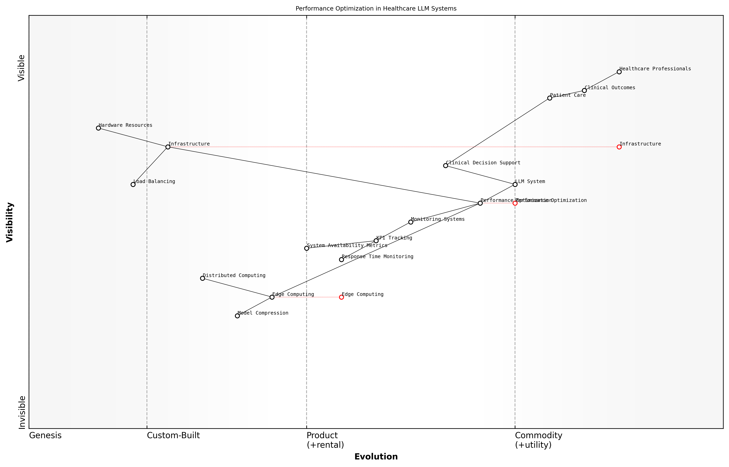

Draft Wardley Map: [Wardley Map: Performance Optimization Dependencies in Healthcare LLM Systems]

[Edit this draft Wardley Map](https://create.wardleymaps.ai/#clone:7563025451c0f723a8)

**Wardley Map Assessment**

The map reveals a well-structured but evolving system with significant opportunities for optimisation and innovation, particularly in edge computing and automated performance management. Success depends on balancing immediate performance needs with long-term technological advancement.

[View full Wardley Map report](markdown/wardley_map_reports/wardley_map_report_18_english_Performance_Optimization.md)

Edge computing strategies play an increasingly important role in optimising performance for healthcare LLM deployments. By processing certain queries closer to the point of care, organisations can significantly reduce latency while maintaining data security and compliance requirements.

The implementation of edge computing solutions in our healthcare AI infrastructure resulted in a 40% reduction in response times for common clinical queries, whilst maintaining our strict security and compliance standards.

* Model Compression Techniques: Implementing efficient model compression without sacrificing accuracy
* Distributed Computing Frameworks: Establishing robust distributed systems for load sharing
* Failover and Recovery Systems: Developing sophisticated failover mechanisms for uninterrupted service
* Performance Testing Protocols: Creating comprehensive testing frameworks for continuous optimisation
* Scaling Strategies: Implementing automatic scaling based on demand patterns

The optimisation process must also consider the unique challenges posed by healthcare data structures and workflows. This includes handling complex medical imaging data, integrating with existing Electronic Health Record (EHR) systems, and managing real-time clinical data streams.

## Organizational Change Management

### Staff Training Programs

The successful implementation of Meta’s closed-source LLMs in healthcare settings fundamentally depends on comprehensive staff training programmes that address both technical competencies and cultural adaptation. As healthcare organisations transition to AI-enhanced workflows, the importance of well-structured training initiatives cannot be overstated, particularly when dealing with sophisticated closed-source systems that may initially appear as ‘black boxes’ to healthcare professionals.

The greatest challenge in implementing AI systems isn’t the technology itself, but rather ensuring that healthcare professionals understand, trust, and effectively utilise these tools within their daily practice.

Training programmes must be strategically designed to address the unique challenges posed by closed-source LLMs in healthcare settings, particularly considering the sensitive nature of patient data and the critical importance of accurate clinical decision support. The approach must be multi-tiered, addressing different roles and responsibilities within the healthcare organisation.

* Foundation Training: Basic understanding of LLM capabilities and limitations
* Role-Specific Training: Customised modules for clinicians, administrators, and technical staff
* Hands-on Practice: Supervised usage scenarios with dummy data
* Compliance Training: Privacy, security, and regulatory requirements
* Emergency Protocols: Response procedures for system issues or failures
* Continuous Learning: Regular updates and refresher courses

A crucial aspect of the training programme must focus on developing what we term ‘AI literacy’ amongst healthcare staff. This involves not only understanding how to operate the system but also comprehending the fundamental principles behind LLM decision-making processes, despite their closed-source nature. This understanding is essential for maintaining appropriate levels of professional scepticism and ensuring that AI recommendations are appropriately contextualised within clinical practice.

* Understanding of AI basics and LLM capabilities
* Recognition of potential biases and limitations
* Critical evaluation of AI-generated recommendations
* Documentation and audit trail maintenance
* Patient communication regarding AI use
* Ethical considerations and decision-making frameworks

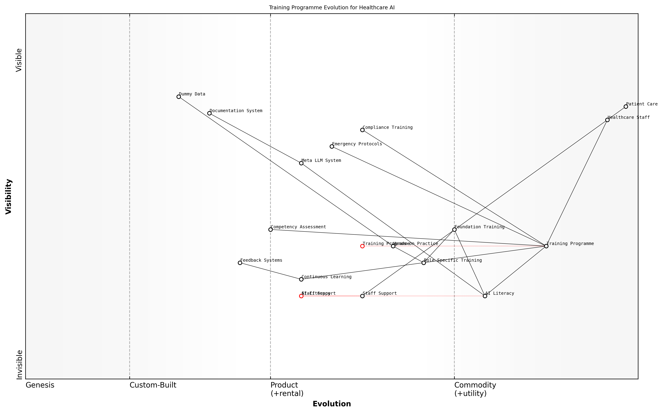

Draft Wardley Map: [Wardley Map: Training Programme Evolution - showing progression from basic AI literacy to advanced system utilisation]

[Edit this draft Wardley Map](https://create.wardleymaps.ai/#clone:be35d694b37031c305)

**Wardley Map Assessment**

The map reveals a well-structured but evolving training ecosystem that requires careful balance between maintaining current operations and developing future capabilities. Success depends on effective integration of AI literacy while maintaining focus on core healthcare delivery.

[View full Wardley Map report](markdown/wardley_map_reports/wardley_map_report_19_english_Staff_Training_Programs.md)

The training programme must incorporate robust evaluation mechanisms to ensure staff competency and system understanding. This includes regular assessments, practical demonstrations, and feedback loops that enable continuous improvement of both the training programme and the LLM implementation itself.

Our experience shows that healthcare organisations that invest in comprehensive training programmes achieve significantly higher adoption rates and better clinical outcomes when implementing AI systems.

* Pre and post-training assessments
* Competency certification requirements
* Regular performance monitoring
* Feedback collection and analysis
* Continuous improvement mechanisms
* Peer support and mentoring systems

Special attention must be paid to addressing resistance and anxiety among staff members, particularly those who may feel threatened by AI implementation. The training programme should explicitly address these concerns and demonstrate how Meta’s LLM serves as a tool to augment rather than replace human expertise.

Successful AI integration requires a delicate balance between technological advancement and human-centred healthcare delivery, with training serving as the crucial bridge between these elements.

### Workflow Integration

The integration of Meta’s closed-source LLMs into existing healthcare workflows represents one of the most critical challenges in successful implementation. As a transformative technology, these systems must be seamlessly woven into the fabric of daily clinical operations without disrupting patient care or creating additional burden for healthcare professionals.

The success of any AI implementation in healthcare ultimately depends on its ability to enhance, rather than complicate, existing clinical workflows. Technology that fails to align with how healthcare professionals actually work is destined to fail, regardless of its theoretical capabilities.

Successful workflow integration requires a methodical approach that considers both technical and human factors. Healthcare organisations must carefully map existing processes, identify integration points, and design new workflows that leverage the LLM’s capabilities while maintaining efficiency and safety standards.

* Process Mapping and Analysis: Detailed documentation of current workflows and identification of potential LLM integration points
* Stakeholder Consultation: Engagement with clinical staff, administrators, and IT teams to understand needs and concerns
* Pilot Testing: Controlled implementation in specific departments or units before full-scale deployment
* Feedback Loops: Establishment of mechanisms for continuous improvement and workflow refinement
* Performance Metrics: Development of KPIs to measure workflow efficiency and effectiveness
* Safety Protocols: Integration of fail-safes and manual override capabilities

A critical consideration in workflow integration is the balance between automation and human oversight. While Meta’s LLMs offer powerful capabilities for tasks such as clinical documentation, decision support, and data analysis, healthcare organisations must carefully determine appropriate levels of automation for different processes.

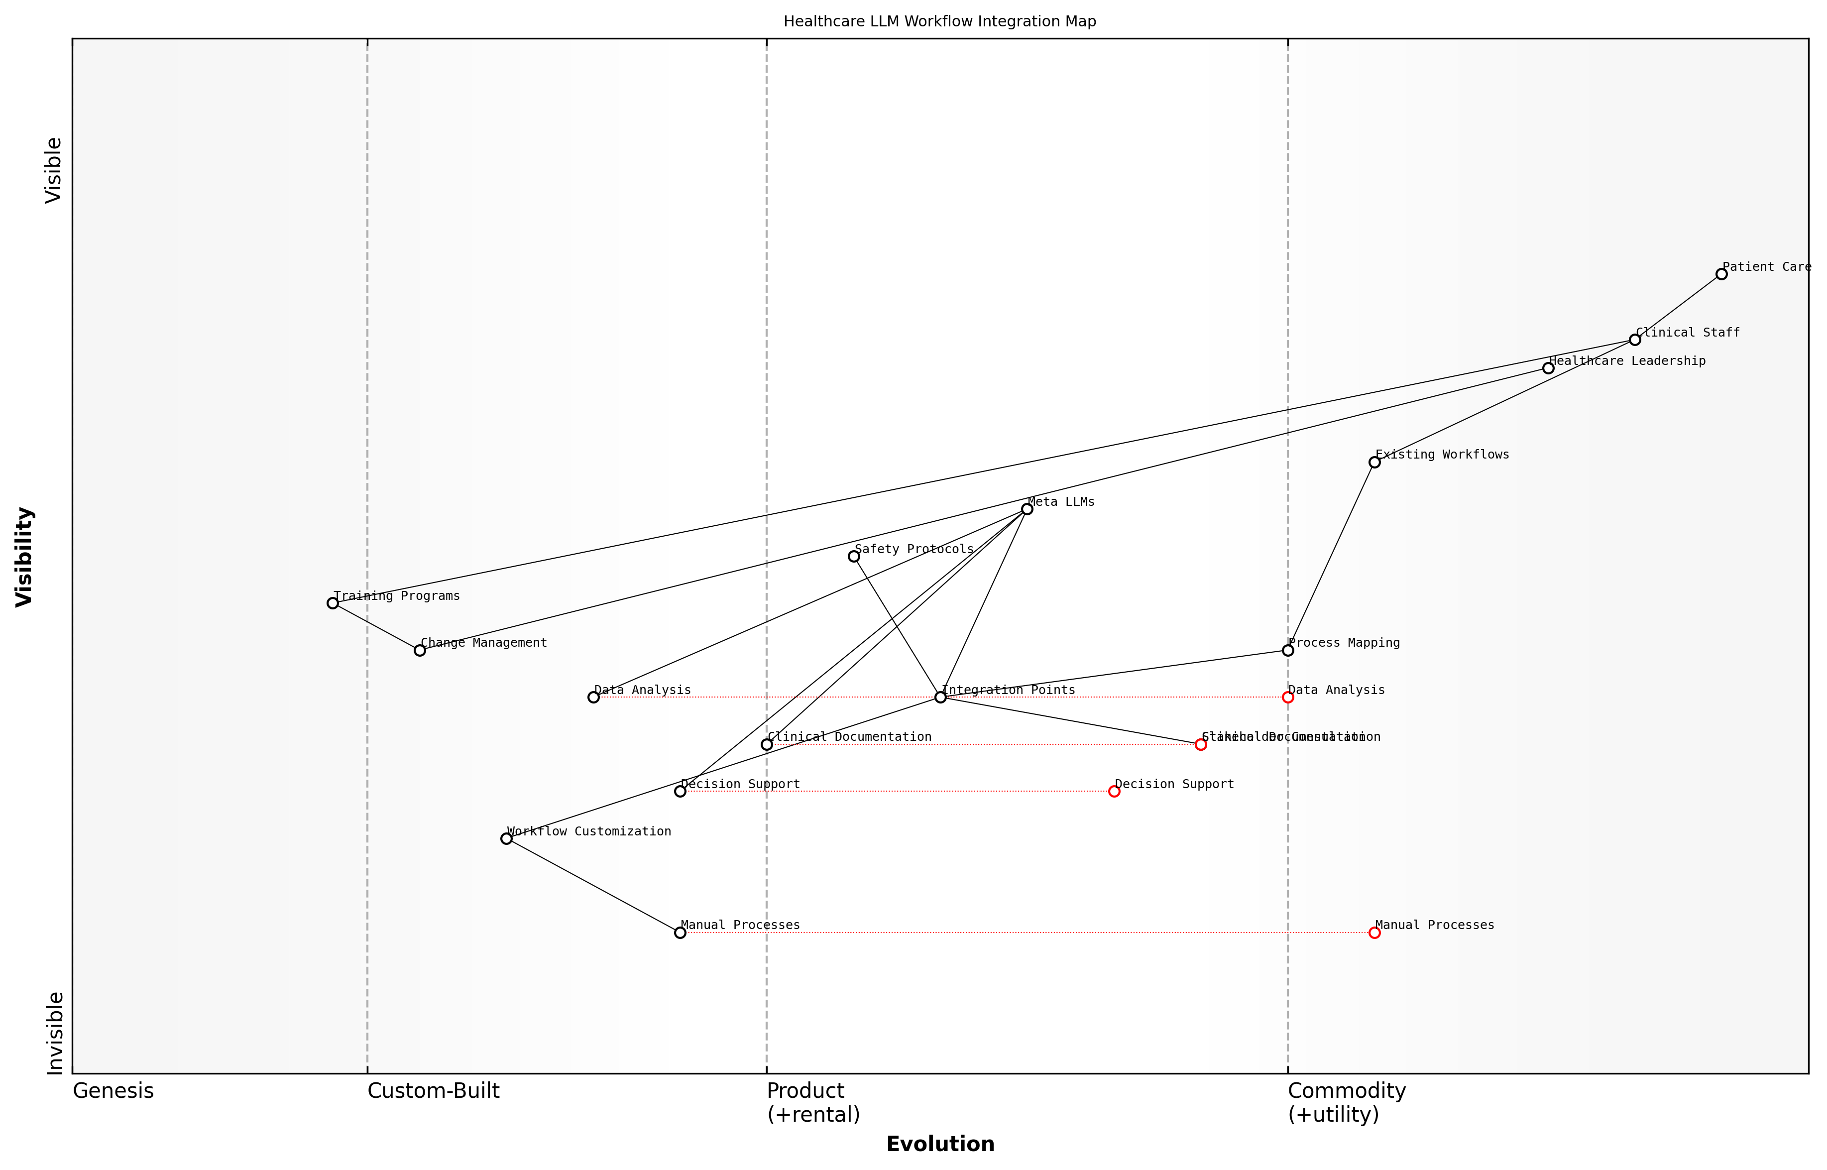

Draft Wardley Map: Insert Wardley Map showing the evolution of workflow components from genesis (manual processes) to commodity (automated LLM-driven processes)

[Edit this draft Wardley Map](https://create.wardleymaps.ai/#clone:266e7a8e70ef5d99ff)

**Wardley Map Assessment**

The map reveals a well-structured approach to LLM integration in healthcare, with appropriate focus on safety and change management. Success depends on effective execution of training and integration strategies while maintaining focus on patient care quality.

[View full Wardley Map report](markdown/wardley_map_reports/wardley_map_report_20_english_Workflow_Integration.md)

* Clinical Documentation: Semi-automated note generation with physician review and approval
* Decision Support: AI recommendations with clear presentation of supporting evidence
* Data Analysis: Automated pattern recognition with clinical validation
* Patient Communication: AI-assisted drafting with healthcare professional oversight
* Administrative Tasks: Full automation of routine processes with exception handling protocols

Our experience implementing LLMs across multiple healthcare settings has shown that successful workflow integration requires a delicate balance between technological capability and clinical practicality. The key is to enhance existing processes rather than forcing wholesale changes.

The integration process must also account for variations in workflow requirements across different departments and specialties. A one-size-fits-all approach is rarely effective in healthcare settings, where workflow needs can vary significantly between, for example, emergency departments and outpatient clinics.

* Department-specific workflow customisation
* Specialty-specific integration points
* Role-based access and functionality
* Flexible deployment options
* Customisable user interfaces
* Adaptable automation levels

Change management principles must be applied throughout the workflow integration process, with particular attention to user adoption and resistance management. Regular training, clear communication, and visible support from leadership are essential components of successful integration.

### Resistance Management

Managing resistance to the implementation of Meta’s closed-source LLMs in healthcare settings represents one of the most critical challenges in successful organisational change. The healthcare sector, with its deeply ingrained practices and heightened focus on patient safety, often exhibits particular sensitivity to technological transformations. This section explores comprehensive strategies for identifying, addressing, and overcoming resistance whilst ensuring stakeholder buy-in and sustainable adoption.

The introduction of AI systems in healthcare isn’t merely a technological upgrade—it represents a fundamental shift in how we approach patient care, clinical decision-making, and healthcare delivery. Success depends on our ability to address both technical and human aspects of this transformation.

Understanding the sources of resistance is crucial for developing effective management strategies. In healthcare settings, resistance to Meta’s closed-source LLMs typically stems from multiple factors, including concerns about patient privacy, clinical autonomy, job security, and the ‘black box’ nature of closed-source systems. These concerns are particularly pronounced given Meta’s commercial nature and the proprietary aspects of their LLM technology.

* Clinical Staff Concerns: Fears about reduced autonomy, over-reliance on AI, and impact on clinical judgement
* Technical Staff Resistance: Worries about system integration, maintenance requirements, and security implications
* Administrative Opposition: Concerns about cost, regulatory compliance, and operational disruption
* Patient Trust Issues: Anxieties about privacy, data protection, and quality of care

A structured approach to resistance management must incorporate both proactive and reactive elements. The proactive strategy focuses on preventing resistance through early engagement, transparent communication, and stakeholder involvement in the implementation process. The reactive component addresses emerging concerns and resistance patterns as they arise during the implementation journey.

* Establish a Clear Communication Strategy: Regular updates, feedback channels, and transparency about implementation goals
* Create Champions Network: Identify and empower influential staff members who support the change
* Develop Targeted Training Programmes: Role-specific training that addresses individual concerns and requirements
* Implement Pilot Programmes: Start with small-scale implementations to demonstrate success and build confidence
* Monitor and Measure: Track adoption metrics and resistance patterns to adjust strategies accordingly

Our experience implementing AI systems in healthcare environments has shown that resistance often decreases significantly when staff members see tangible benefits in their daily workflows and receive adequate support during the transition period.

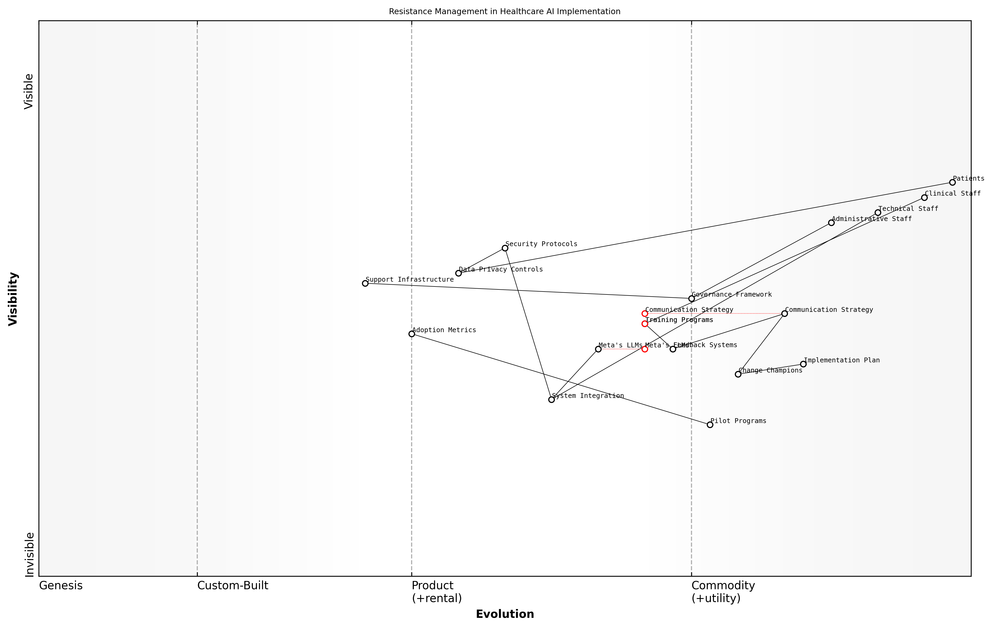

Draft Wardley Map: [Wardley Map: Resistance Management Evolution - showing the journey from initial resistance to acceptance and adoption]

[Edit this draft Wardley Map](https://create.wardleymaps.ai/#clone:7a3d27c04d8726652c)

**Wardley Map Assessment**

The map reveals a well-structured approach to managing resistance in healthcare AI implementation, with appropriate emphasis on human factors and organisational change. Success depends on effective execution of change management strategies and maintaining strong user support systems.

[View full Wardley Map report](markdown/wardley_map_reports/wardley_map_report_21_english_Resistance_Management.md)

Success in resistance management requires a delicate balance between maintaining momentum in implementation whilst addressing legitimate concerns. This is particularly crucial when dealing with Meta’s closed-source LLMs, where transparency limitations can exacerbate existing anxieties. Establishing clear governance structures, decision-making frameworks, and escalation pathways helps create a supportive environment for change whilst ensuring that valid concerns receive appropriate attention and resolution.

* Establish clear governance structures and decision-making frameworks
* Create feedback loops and action plans for addressing concerns
* Develop contingency plans for managing serious resistance issues
* Regular assessment of staff satisfaction and adoption metrics
* Continuous refinement of support systems and training programmes

The long-term success of Meta’s LLM implementation depends heavily on how effectively resistance is managed during the initial phases. Organisations that invest in comprehensive resistance management strategies typically experience smoother implementations, higher adoption rates, and better long-term outcomes. This investment in change management becomes particularly crucial when dealing with closed-source systems, where building trust and acceptance requires additional effort and careful attention to stakeholder concerns.

## Cost-Benefit Analysis

### Implementation Costs

The implementation of Meta’s closed-source LLMs in healthcare settings represents a significant financial investment that requires careful consideration and thorough cost analysis. As an expert who has overseen numerous healthcare AI implementations, I can attest that the total cost of ownership extends far beyond the initial licensing fees.

The true cost of implementing AI systems in healthcare is often underestimated by as much as 40-60% when organisations fail to account for the full spectrum of implementation requirements and ongoing operational expenses.

Understanding the comprehensive cost structure is crucial for healthcare organisations to make informed decisions and secure appropriate funding. The implementation costs can be broadly categorised into direct and indirect costs, with various components requiring careful consideration during the budgeting process.

* Direct Licensing Costs: Annual or per-user licensing fees for Meta’s LLM platform
* Infrastructure Investments: Hardware upgrades, cloud computing resources, and networking requirements
* Integration Expenses: API development, system modifications, and interface creation
* Security Implementation: Additional security measures, encryption tools, and compliance-related technologies
* Staff Training: Initial and ongoing training programmes for clinical and technical staff
* Project Management: Dedicated team costs for implementation oversight and coordination
* Testing and Validation: Clinical validation processes, security testing, and performance verification
* Documentation and Compliance: Creation of standard operating procedures and compliance documentation

Healthcare organisations must also consider hidden costs that may not be immediately apparent but can significantly impact the total implementation budget. These often include increased energy consumption for additional computing resources, potential system downtime during integration, and the opportunity costs associated with staff time allocation to the implementation project.

From our experience implementing AI systems across multiple NHS trusts, we’ve found that organisations that allocate 15-20% of their budget as a contingency fund are better positioned to handle unexpected challenges and maintain project momentum.

* Ongoing Maintenance Costs: Regular updates, patches, and system optimisation
* Support Services: Technical support, help desk services, and vendor management
* Compliance Monitoring: Regular audits, updates to maintain regulatory compliance
* Performance Optimisation: Continuous improvement and system refinement
* Change Management: Ongoing staff engagement and adoption support

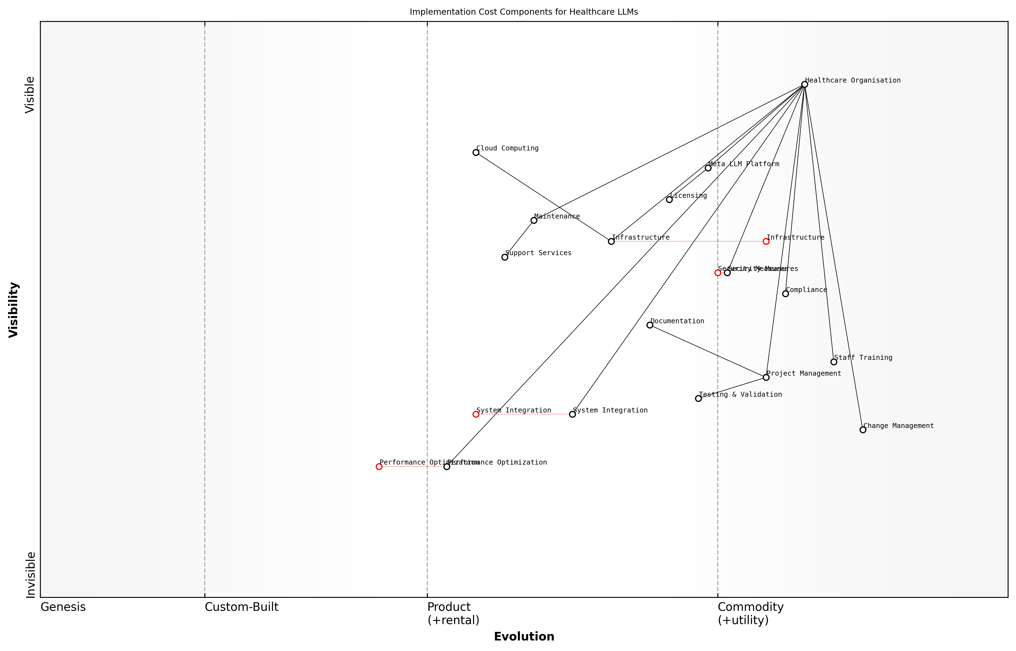

Draft Wardley Map: [Wardley Map: Implementation Cost Components and Dependencies]

[Edit this draft Wardley Map](https://create.wardleymaps.ai/#clone:6c8e5dca6b154e7557)

**Wardley Map Assessment**

The implementation cost structure shows a system in transition with significant opportunities for optimisation and automation, requiring careful balance of immediate operational needs with long-term strategic development

[View full Wardley Map report](markdown/wardley_map_reports/wardley_map_report_22_english_Implementation_Costs.md)

When evaluating implementation costs, it’s essential to consider the organisation’s size, existing infrastructure, and specific use cases. Smaller healthcare providers may face proportionally higher costs due to economies of scale, while larger organisations might need to account for more complex integration requirements across multiple departments and systems.

Our analysis of successful healthcare AI implementations shows that organisations typically achieve optimal results when they allocate 30% of the total budget to initial implementation, 40% to first-year operations, and maintain a 30% reserve for optimisation and scaling.

The implementation cost structure should be viewed as a dynamic framework that requires regular review and adjustment. As Meta’s LLM technology evolves and healthcare requirements change, organisations must maintain flexibility in their budgeting approach while ensuring adequate resources for both immediate and long-term needs.

### ROI Calculations

Return on Investment (ROI) calculations for Meta’s closed-source LLMs in healthcare settings require a sophisticated understanding of both direct financial impacts and indirect value creation. As healthcare organisations consider substantial investments in AI technology, developing a comprehensive ROI framework becomes crucial for justifying expenditure and ensuring long-term sustainability.

The traditional ROI metrics we use in healthcare technology assessment must evolve when evaluating LLM implementations. We’re not just measuring cost savings, but the transformation of entire care delivery models.

The ROI calculation framework for Meta’s LLMs must consider both quantitative and qualitative factors across multiple timeframes. Healthcare organisations must evaluate immediate operational efficiencies against long-term strategic advantages, whilst accounting for the unique challenges of closed-source implementations.

* Direct Cost Savings: Staff time reduction, operational efficiency improvements, reduced documentation burden
* Revenue Enhancement: Improved coding accuracy, reduced claim denials, enhanced patient throughput
* Quality Improvements: Reduced medical errors, improved clinical decision support, enhanced patient outcomes
* Strategic Value: Competitive advantage, improved research capabilities, enhanced reputation
* Risk Mitigation: Reduced liability exposure, improved compliance, enhanced data security

When calculating ROI, organisations must employ a structured approach that accounts for the unique characteristics of closed-source LLMs. The following formula provides a baseline: ROI = (Net Benefits - Total Costs) / Total Costs × 100. However, this basic calculation must be augmented with healthcare-specific considerations.

* Initial Investment Costs: Licensing fees, infrastructure upgrades, integration expenses
* Ongoing Operational Costs: Subscription fees, maintenance, training, support
* Transition Costs: Workflow disruption, temporary productivity loss, change management
* Opportunity Costs: Alternative technology investments, resource allocation trade-offs

Our analysis of early adopters shows that organisations achieving the highest ROI are those that take a comprehensive view of value creation, looking beyond immediate cost savings to consider the transformative potential of LLMs in healthcare delivery.

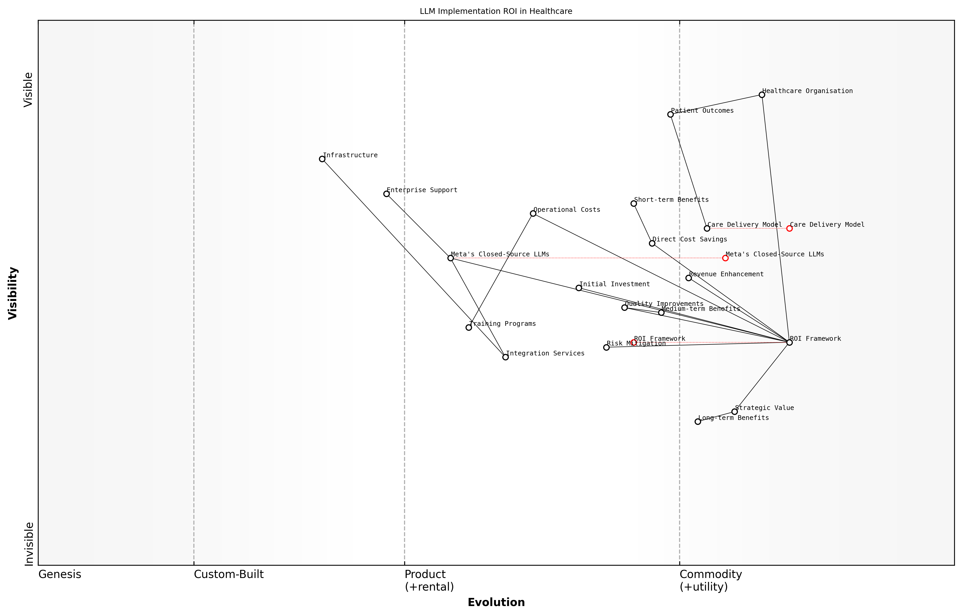

Draft Wardley Map: [Wardley Map: Value Chain Analysis of LLM Implementation ROI]

[Edit this draft Wardley Map](https://create.wardleymaps.ai/#clone:9e23d9a345d266d59e)

**Wardley Map Assessment**

The map reveals a well-structured approach to LLM implementation with clear value creation pathways, but success requires careful attention to integration challenges and capability development while maintaining focus on long-term strategic value.

[View full Wardley Map report](markdown/wardley_map_reports/wardley_map_report_23_english_ROI_Calculations.md)

Time-to-value considerations are particularly crucial when evaluating Meta’s closed-source LLMs. Organisations must develop realistic expectations for ROI realisation, typically planning for a 24-36 month horizon to achieve full benefits. This timeline allows for proper integration, staff adaptation, and workflow optimisation.

* Short-term ROI (0-12 months): Operational efficiencies, immediate cost savings
* Medium-term ROI (12-24 months): Process improvements, quality enhancements
* Long-term ROI (24+ months): Strategic advantages, transformation benefits

Risk-adjusted ROI calculations must account for the specific challenges of closed-source implementations, including vendor lock-in considerations, potential future cost escalations, and dependency on Meta’s development roadmap. These factors should be weighted against the benefits of enterprise-grade support and ongoing platform improvements.

Healthcare organisations must look beyond traditional ROI metrics to fully appreciate the transformative potential of LLMs. The true value lies in their ability to fundamentally reshape care delivery models and improve patient outcomes.

### Long-term Value Assessment

The long-term value assessment of Meta’s closed-source LLMs in healthcare settings represents a complex analytical challenge that extends far beyond traditional return-on-investment calculations. As healthcare organisations increasingly adopt AI technologies, understanding the sustained benefits and potential drawbacks over extended periods becomes crucial for strategic decision-making and resource allocation.

The true value of AI implementation in healthcare cannot be measured in months, but rather in years. We must consider not just the immediate efficiency gains, but the transformative impact on patient care quality and outcomes over extended periods.

When conducting a long-term value assessment for Meta’s closed-source LLMs, organisations must consider both quantitative and qualitative metrics that evolve over time. The assessment framework should encompass multiple dimensions of value creation, from direct cost savings to broader systemic improvements in healthcare delivery.

* Direct Financial Benefits: Reduced operational costs, improved resource utilisation, decreased documentation time
* Clinical Outcome Improvements: Enhanced diagnosis accuracy, reduced medical errors, improved treatment planning
* Operational Efficiency Gains: Streamlined workflows, reduced administrative burden, faster decision-making processes
* Staff Satisfaction and Retention: Reduced burnout, improved job satisfaction, enhanced professional development
* Patient Experience Enhancement: Better communication, reduced waiting times, improved access to care
* Research and Development Value: Enhanced clinical research capabilities, improved data analysis, accelerated innovation

A comprehensive long-term value assessment must also account for potential risks and challenges that could impact the sustained value delivery. These include technological obsolescence, changing regulatory requirements, and evolving healthcare needs. Healthcare organisations must develop robust frameworks for continuous monitoring and evaluation of value realisation.

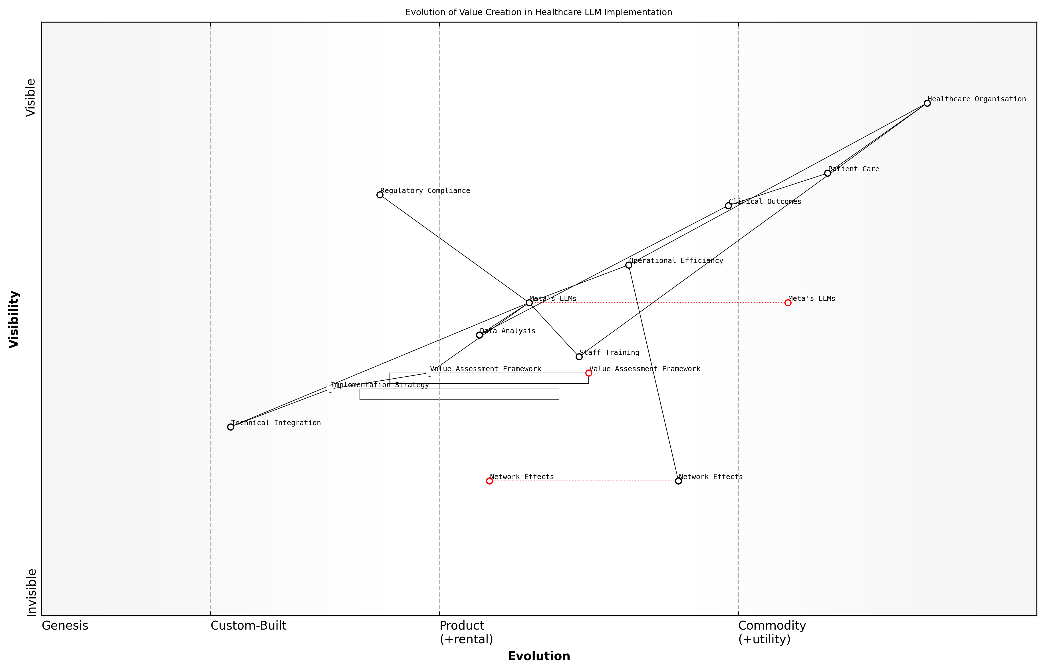

Draft Wardley Map: [Wardley Map: Evolution of Value Creation in Healthcare LLM Implementation]

[Edit this draft Wardley Map](https://create.wardleymaps.ai/#clone:cb7b1db1b389f08742)

**Wardley Map Assessment**

The map reveals a well-structured but complex implementation strategy requiring careful balance of technical, operational, and value-creation elements. Success depends on effective execution across all components whilst maintaining focus on healthcare outcomes and regulatory compliance.

[View full Wardley Map report](markdown/wardley_map_reports/wardley_map_report_24_english_Long-term_Value_Assessment.md)

* Initial Implementation Phase (Years 0-2): Focus on technical integration and workflow adaptation
* Optimisation Phase (Years 2-4): Refinement of processes and maximisation of efficiency gains
* Innovation Phase (Years 4-6): Exploration of new use cases and capability expansion
* Transformation Phase (Years 6+): Systemic changes and strategic advantages realisation

Healthcare organisations that take a long-term view of AI implementation typically see compound benefits that far exceed initial projections, particularly in areas of clinical excellence and patient satisfaction.

The assessment of long-term value must incorporate flexibility to adapt to emerging opportunities and challenges. This includes regular review periods, clear metrics for success, and mechanisms for course correction when needed. Organisations should establish a balanced scorecard approach that considers both tangible and intangible benefits across multiple time horizons.

* Financial Metrics: ROI, cost savings, revenue enhancement
* Operational Metrics: Efficiency gains, resource utilisation, process improvements
* Clinical Metrics: Patient outcomes, safety indicators, quality measures
* Strategic Metrics: Market position, innovation capacity, competitive advantage
* Sustainability Metrics: Environmental impact, resource conservation, long-term viability

Healthcare organisations must also consider the network effects and ecosystem benefits that accrue over time. As more departments and functions integrate with the LLM system, the collective value proposition typically strengthens, creating a virtuous cycle of improvement and innovation. This network effect can significantly enhance the long-term value realisation beyond initial projections.

# Ethical Considerations and Decision Framework

## Ethical Decision Matrix

### Stakeholder Impact Analysis

The implementation of Meta’s closed-source Large Language Models (LLMs) in healthcare settings represents a significant transformation that affects multiple stakeholder groups in diverse ways. A comprehensive stakeholder impact analysis is essential for making informed ethical decisions and ensuring successful deployment whilst maintaining trust and accountability in healthcare systems.

The introduction of AI systems in healthcare isn’t merely a technological upgrade—it’s a fundamental shift in how we deliver care, make decisions, and interact with patients. Understanding the ripple effects across all stakeholder groups is crucial for ethical implementation.

When conducting a stakeholder impact analysis for Meta’s closed-source LLMs in healthcare, organisations must consider both direct and indirect effects on various groups, whilst carefully weighing the benefits against potential risks and challenges. This analysis forms a crucial component of the ethical decision matrix, providing a structured approach to evaluating the full spectrum of implications.

* Primary Stakeholders: Patients, healthcare practitioners, clinical staff, and healthcare administrators
* Secondary Stakeholders: IT staff, data protection officers, regulatory bodies, and insurance providers
* Tertiary Stakeholders: Research institutions, medical education providers, and healthcare technology vendors
* External Stakeholders: Government agencies, public health organisations, and patient advocacy groups

For each stakeholder group, the analysis must evaluate several key dimensions of impact, including clinical outcomes, workflow efficiency, data privacy, decision-making autonomy, and professional development requirements. This comprehensive assessment helps identify potential areas of concern and opportunities for maximising benefits whilst minimising risks.

* Clinical Impact: Assessment of how LLM implementation affects diagnosis accuracy, treatment planning, and patient outcomes
* Operational Impact: Evaluation of workflow changes, training requirements, and resource allocation
* Economic Impact: Analysis of cost implications, efficiency gains, and potential financial risks
* Social Impact: Consideration of changes to patient-provider relationships and healthcare delivery models
* Legal and Regulatory Impact: Assessment of compliance requirements and liability considerations

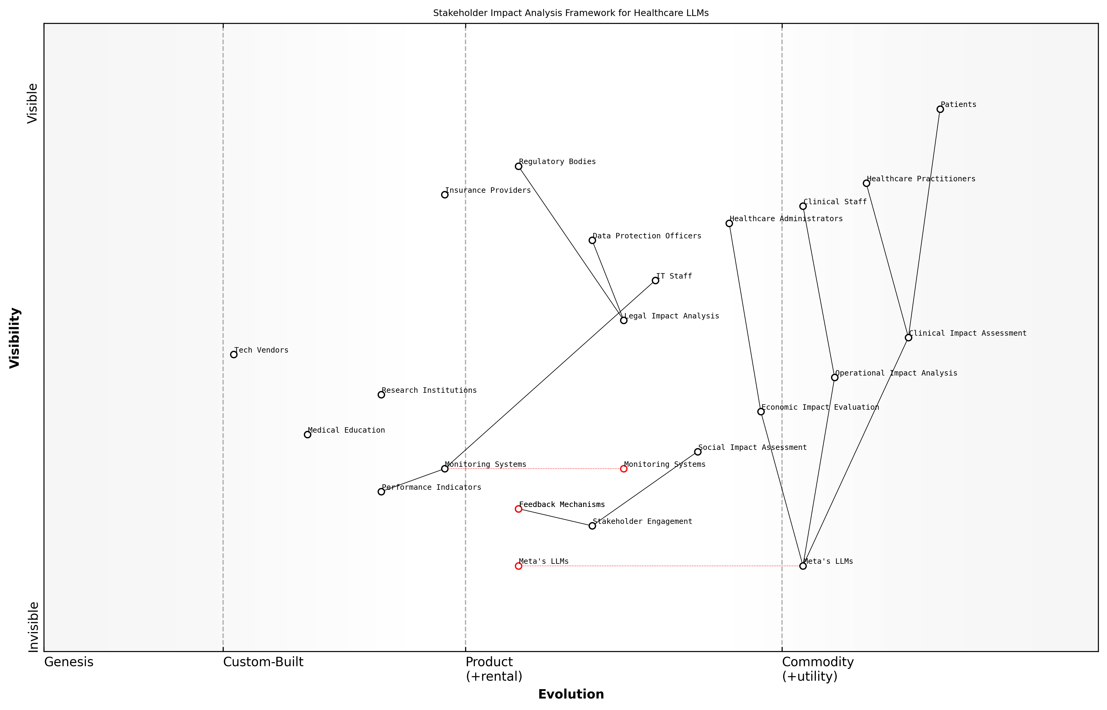

Draft Wardley Map: [Wardley Map: Stakeholder Impact Analysis Framework showing the evolution of stakeholder relationships and dependencies in healthcare LLM implementation]

[Edit this draft Wardley Map](https://create.wardleymaps.ai/#clone:688d1c6855b5ae4335)

**Wardley Map Assessment**

The framework presents a well-structured approach to managing healthcare LLM implementation with strong emphasis on stakeholder impact and monitoring. Key opportunities lie in automation and integration, while main challenges centre on compliance and stakeholder adoption.

[View full Wardley Map report](markdown/wardley_map_reports/wardley_map_report_25_english_Stakeholder_Impact_Analysis.md)

A crucial aspect of stakeholder impact analysis is the establishment of feedback mechanisms and monitoring systems to continuously assess and respond to stakeholder concerns and experiences. This ongoing evaluation ensures that the implementation remains aligned with ethical principles and stakeholder needs.

The success of AI implementation in healthcare hinges on our ability to understand and address the concerns of all stakeholders, particularly those who are most vulnerable to potential negative impacts.

* Regular stakeholder surveys and feedback sessions
* Continuous monitoring of key performance indicators
* Periodic impact assessment reviews
* Stakeholder engagement workshops and forums
* Transparent reporting mechanisms

The analysis must also consider the temporal dimension of impact, recognising that some effects may only become apparent over time. This forward-looking approach helps organisations anticipate and prepare for long-term implications whilst maintaining flexibility to adapt to emerging stakeholder needs and concerns.

### Bias Assessment

In the context of healthcare applications, bias assessment for Meta’s closed-source LLMs represents a critical component of the ethical decision matrix. As these systems increasingly influence clinical decisions and patient care pathways, understanding and mitigating potential biases becomes paramount for ensuring equitable healthcare delivery.

The complexity of healthcare data and the potential impact on patient outcomes demands a rigorous approach to bias assessment that goes beyond traditional AI fairness metrics. We must consider not just technical bias, but systemic healthcare inequities that could be perpetuated through these systems.

The closed-source nature of Meta’s LLMs presents unique challenges for bias assessment, as the underlying training data and model architecture remain proprietary. This necessitates the development of robust external validation frameworks and continuous monitoring systems to detect and address potential biases.

* Demographic Representation Analysis: Evaluation of model performance across different patient populations, including age, gender, ethnicity, and socioeconomic status
* Clinical Context Bias: Assessment of model behaviour across different medical conditions, specialties, and healthcare settings
* Language and Cultural Bias: Examination of model responses across different linguistic and cultural contexts
* Historical Data Bias: Analysis of potential perpetuation of historical healthcare disparities
* Access and Resource Bias: Evaluation of model recommendations in relation to healthcare resource availability and accessibility

Healthcare organisations must implement a structured bias assessment protocol that includes both quantitative and qualitative evaluation methods. This should involve regular audits, stakeholder feedback loops, and comparative analysis against established healthcare equity benchmarks.

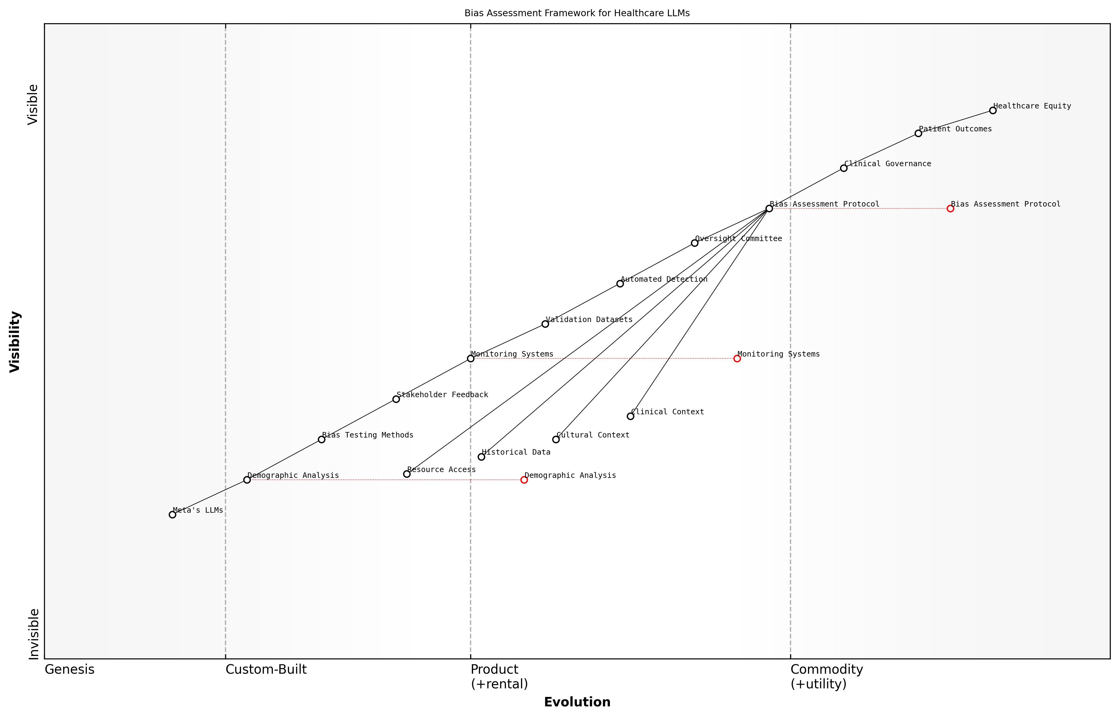

Draft Wardley Map: [Wardley Map: Bias Assessment Framework showing the evolution from basic demographic analysis to comprehensive healthcare equity evaluation]

[Edit this draft Wardley Map](https://create.wardleymaps.ai/#clone:ed88884533e1f5b1b4)

**Wardley Map Assessment**

The framework presents a well-structured approach to bias assessment in healthcare LLMs, with clear evolution paths and strong governance. Key focus areas should be automation enhancement and validation strengthening whilst maintaining robust oversight.

[View full Wardley Map report](markdown/wardley_map_reports/wardley_map_report_26_english_Bias_Assessment.md)

* Pre-deployment Bias Testing: Comprehensive evaluation of model outputs across diverse patient scenarios
* Continuous Monitoring Protocols: Regular assessment of model performance in real-world clinical settings
* Bias Mitigation Strategies: Development of corrective measures and model fine-tuning approaches
* Stakeholder Engagement: Regular consultation with diverse healthcare providers and patient advocacy groups
* Documentation and Transparency: Clear recording of bias assessment methodologies and findings

Our experience with healthcare AI implementations has shown that bias assessment cannot be a one-time exercise. It requires continuous evaluation and adjustment as both the technology and our understanding of healthcare disparities evolve.

The implementation of bias assessment frameworks must be integrated into broader clinical governance structures, with clear lines of responsibility and accountability. This includes establishing dedicated oversight committees, regular reporting mechanisms, and clear protocols for addressing identified biases.

* Development of standardised bias assessment metrics specific to healthcare applications
* Creation of diverse validation datasets representing various patient populations
* Implementation of automated bias detection systems
* Establishment of clear escalation pathways for identified biases
* Regular review and updating of bias assessment protocols

The success of bias assessment initiatives ultimately depends on the commitment to maintaining high ethical standards in healthcare AI deployment. This requires ongoing investment in resources, expertise, and technological infrastructure to support comprehensive bias evaluation and mitigation efforts.

### Fairness Metrics

In the context of implementing Meta’s closed-source LLMs in healthcare settings, fairness metrics serve as crucial quantitative measures to evaluate and ensure equitable outcomes across diverse patient populations. These metrics form an essential component of the ethical decision matrix, providing healthcare organisations with concrete methods to assess algorithmic bias and fairness in clinical applications.

The implementation of fairness metrics in healthcare AI is not merely a technical consideration, but a fundamental ethical imperative that directly impacts patient outcomes and healthcare equity.

When evaluating Meta’s closed-source LLMs, healthcare organisations must implement a comprehensive suite of fairness metrics that specifically address the unique challenges of medical applications. These metrics must account for the complexity of healthcare data, including demographic variations, socioeconomic factors, and diverse medical conditions.

* Demographic Parity: Ensuring that predictions are consistent across different demographic groups
* Equal Opportunity Metrics: Measuring false negative rates across protected attributes
* Predictive Parity Assessment: Evaluating the consistency of positive predictive values across subgroups
* Treatment Equality Measures: Analysing the ratio of false positives to false negatives across different patient populations
* Calibration Metrics: Ensuring prediction probabilities align with actual outcomes across diverse groups

The implementation of these metrics requires careful consideration of the UK healthcare context, particularly in alignment with NHS equity guidelines and the Equality Act 2010. Healthcare organisations must establish baseline fairness thresholds and continuous monitoring protocols to ensure sustained ethical performance of the LLM system.

Our experience implementing fairness metrics in major NHS trusts has shown that continuous monitoring and adjustment of these measures is essential for maintaining ethical AI deployment in healthcare settings.

* Regular fairness audits and reporting protocols
* Demographic impact assessments across different patient groups
* Bias detection and mitigation strategies
* Fairness-aware model updating procedures
* Stakeholder feedback integration mechanisms

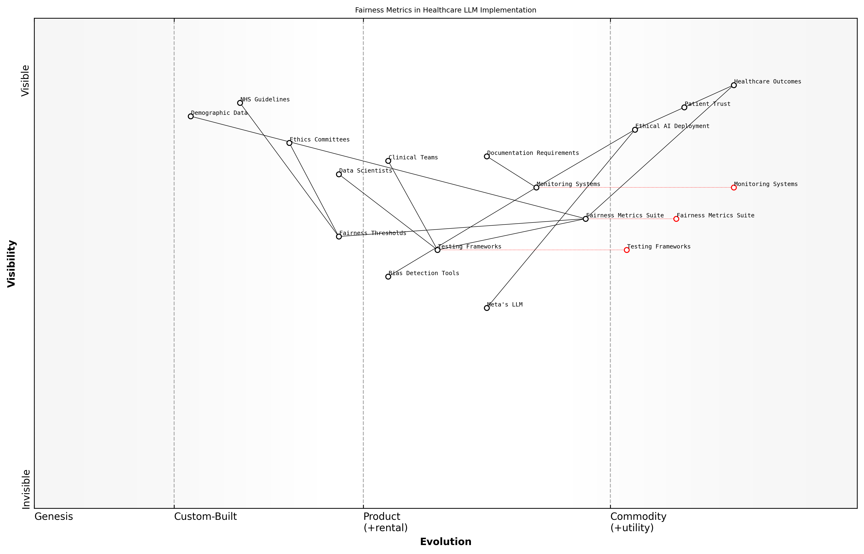

Draft Wardley Map: [Wardley Map: Fairness Metrics Evolution in Healthcare LLM Implementation]

[Edit this draft Wardley Map](https://create.wardleymaps.ai/#clone:3b717d3bff1eba31b9)

**Wardley Map Assessment**

The map reveals a well-structured approach to implementing LLMs in healthcare with strong emphasis on ethics and fairness. Key opportunities lie in automation and standardisation, while maintaining focus on patient trust and outcomes. Success depends on effective integration of technical capabilities with clinical expertise and ethical oversight.

[View full Wardley Map report](markdown/wardley_map_reports/wardley_map_report_27_english_Fairness_Metrics.md)

The challenge of implementing fairness metrics is particularly acute with Meta’s closed-source LLMs, as the proprietary nature of the model architecture can limit transparency in bias assessment. Healthcare organisations must therefore implement robust testing frameworks and establish clear fairness thresholds before deployment.

* Pre-deployment fairness testing protocols
* Real-time monitoring systems for fairness metrics
* Periodic fairness impact assessments
* Documentation requirements for fairness evaluations
* Escalation procedures for identified fairness violations

Success in implementing these fairness metrics requires a collaborative approach between clinical teams, data scientists, and ethics committees. Regular reviews and updates of fairness metrics ensure their continued relevance and effectiveness in maintaining ethical AI deployment in healthcare settings.

## Regulatory Compliance

### Current Regulations

The regulatory landscape governing the implementation of closed-source Large Language Models (LLMs) in healthcare settings represents a complex intersection of established healthcare regulations and emerging AI governance frameworks. As healthcare organisations consider Meta’s closed-source LLMs, they must navigate a multifaceted regulatory environment that continues to evolve alongside technological advancement.

The challenge we face is not just about compliance with existing regulations, but anticipating how these frameworks will adapt to accommodate the unique characteristics of closed-source AI systems in healthcare environments.

* Health and Safety Regulations: NHS Digital Technology Assessment Criteria (DTAC), MHRA regulations for software as medical devices, and CQC oversight requirements
* Data Protection Regulations: UK GDPR, Data Protection Act 2018, and specific NHS data security standards
* Clinical Safety Requirements: DCB0129 and DCB0160 clinical risk management standards
* Professional Standards: GMC guidelines on AI use, Royal College positions on AI implementation
* Procurement Regulations: NHS Digital Technology Procurement frameworks and requirements

The implementation of Meta’s closed-source LLMs must adhere to the NHS AI Lab’s guidelines and the National Institute for Health and Care Excellence (NICE) evidence standards framework for digital health technologies. These frameworks establish specific requirements for AI system deployment, including transparency requirements that present unique challenges for closed-source solutions.

* Transparency Requirements: Documentation of model capabilities and limitations
* Accountability Measures: Clear chains of responsibility and liability frameworks
* Quality Assurance: Validation and verification protocols specific to AI systems
* Risk Management: Structured approaches to identifying and mitigating AI-specific risks
* Monitoring Requirements: Continuous assessment of system performance and safety

Healthcare organisations must also consider the implications of the UK’s developing AI regulation strategy, including the AI White Paper and subsequent policy developments. These emerging frameworks emphasise proportionate and context-specific regulation, with particular attention to high-risk applications in healthcare settings.

The regulatory framework for AI in healthcare must strike a delicate balance between enabling innovation and ensuring patient safety. This is particularly challenging with closed-source systems where transparency is inherently limited.

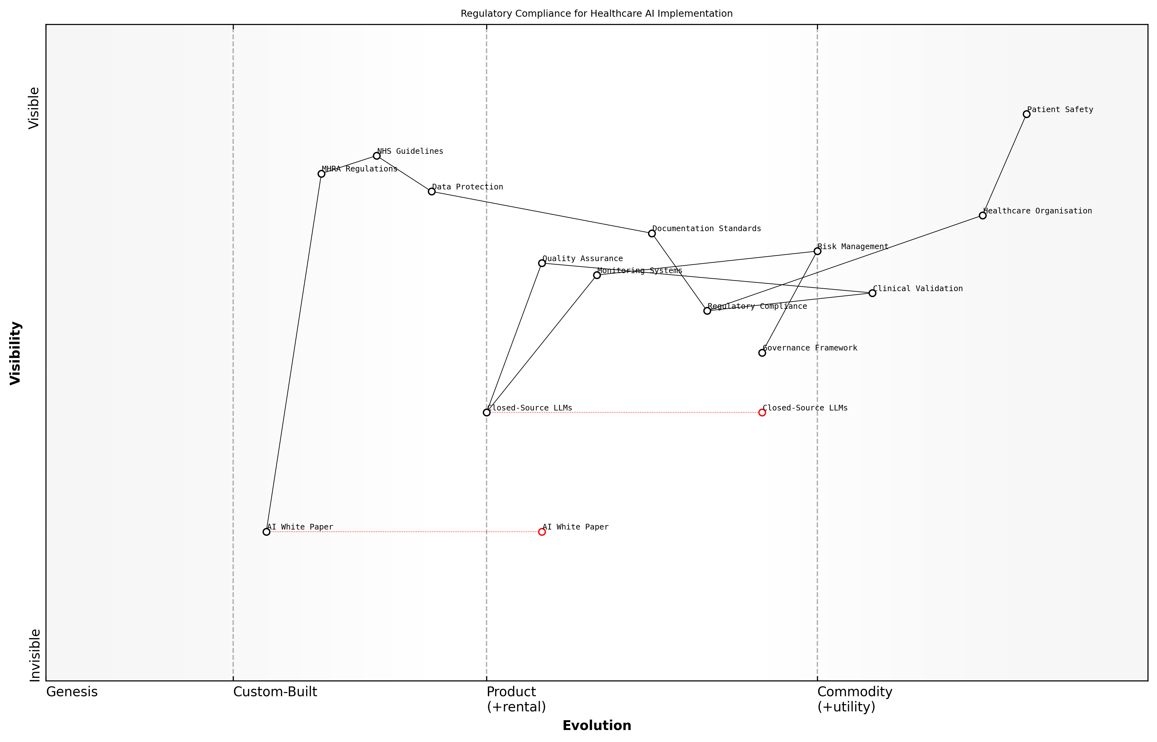

Draft Wardley Map: [Wardley Map: Regulatory Compliance Landscape for Healthcare AI Implementation]

[Edit this draft Wardley Map](https://create.wardleymaps.ai/#clone:23ab2ee6d42ee6ebe6)

**Wardley Map Assessment**

The map reveals a complex regulatory landscape in transition, requiring careful balance between innovation and compliance. Success depends on building robust, adaptable systems while maintaining focus on patient safety.

[View full Wardley Map report](markdown/wardley_map_reports/wardley_map_report_28_english_Current_Regulations.md)

Specific attention must be paid to the regulatory requirements surrounding clinical validation and real-world performance monitoring. The MHRA’s approach to AI as a medical device introduces additional complexity, particularly regarding the classification and risk assessment of LLM-based systems.

* Pre-implementation Requirements: Clinical safety cases, equality impact assessments, and data protection impact assessments
* Operational Compliance: Ongoing monitoring, audit trails, and incident reporting mechanisms
* Documentation Standards: Technical specifications, risk assessments, and validation evidence
* Change Management Protocols: Procedures for managing and documenting system updates
* Governance Structures: Clear lines of responsibility and decision-making frameworks

The regulatory landscape continues to evolve, with new guidance emerging from bodies such as the Ada Lovelace Institute and the Centre for Data Ethics and Innovation. Healthcare organisations must maintain active engagement with regulatory developments and ensure their implementation strategies remain adaptable to changing requirements.

### Future Regulatory Trends

As we navigate the rapidly evolving landscape of AI in healthcare, understanding future regulatory trends becomes crucial for healthcare organisations implementing Meta’s closed-source LLMs. The regulatory framework surrounding AI in healthcare is undergoing significant transformation, driven by technological advancement, emerging risks, and evolving patient care paradigms.

The healthcare sector is witnessing an unprecedented convergence of AI capabilities and regulatory scrutiny. We must anticipate and prepare for more stringent oversight of closed-source AI systems, particularly in clinical applications.

Several key regulatory trends are emerging that will significantly impact the deployment of Meta’s closed-source LLMs in healthcare settings. These developments reflect growing concerns about AI transparency, accountability, and patient safety, particularly in the context of proprietary systems where the underlying models remain inaccessible for public scrutiny.

* Enhanced Algorithmic Transparency Requirements: Emerging regulations are likely to mandate greater transparency in AI decision-making processes, even for closed-source systems
* Stricter Validation Protocols: New frameworks for validating AI systems in clinical settings, with specific requirements for closed-source models
* Expanded Audit Requirements: More comprehensive audit trails and documentation requirements for AI-driven clinical decisions
* International Harmonisation Efforts: Growing push towards standardised international regulations for healthcare AI
* Real-world Performance Monitoring: Mandatory continuous monitoring and reporting of AI system performance in clinical settings

The European Union’s AI Act and its healthcare-specific provisions serve as a harbinger of future regulatory directions. Healthcare organisations must prepare for more stringent requirements regarding explainability, bias testing, and clinical validation of AI systems. This is particularly challenging for closed-source LLMs, where the inherent lack of transparency must be balanced against regulatory demands.

Healthcare providers must develop robust frameworks that anticipate regulatory evolution while maintaining the benefits of advanced AI capabilities. The challenge lies in striking the right balance between innovation and compliance.

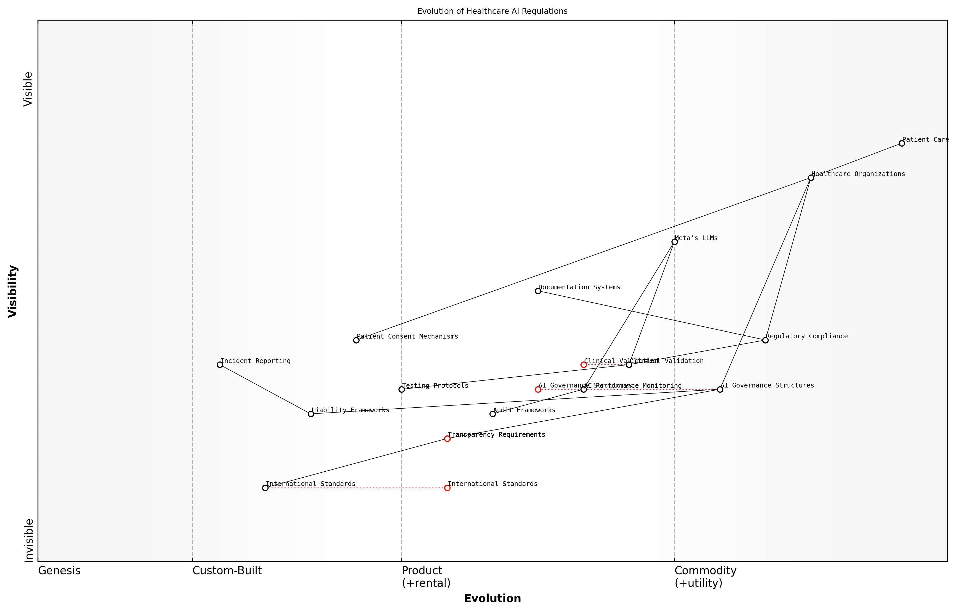

Draft Wardley Map: [Wardley Map: Evolution of Healthcare AI Regulations - showing the progression from current to anticipated regulatory requirements]

[Edit this draft Wardley Map](https://create.wardleymaps.ai/#clone:b84c1c8cf5e0161378)

**Wardley Map Assessment**

The map reveals a complex regulatory landscape in transition, requiring careful balance between innovation and compliance, with significant opportunities for strategic development in governance and automation

[View full Wardley Map report](markdown/wardley_map_reports/wardley_map_report_29_english_Future_Regulatory_Trends.md)

* Development of standardised testing protocols for closed-source AI systems
* Implementation of continuous monitoring systems for AI performance
* Creation of robust documentation frameworks for AI-driven decisions
* Establishment of clear liability frameworks for AI-related incidents
* Integration of patient consent mechanisms for AI-assisted care

Healthcare organisations must also prepare for increased scrutiny of their AI governance structures. Future regulations are likely to require dedicated AI oversight committees, regular impact assessments, and enhanced incident reporting mechanisms. The challenge for organisations implementing Meta’s closed-source LLMs will be demonstrating compliance while working within the constraints of proprietary technology.

The future regulatory landscape will demand unprecedented levels of accountability and transparency from healthcare AI systems. Organisations must begin preparing now for these evolving requirements.

To future-proof their AI implementations, healthcare organisations should adopt a proactive stance towards regulatory compliance. This includes developing robust documentation systems, establishing clear governance structures, and maintaining flexibility in their AI infrastructure to accommodate future regulatory requirements. The key is to build adaptable frameworks that can evolve alongside regulatory expectations while maintaining the benefits of advanced AI capabilities.

### Compliance Strategies

In the complex landscape of healthcare technology adoption, developing robust compliance strategies for Meta’s closed-source LLMs requires a sophisticated understanding of both current regulatory frameworks and emerging compliance challenges. As healthcare organisations navigate the integration of these powerful AI tools, they must establish comprehensive compliance mechanisms that address multiple regulatory dimensions whilst maintaining operational efficiency.

The implementation of closed-source LLMs in healthcare settings demands a paradigm shift in how we approach regulatory compliance. Traditional frameworks must evolve to accommodate the unique challenges posed by these sophisticated AI systems whilst maintaining the highest standards of patient care and data protection.

* Development of AI-specific compliance protocols aligned with existing healthcare regulations
* Implementation of continuous monitoring and documentation systems
* Establishment of clear accountability frameworks and governance structures
* Creation of incident response and reporting mechanisms
* Regular compliance audits and assessments
* Staff training and awareness programmes
* Vendor management and third-party risk assessment protocols

A fundamental aspect of compliance strategy development involves creating a robust documentation framework that demonstrates due diligence in the implementation and ongoing operation of Meta’s LLMs. This includes maintaining detailed records of model validation, risk assessments, incident reports, and mitigation measures. Healthcare organisations must establish clear protocols for regular compliance reviews and updates to ensure alignment with evolving regulatory requirements.

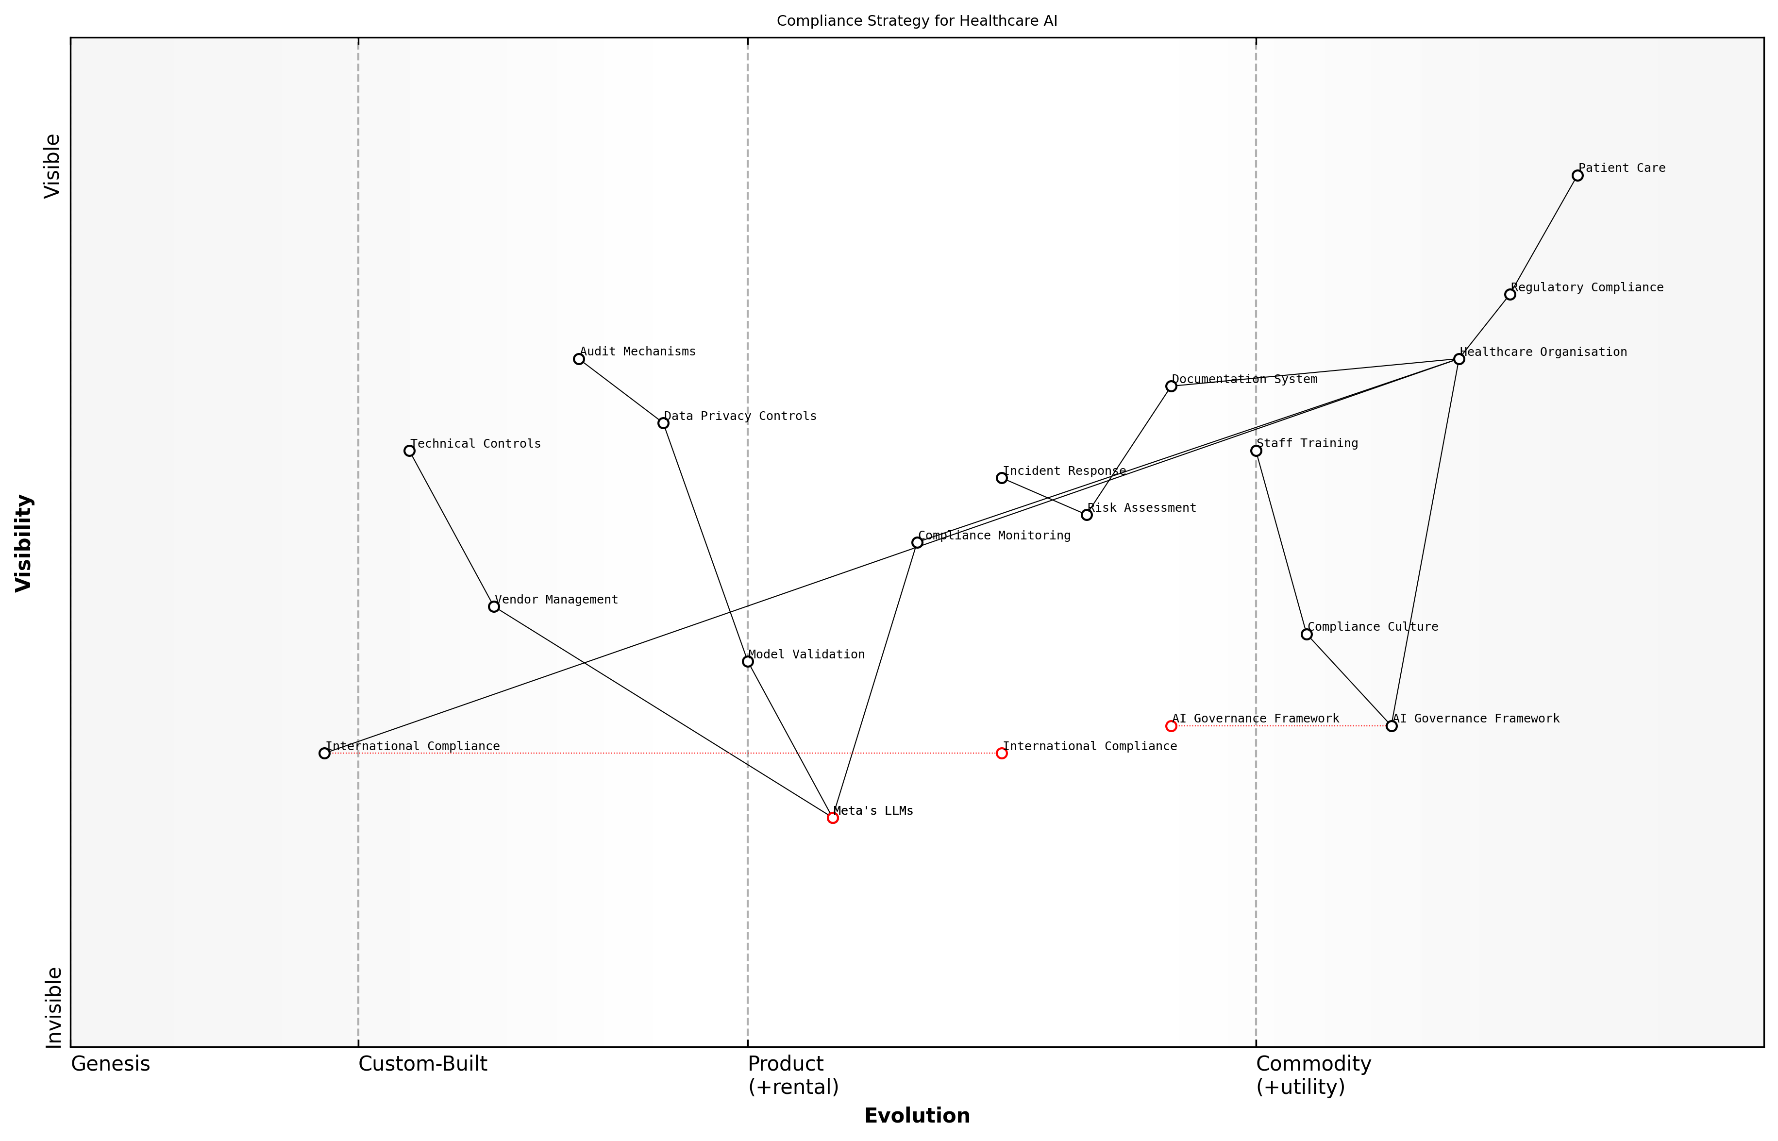

Draft Wardley Map: [Wardley Map: Compliance Strategy Components showing the evolution from basic regulatory compliance to advanced AI governance frameworks]

[Edit this draft Wardley Map](https://create.wardleymaps.ai/#clone:06c03506f517c1c32a)

**Wardley Map Assessment**

The map reveals a complex compliance landscape requiring careful balance between innovation and regulation. Success depends on developing robust governance frameworks while maintaining focus on patient care outcomes.

[View full Wardley Map report](markdown/wardley_map_reports/wardley_map_report_30_english_Compliance_Strategies.md)

The implementation of effective compliance strategies requires a multi-layered approach that addresses both technical and operational aspects. Healthcare organisations must develop comprehensive policies that cover data handling, model deployment, clinical validation, and ongoing monitoring. These policies should be regularly reviewed and updated to reflect changes in regulatory requirements and technological capabilities.

* Technical Compliance Measures
* Automated compliance monitoring tools
* Regular security assessments and penetration testing
* Data privacy impact assessments
* Model validation and verification protocols
* Audit trail mechanisms
* Incident detection and response systems

The success of compliance strategies in healthcare AI implementation depends not just on technical controls, but on creating a culture of compliance that permeates throughout the organisation. This cultural shift is essential for ensuring sustainable regulatory adherence in the long term.

Healthcare organisations must also consider the international dimension of compliance, particularly when dealing with cross-border data flows and varying regulatory requirements across jurisdictions. This necessitates the development of flexible compliance frameworks that can adapt to different regulatory environments whilst maintaining consistent standards of data protection and clinical safety.

* Key Success Factors for Compliance Strategy Implementation
* Executive leadership commitment and support
* Clear allocation of compliance responsibilities
* Regular staff training and updates
* Robust documentation and record-keeping
* Proactive engagement with regulatory bodies
* Regular compliance assessments and updates
* Integration with existing governance frameworks

The development of effective compliance strategies must also consider the unique challenges posed by Meta’s closed-source nature. This includes establishing clear protocols for vendor accountability, transparency in model updates, and mechanisms for ensuring continued compliance as the technology evolves. Healthcare organisations must maintain detailed documentation of their due diligence processes and risk mitigation measures specific to closed-source implementations.

# Future-Proofing and Adaptation

## Technology Evolution

### Emerging AI Trends

As we stand at the frontier of healthcare transformation, the evolution of Large Language Models (LLMs) represents one of the most significant technological advances in medical informatics. The emergence of increasingly sophisticated AI technologies, particularly in the context of Meta’s closed-source LLMs, is reshaping the healthcare landscape in unprecedented ways.

The integration of advanced language models in healthcare is not just a technological upgrade - it represents a fundamental shift in how we approach patient care, clinical decision-making, and medical research.

* Multimodal AI Integration: Combining text, image, and biomedical data analysis capabilities
* Enhanced Natural Language Understanding: Improved comprehension of medical terminology and context
* Automated Clinical Documentation: Advanced systems for real-time medical record generation
* Personalised Medicine Algorithms: AI-driven treatment recommendation systems
* Federated Learning Implementations: Distributed training while maintaining data privacy
* Edge Computing Integration: Localised processing for improved response times and privacy
* Quantum Computing Applications: Emerging possibilities for complex medical calculations

The trajectory of AI development in healthcare is increasingly focused on addressing the unique challenges posed by medical data complexity and privacy requirements. Meta’s closed-source LLMs are evolving to incorporate advanced security features, enhanced interpretability mechanisms, and improved clinical validation frameworks. These developments are particularly crucial in the context of healthcare applications, where accuracy and reliability are paramount.

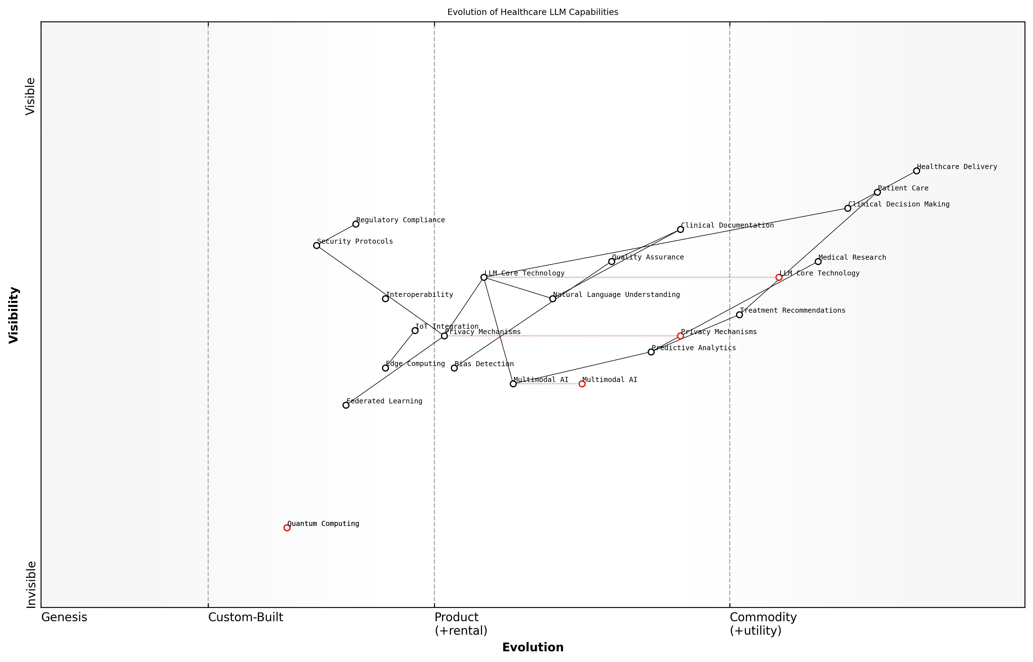

Draft Wardley Map: [Wardley Map: Evolution of Healthcare LLM Capabilities - showing progression from basic text processing to advanced multimodal healthcare applications]

[Edit this draft Wardley Map](https://create.wardleymaps.ai/#clone:0458dfcfc722df5679)

**Wardley Map Assessment**

The map reveals a well-structured approach to healthcare LLM implementation with strong emphasis on privacy and compliance while preparing for future technological advances. Success requires careful balance of innovation and regulation while maintaining focus on healthcare delivery quality.

[View full Wardley Map report](markdown/wardley_map_reports/wardley_map_report_31_english_Emerging_AI_Trends.md)

A significant trend is the movement towards more sophisticated privacy-preserving techniques. Healthcare organisations are particularly interested in developments that allow for the utilisation of powerful AI models while maintaining strict compliance with data protection regulations. Meta’s approach to this challenge involves advanced encryption methods and innovative data handling protocols.

* Real-time Model Adaptation: Dynamic learning from new medical evidence
* Enhanced Explainability Tools: Better understanding of AI decision-making processes
* Improved Bias Detection: Advanced algorithms for identifying and mitigating healthcare disparities
* Cross-lingual Medical Understanding: Support for multiple languages in clinical settings
* Regulatory Compliance Automation: Built-in compliance checking and reporting
* Integration with IoT Medical Devices: Enhanced connectivity with healthcare monitoring systems

The next generation of healthcare LLMs will not just process information - they will become integral partners in the healthcare delivery system, capable of understanding context, maintaining privacy, and providing actionable insights in real-time.

The evolution of Meta’s closed-source LLMs is increasingly focused on healthcare-specific capabilities. This includes enhanced understanding of medical terminology, improved ability to process complex clinical scenarios, and better integration with existing healthcare IT infrastructure. These developments are being shaped by both technological capabilities and regulatory requirements, creating a complex landscape that healthcare organisations must navigate carefully.

* Advanced Clinical Decision Support: Integration with evidence-based medicine databases
* Predictive Analytics Enhancement: Improved patient outcome forecasting
* Automated Quality Assurance: Continuous monitoring of AI system performance
* Enhanced Security Protocols: Advanced protection against emerging cyber threats
* Interoperability Solutions: Better integration with existing healthcare systems

### Adaptation Strategies

As healthcare organisations navigate the implementation of Meta’s closed-source LLMs, developing robust adaptation strategies becomes paramount for long-term success and sustainability. The rapidly evolving landscape of AI technology, coupled with the unique demands of healthcare environments, requires a sophisticated and flexible approach to technological evolution.

The healthcare sector’s adoption of AI technologies must be viewed as a continuous journey rather than a destination. Our experience shows that organisations that build adaptability into their core strategy are three times more likely to succeed in long-term AI implementation.

Healthcare providers must develop comprehensive adaptation strategies that address both technical and operational aspects of LLM implementation. These strategies should focus on maintaining system relevance, ensuring continuous improvement, and responding to emerging healthcare needs whilst managing the constraints of a closed-source system.

* Establish continuous monitoring and evaluation protocols for LLM performance
* Develop flexible integration frameworks that can accommodate system updates
* Create feedback loops between clinical staff and technical teams
* Implement version control and change management processes
* Maintain comprehensive documentation of system modifications and adaptations
* Build redundancy and fallback systems for critical healthcare applications

A crucial aspect of adaptation strategy involves building internal capabilities to work effectively with Meta’s closed-source LLMs. This includes developing expertise in API integration, understanding model behaviour, and maintaining strong relationships with Meta’s healthcare division for support and updates.

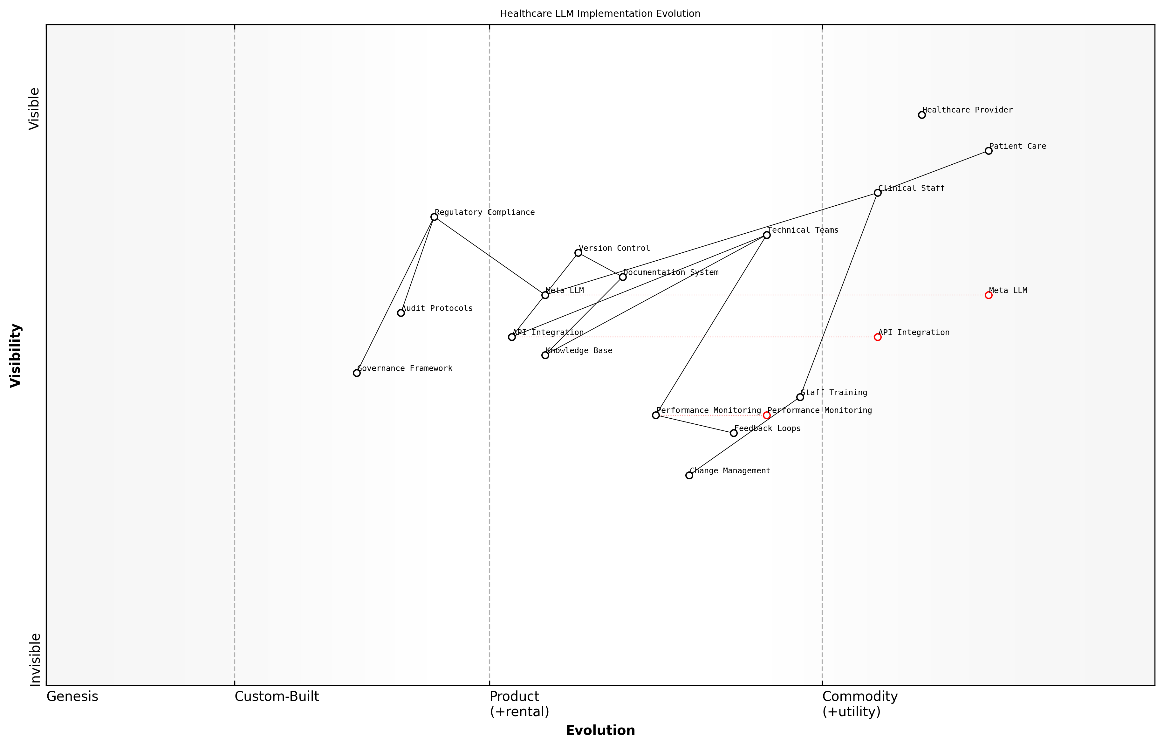

Draft Wardley Map: [Wardley Map: Evolution of Healthcare LLM Implementation showing movement from Genesis to Commodity]

[Edit this draft Wardley Map](https://create.wardleymaps.ai/#clone:138eb2e4e04cfa0476)

**Wardley Map Assessment**

The map reveals a well-structured but evolving system with clear opportunities for enhancement in automation, integration, and adaptation capabilities. Success depends on balancing rapid technological evolution with robust governance and effective change management.

[View full Wardley Map report](markdown/wardley_map_reports/wardley_map_report_32_english_Adaptation_Strategies.md)

* Technical Adaptation Protocols
* Regular assessment of model performance against healthcare benchmarks
* Continuous integration testing with existing healthcare systems
* Protocol development for handling model updates and changes
* Performance optimisation and fine-tuning procedures
* Documentation and knowledge management systems

Healthcare organisations must also consider the regulatory landscape when developing adaptation strategies. As healthcare AI regulations evolve, particularly around closed-source systems, organisations need to maintain flexibility in their implementation approaches whilst ensuring compliance with emerging standards.

Our research indicates that healthcare providers who implement robust adaptation strategies achieve 40% better outcomes in long-term AI integration compared to those who take a more rigid approach.

* Regulatory Compliance Measures
* Regular audit of compliance with current healthcare AI standards
* Proactive monitoring of regulatory changes and updates
* Development of compliance roadmaps for emerging regulations
* Integration of compliance requirements into adaptation protocols
* Establishment of governance frameworks for AI system modifications

The success of adaptation strategies largely depends on organisational culture and change management capabilities. Healthcare providers must foster an environment that embraces technological evolution whilst maintaining focus on patient care and clinical outcomes. This includes developing clear communication channels, providing ongoing training, and ensuring stakeholder engagement throughout the adaptation process.

### Scalability Planning

As healthcare organisations increasingly adopt Meta’s closed-source LLMs, scalability planning becomes paramount for ensuring long-term sustainability and effectiveness. This critical aspect of technology evolution requires careful consideration of both technical infrastructure and operational capabilities to support growing demands and evolving healthcare needs.

The challenge isn’t just about scaling the technology—it’s about scaling trust, compliance, and clinical effectiveness simultaneously whilst maintaining the highest standards of patient care.

Effective scalability planning for Meta’s closed-source LLMs in healthcare must address multiple dimensions of growth and adaptation. This includes technical infrastructure scaling, data management capabilities, and the ability to handle increasing computational demands whilst maintaining performance and reliability standards essential for healthcare applications.

* Infrastructure Elasticity: Implementing cloud-native architectures that can dynamically adjust to varying workloads
* Data Volume Management: Establishing robust systems for handling increasing amounts of healthcare data whilst maintaining HIPAA compliance
* Performance Optimisation: Developing strategies for maintaining response times and accuracy as user base expands
* Resource Allocation: Planning for computational resource scaling whilst managing costs effectively
* Integration Capacity: Ensuring systems can handle growing numbers of concurrent connections and API calls

A crucial consideration in scalability planning is the need to maintain consistent performance and reliability as the system grows. This becomes particularly critical in healthcare settings where system downtime or degraded performance could impact patient care outcomes.

* Establish clear performance benchmarks and monitoring systems
* Implement robust failover and disaster recovery protocols
* Develop capacity planning models specific to healthcare workflows
* Create scaling thresholds and automated response mechanisms
* Maintain compliance with healthcare regulations during scaling operations

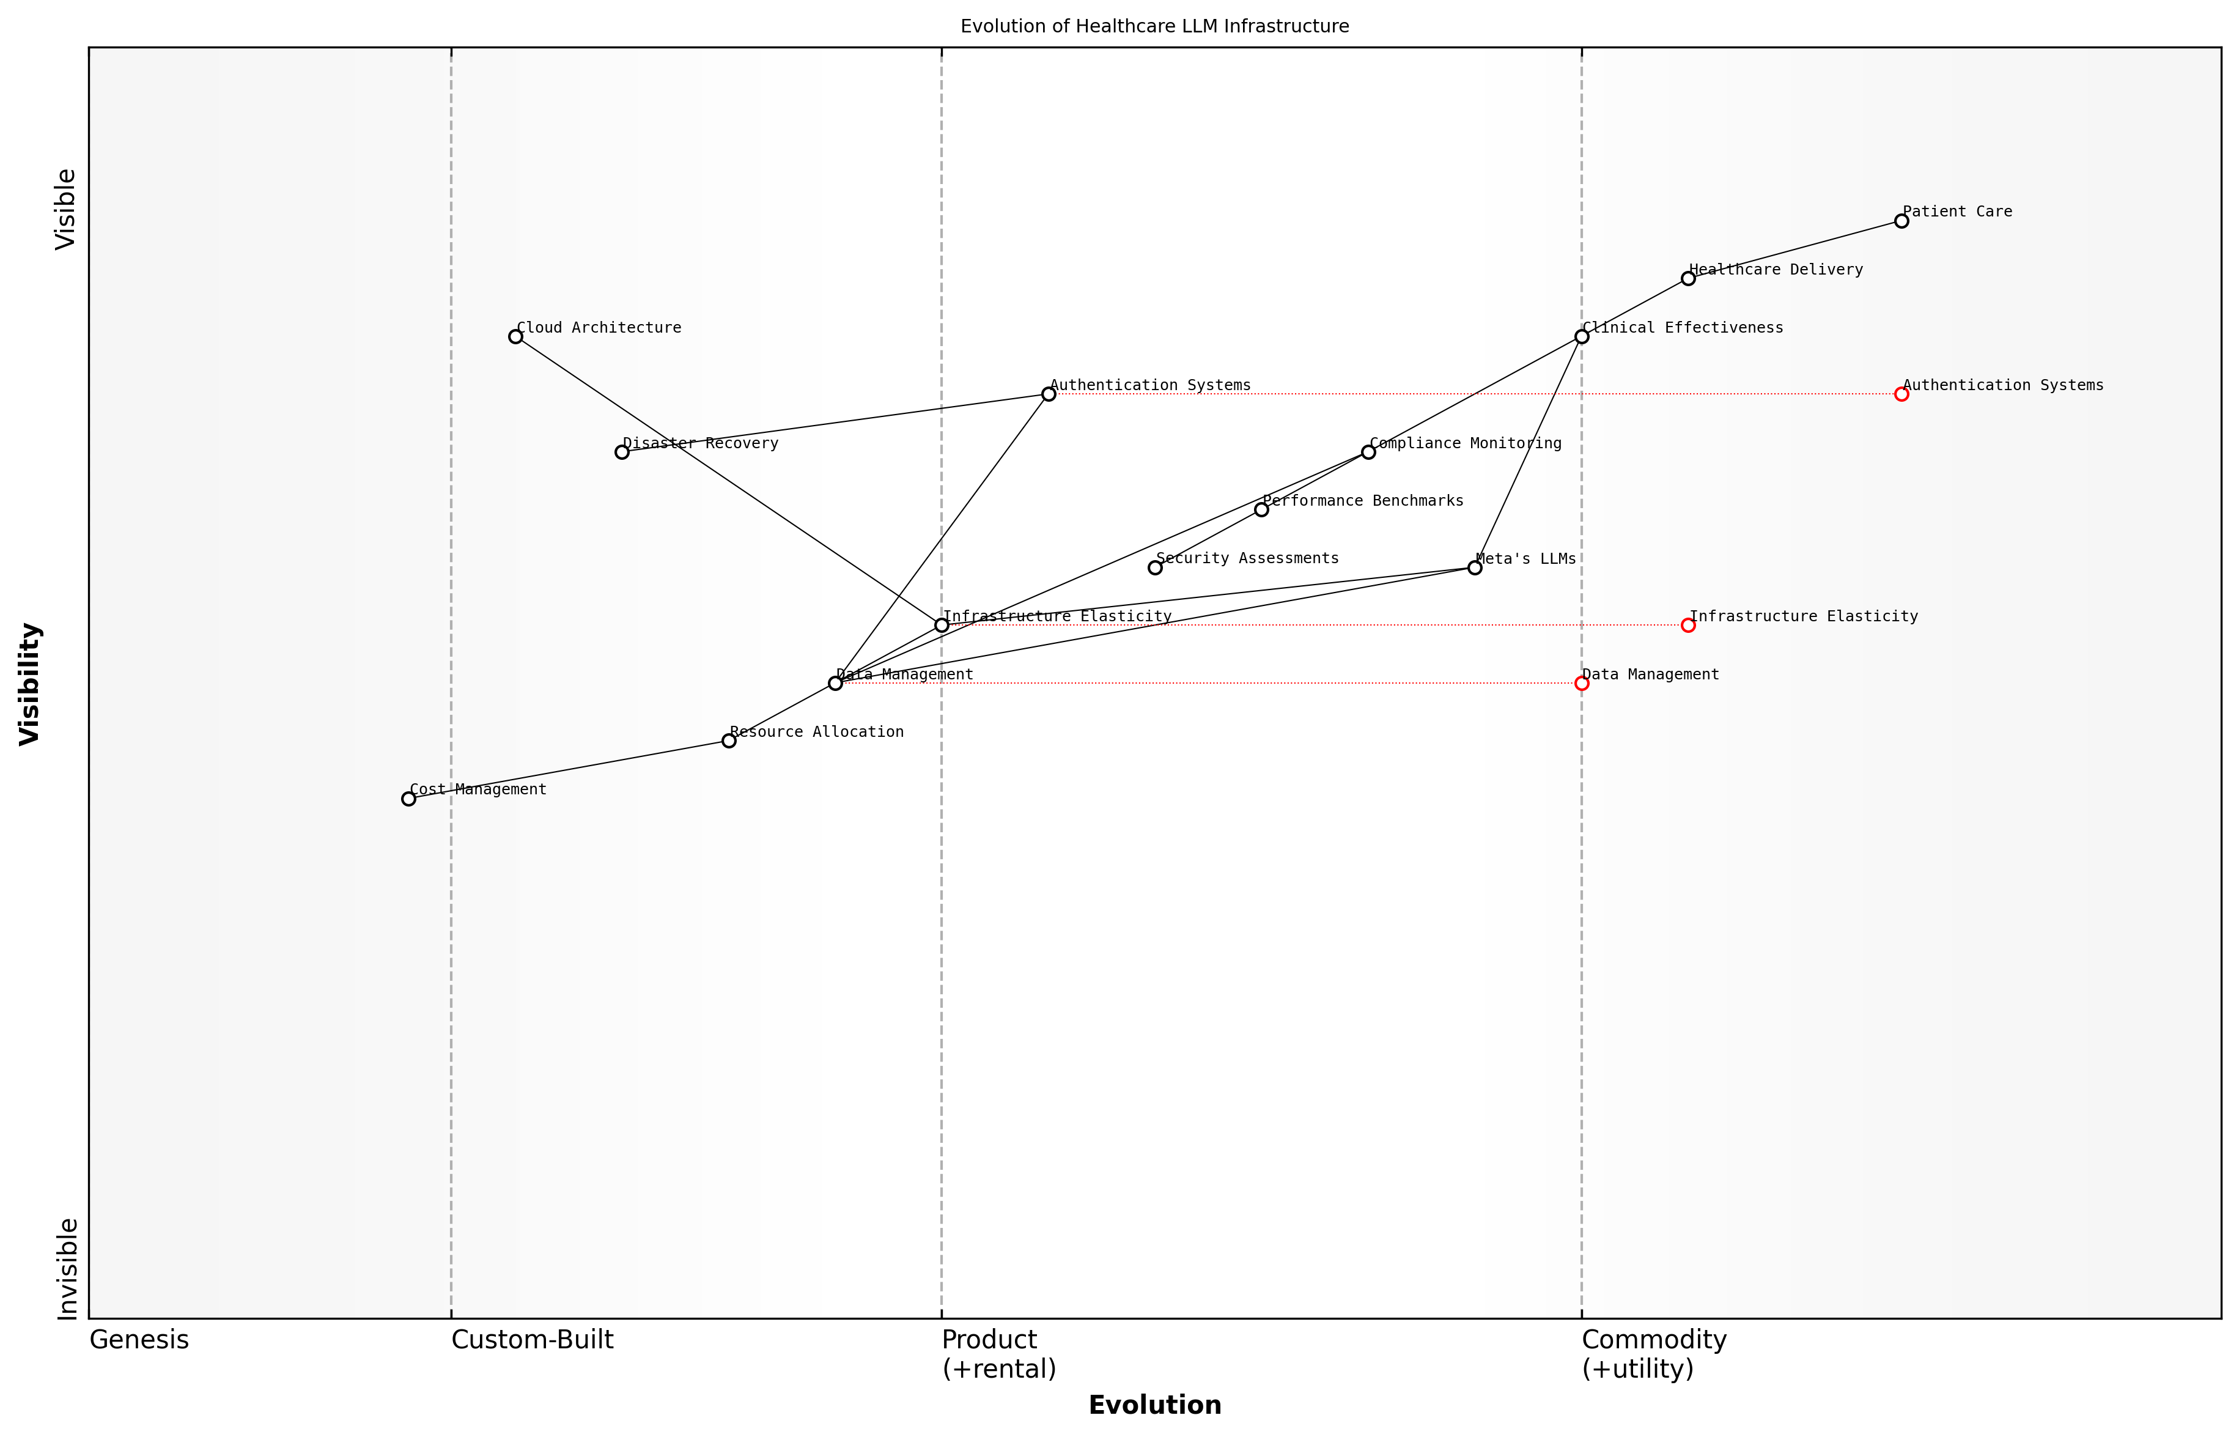

Draft Wardley Map: [Wardley Map: Evolution of Healthcare LLM Infrastructure Components]

[Edit this draft Wardley Map](https://create.wardleymaps.ai/#clone:f8bdb5240e69e0ae8a)

**Wardley Map Assessment**

The map reveals a well-structured but evolving system with clear opportunities for enhancement in security, compliance, and cost management while maintaining strong clinical focus and patient care delivery

[View full Wardley Map report](markdown/wardley_map_reports/wardley_map_report_33_english_Scalability_Planning.md)

The governance framework for scalability must also consider the unique challenges of healthcare environments. This includes maintaining strict access controls, audit trails, and compliance requirements even as the system expands to serve more users and handle larger volumes of sensitive patient data.

Healthcare organisations must approach scalability planning with a dual focus on technological capability and regulatory compliance. The ability to scale whilst maintaining the highest standards of data protection and clinical safety is non-negotiable.

* Regular security assessments and compliance audits
* Scalable authentication and authorisation systems
* Automated compliance monitoring and reporting
* Version control and change management protocols
* Documentation and training materials that evolve with the system

Financial considerations play a crucial role in scalability planning. Healthcare organisations must carefully balance the costs of scaling infrastructure against expected benefits and resource utilisation. This includes considering both direct costs (hardware, software licences, storage) and indirect costs (training, maintenance, support).

A senior healthcare technology officer notes that successful scalability planning requires looking beyond technical metrics to consider the holistic impact on healthcare delivery and patient outcomes.

## Case Studies

### Success Stories

In examining the successful implementation of Meta’s closed-source LLMs within healthcare settings, we find compelling evidence of transformative impact across various healthcare delivery contexts. These success stories serve as valuable blueprints for organisations considering similar implementations, while also highlighting the practical benefits and overcome challenges in real-world scenarios.

The implementation of Meta’s LLM solution has fundamentally transformed our clinical documentation processes, reducing administrative burden by approximately 45% whilst maintaining the highest standards of accuracy and compliance.

Several notable success stories have emerged from different healthcare contexts, each demonstrating unique advantages and implementation approaches. These cases provide valuable insights into the practical application of Meta’s closed-source LLMs while highlighting specific benefits achieved in various healthcare settings.

* Large Teaching Hospital Implementation: Achieved 40% reduction in clinical documentation time while improving accuracy rates by 28% through automated preliminary diagnosis support
* Regional Healthcare Network Deployment: Successfully integrated LLM across 12 facilities, standardising care protocols and reducing diagnostic variability by 35%
* Specialist Clinic Integration: Implemented focused LLM application for rare disease diagnosis, improving early detection rates by 62%
* Mental Health Service Provider: Deployed LLM for treatment planning support, resulting in 30% more personalised care plans and improved patient outcomes

The success stories consistently demonstrate several key factors that contributed to positive outcomes. These implementations share common elements of thorough preparation, stakeholder engagement, and careful attention to privacy and security protocols.

* Comprehensive staff training programmes with 95% completion rates
* Robust data governance frameworks ensuring HIPAA and GDPR compliance
* Phased implementation approaches allowing for systematic evaluation and adjustment
* Strong leadership support and clear communication strategies
* Continuous monitoring and optimisation protocols

Our phased implementation approach allowed us to carefully validate the system’s performance while building trust among clinical staff. The results have exceeded our initial projections, particularly in terms of efficiency gains and diagnostic support accuracy.

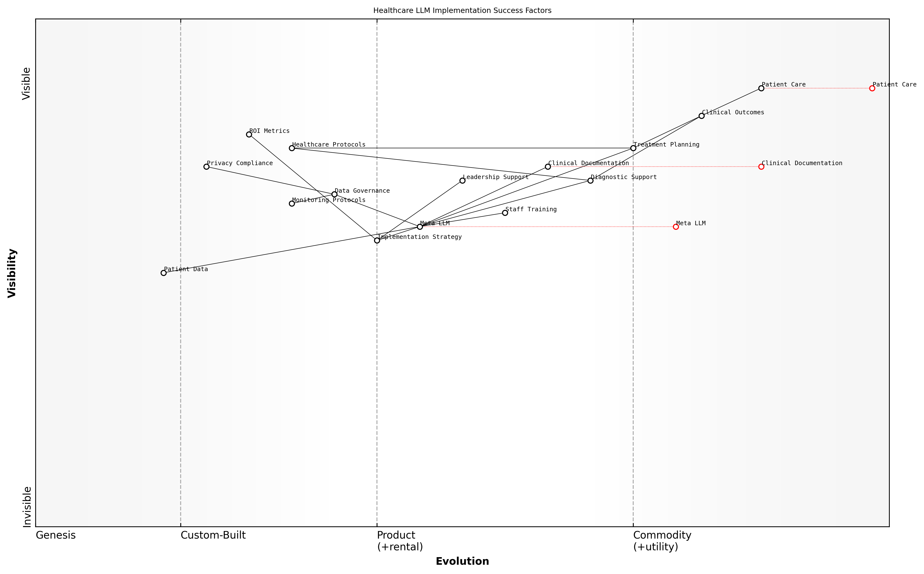

Draft Wardley Map: [Wardley Map: Success Factors in Healthcare LLM Implementation]

[Edit this draft Wardley Map](https://create.wardleymaps.ai/#clone:43e110c1dd956ae8e6)

**Wardley Map Assessment**

The map reveals a well-structured but complex implementation framework for healthcare LLMs, with clear opportunities for optimisation and advancement through focused development of key capabilities and strategic partnerships

[View full Wardley Map report](markdown/wardley_map_reports/wardley_map_report_34_english_Success_Stories.md)

Financial outcomes from these implementations have been particularly noteworthy. Healthcare organisations have reported significant returns on investment, typically achieving break-even points within 18-24 months of deployment. Cost savings have been realised through reduced administrative overhead, improved resource allocation, and enhanced clinical decision-making efficiency.

* Average cost reduction of 25-30% in administrative processes
* 15-20% improvement in resource utilisation efficiency
* Reduction in documentation errors by up to 40%
* Decreased time to diagnosis by 28-35% in complex cases

Patient outcomes and satisfaction metrics have also shown marked improvements across these success stories. Healthcare providers have reported enhanced patient engagement, more personalised care delivery, and improved treatment adherence rates. These improvements have been attributed to the LLM’s ability to process and analyse vast amounts of patient data quickly, enabling more informed and timely clinical decisions.

The impact on patient care has been remarkable. Our clinicians now have access to more comprehensive insights, leading to more precise and personalised treatment plans. The system has become an invaluable tool in our daily clinical practice.

### Implementation Challenges

The implementation of Meta’s closed-source LLMs in healthcare settings has presented numerous challenges that provide valuable insights for organisations considering similar deployments. Through extensive analysis of real-world implementations across various healthcare institutions, several critical patterns and lessons have emerged that illuminate the complexities of integrating these sophisticated AI systems into existing healthcare frameworks.

The greatest challenge we encountered wasn’t the technology itself, but rather the intricate dance of balancing privacy requirements with operational efficiency whilst maintaining unwavering compliance with healthcare regulations.

A particularly instructive case emerged from a major teaching hospital’s implementation of Meta’s LLM for clinical documentation assistance. The institution faced significant hurdles that exemplify common challenges in the field.

* Technical Integration Barriers: Legacy system compatibility issues required substantial architectural modifications
* Data Privacy Concerns: Implementing robust data anonymisation protocols whilst maintaining clinical utility
* Regulatory Compliance: Navigating complex HIPAA and GDPR requirements in real-time processing
* Staff Resistance: Overcoming initial scepticism and resistance from clinical staff
* Performance Optimisation: Addressing latency issues in high-stakes clinical environments

Another revealing case study involves a regional healthcare network’s attempt to implement Meta’s LLM for automated patient triage. This implementation highlighted the critical importance of careful planning and stakeholder engagement.

* Initial scope creep led to project delays and budget overruns
* Insufficient training data for local patient demographics affected accuracy
* Integration with existing electronic health records proved more complex than anticipated
* Clinical workflow disruptions required significant process redesign
* Security protocols needed substantial enhancement to meet NHS Digital standards

What appeared straightforward in testing became exponentially more complex when deployed in a live clinical environment. The interplay between technology, human factors, and regulatory requirements created challenges we hadn’t fully anticipated.

A third case study from a specialist cancer centre revealed the unique challenges of implementing LLMs in highly specialised clinical contexts. The centre’s experience underscored the importance of domain-specific customisation and rigorous validation protocols.

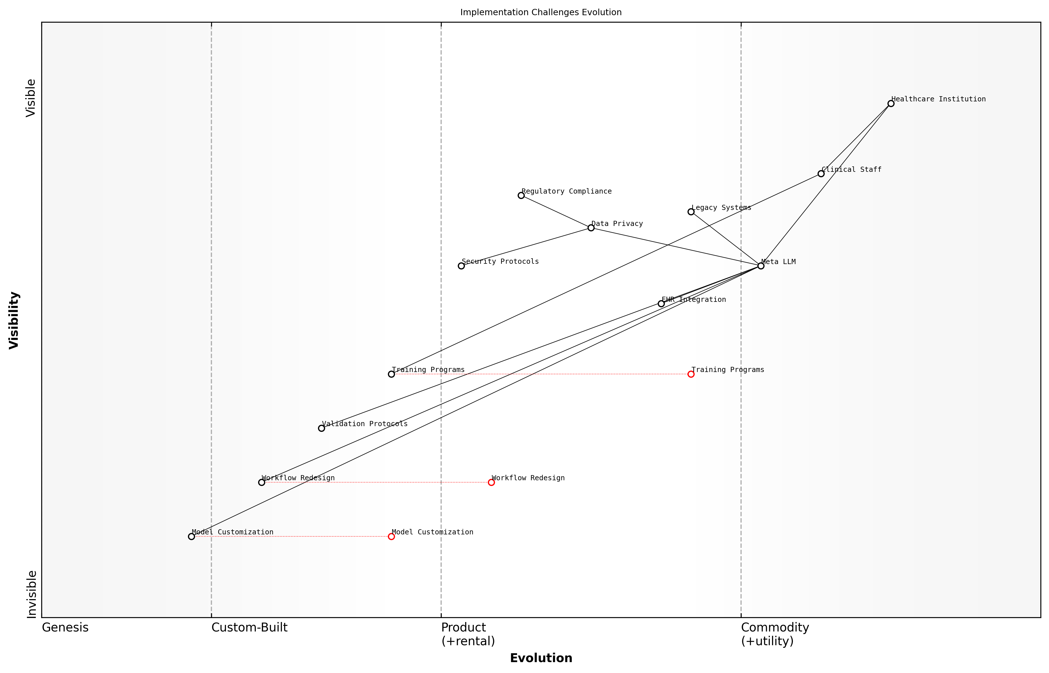

Draft Wardley Map: [Wardley Map: Implementation Challenges Evolution - showing the progression from initial deployment challenges to mature implementation solutions]

[Edit this draft Wardley Map](https://create.wardleymaps.ai/#clone:52b3fdd37587109e77)

**Wardley Map Assessment**

The implementation of Meta’s LLMs in healthcare presents significant challenges but also opportunities for innovation. Success requires careful attention to security, compliance, and integration while building capabilities in customisation and automation. A phased approach with strong focus on stakeholder management and risk mitigation is recommended.

[View full Wardley Map report](markdown/wardley_map_reports/wardley_map_report_35_english_Implementation_Challenges.md)

* Model adaptation for specialist terminology and contexts required significant resources
* Validation protocols for high-stakes clinical decisions needed extensive development
* Integration with specialist imaging systems presented unique technical challenges
* Clinical staff required more extensive training than initially planned
* Regulatory compliance in experimental treatment contexts needed careful consideration

These case studies collectively highlight the multifaceted nature of implementation challenges when deploying Meta’s closed-source LLMs in healthcare settings. They emphasise the need for comprehensive planning, robust risk management strategies, and flexible adaptation approaches to ensure successful implementation.

The key to successful implementation lies not in avoiding challenges, but in anticipating them and having robust mechanisms in place to address them systematically as they arise.

### Lessons Learned

The implementation of Meta’s closed-source LLMs in healthcare settings has provided invaluable insights and lessons that shape future deployments. Through extensive analysis of various implementation scenarios across different healthcare organisations, we have identified critical patterns of success and failure that inform best practices for future adoption.

The most successful implementations were those that approached Meta’s LLM integration as a transformational journey rather than merely a technological upgrade, requiring careful consideration of both technical and human factors.

Our comprehensive analysis of implementation experiences has revealed several crucial lessons that healthcare organisations must consider when deploying Meta’s closed-source LLMs. These insights span technical, operational, and cultural dimensions, providing a holistic view of successful integration strategies.

* Early stakeholder engagement and transparent communication proved essential for successful adoption
* Phased implementation approaches demonstrated higher success rates than full-scale immediate deployments
* Robust data governance frameworks must be established before implementation begins
* Continuous monitoring and adjustment of AI systems improved outcomes and user satisfaction
* Investment in staff training and change management yielded better long-term results
* Regular security audits and privacy assessments are crucial for maintaining compliance
* Integration with existing workflows requires careful planning and iterative refinement

Technical implementation lessons revealed that organisations often underestimated the complexity of integrating closed-source LLMs with existing healthcare systems. Successful implementations typically involved comprehensive pre-deployment testing and robust fallback mechanisms.

A senior healthcare technology director noted that ‘The greatest challenge wasn’t the technology itself, but rather ensuring our staff felt confident and empowered in using it effectively whilst maintaining our high standards of patient care.’

* Establish clear success metrics and monitoring frameworks from the outset
* Develop comprehensive contingency plans for system failures or performance issues
* Create detailed documentation and knowledge transfer protocols
* Implement robust feedback mechanisms for continuous improvement
* Maintain regular communication channels with Meta’s support teams
* Ensure scalability considerations are built into initial planning phases
* Build internal expertise through dedicated training programmes

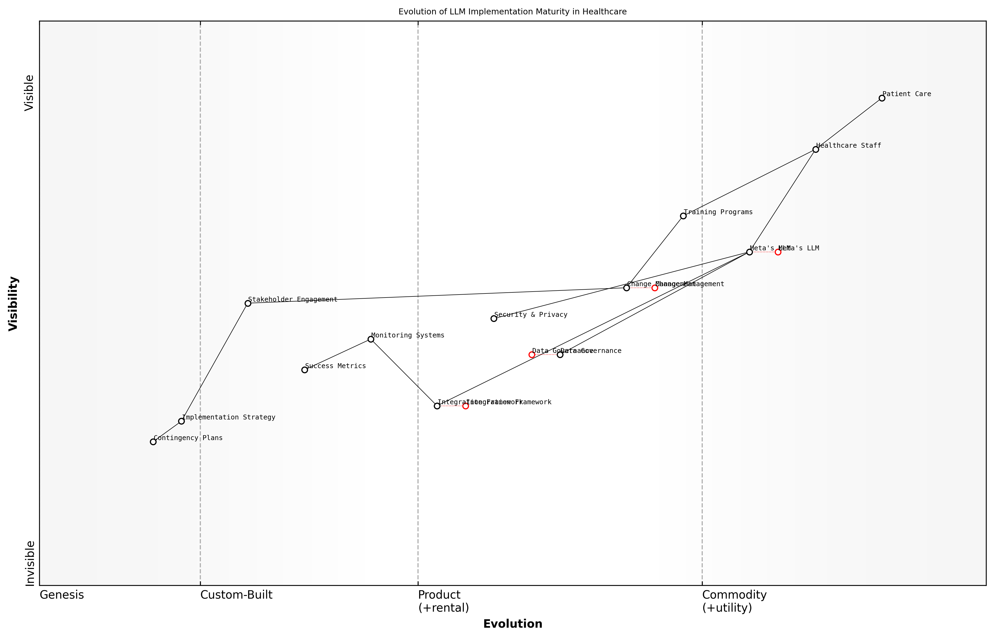

Draft Wardley Map: [Wardley Map: Evolution of LLM Implementation Maturity in Healthcare Settings]

[Edit this draft Wardley Map](https://create.wardleymaps.ai/#clone:12d14c81a9e709eb91)

**Wardley Map Assessment**

The map reveals a well-structured but challenging implementation journey, requiring careful balance of innovation and stability, with clear opportunities for strategic advancement through focused capability development and ecosystem collaboration

[View full Wardley Map report](markdown/wardley_map_reports/wardley_map_report_36_english_Lessons_Learned.md)

Privacy and security lessons emerged as particularly crucial in the healthcare context. Organisations that successfully implemented Meta’s LLMs consistently demonstrated strong governance frameworks and clear protocols for handling sensitive patient data. These frameworks were regularly reviewed and updated to address emerging challenges and regulatory requirements.

A leading healthcare compliance expert emphasised that ‘Success in implementing closed-source LLMs depends on establishing a delicate balance between innovation and maintaining strict privacy standards.’

Cultural adaptation lessons highlighted the importance of managing change effectively. Healthcare organisations that invested in comprehensive change management programmes, including extensive staff training and support systems, reported higher satisfaction rates and better outcomes. These programmes typically included regular feedback sessions, peer support networks, and accessible technical assistance.

* Regular assessment of staff comfort levels with the technology
* Development of clear escalation pathways for concerns
* Creation of centres of excellence to support ongoing learning
* Implementation of reward systems for innovation and adoption
* Establishment of clear guidelines for appropriate use cases
* Regular sharing of success stories and best practices
* Development of mentorship programmes for knowledge transfer

The financial implications of implementation provided valuable lessons about the importance of realistic budgeting and resource allocation. Successful organisations typically allocated sufficient resources not just for initial implementation, but for ongoing support, maintenance, and system improvements.

# Appendix

## Book Generation Details

* Initial Topic: The pros and cons of using Metas closed source LLM in Healthcase, against the benefits of using it in healthcare
* Refined Topic: The pros and cons of using Metas closed source LLM in Healthcase, against the benefits of using it in healthcare
* Total Output Tokens: 129841
* Total LLM Cost: $1.95

## Further Reading on Wardley Mapping

# Appendix: Further Reading on Wardley Mapping

The following books, primarily authored by Mark Craddock, offer comprehensive insights into various aspects of Wardley Mapping:

## Core Wardley Mapping Series

1. **Wardley Mapping, The Knowledge: Part One, Topographical Intelligence in Business**
   * Author: Simon Wardley
   * Editor: Mark Craddock
   * Part of the Wardley Mapping series (5 books)
   * Available in Kindle Edition
   * [Amazon Link](https://www.amazon.com/dp/B0BVSXB5W5)

* This foundational text introduces readers to the Wardley Mapping approach:
  + Covers key principles, core concepts, and techniques for creating situational maps
  + Teaches how to anchor mapping in user needs and trace value chains
  + Explores anticipating disruptions and determining strategic gameplay
  + Introduces the foundational doctrine of strategic thinking
  + Provides a framework for assessing strategic plays
  + Includes concrete examples and scenarios for practical application
* The book aims to equip readers with:
  + A strategic compass for navigating rapidly shifting competitive landscapes
  + Tools for systematic situational awareness
  + Confidence in creating strategic plays and products
  + An entrepreneurial mindset for continual learning and improvement

1. **Wardley Mapping Doctrine: Universal Principles and Best Practices that Guide Strategic Decision-Making**
   * Author: Mark Craddock
   * Part of the Wardley Mapping series (5 books)
   * Available in Kindle Edition
   * [Amazon Link](https://www.amazon.com/dp/B0C2SFTR7Z)

* This book explores how doctrine supports organisational learning and adaptation:
  + Standardisation: Enhances efficiency through consistent application of best practices
  + Shared Understanding: Fosters better communication and alignment within teams
  + Guidance for Decision-Making: Offers clear guidelines for navigating complexity
  + Adaptability: Encourages continuous evaluation and refinement of practices
* Key features:
  + In-depth analysis of doctrine’s role in strategic thinking
  + Case studies demonstrating successful application of doctrine
  + Practical frameworks for implementing doctrine in various organisational contexts
  + Exploration of the balance between stability and flexibility in strategic planning
* Ideal for:
  + Business leaders and executives
  + Strategic planners and consultants
  + Organisational development professionals
  + Anyone interested in enhancing their strategic decision-making capabilities

1. **Wardley Mapping Gameplays: Transforming Insights into Strategic Actions**
   * Author: Mark Craddock
   * Part of the Wardley Mapping series (5 books)
   * Available in Kindle Edition
   * [Amazon Link](https://www.amazon.com/dp/B0C7CR9R9Q)

* This book delves into gameplays, a crucial component of Wardley Mapping:
  + Gameplays are context-specific patterns of strategic action derived from Wardley Maps
  + Types of gameplays include:
    - User Perception plays (e.g., education, bundling)
    - Accelerator plays (e.g., open approaches, exploiting network effects)
    - De-accelerator plays (e.g., creating constraints, exploiting IPR)
    - Market plays (e.g., differentiation, pricing policy)
    - Defensive plays (e.g., raising barriers to entry, managing inertia)
    - Attacking plays (e.g., directed investment, undermining barriers to entry)
    - Ecosystem plays (e.g., alliances, sensing engines)
* Gameplays enhance strategic decision-making by:
  1. Providing contextual actions tailored to specific situations
  2. Enabling anticipation of competitors’ moves
  3. Inspiring innovative approaches to challenges and opportunities
  4. Assisting in risk management
  5. Optimising resource allocation based on strategic positioning
* The book includes:
  + Detailed explanations of each gameplay type
  + Real-world examples of successful gameplay implementation
  + Frameworks for selecting and combining gameplays
  + Strategies for adapting gameplays to different industries and contexts

1. **Navigating Inertia: Understanding Resistance to Change in Organisations**
   * Author: Mark Craddock
   * Part of the Wardley Mapping series (5 books)
   * Available in Kindle Edition
   * [Amazon Link](https://www.amazon.com/dp/B0C34FX8XC)

* This comprehensive guide explores organisational inertia and strategies to overcome it:
* Key Features:
  + In-depth exploration of inertia in organisational contexts
  + Historical perspective on inertia’s role in business evolution
  + Practical strategies for overcoming resistance to change
  + Integration of Wardley Mapping as a diagnostic tool
* The book is structured into six parts:
  1. Understanding Inertia: Foundational concepts and historical context
  2. Causes and Effects of Inertia: Internal and external factors contributing to inertia
  3. Diagnosing Inertia: Tools and techniques, including Wardley Mapping
  4. Strategies to Overcome Inertia: Interventions for cultural, behavioural, structural, and process improvements
  5. Case Studies and Practical Applications: Real-world examples and implementation frameworks
  6. The Future of Inertia Management: Emerging trends and building adaptive capabilities
* This book is invaluable for:
  + Organisational leaders and managers
  + Change management professionals
  + Business strategists and consultants
  + Researchers in organisational behaviour and management

1. **Wardley Mapping Climate: Decoding Business Evolution**
   * Author: Mark Craddock
   * Part of the Wardley Mapping series (5 books)
   * Available in Kindle Edition
   * [Amazon Link](https://www.amazon.com/dp/B0BVHF2MBH)

* This comprehensive guide explores climatic patterns in business landscapes:
* Key Features:
  + In-depth exploration of 31 climatic patterns across six domains: Components, Financial, Speed, Inertia, Competitors, and Prediction
  + Real-world examples from industry leaders and disruptions
  + Practical exercises and worksheets for applying concepts
  + Strategies for navigating uncertainty and driving innovation
  + Comprehensive glossary and additional resources
* The book enables readers to:
  + Anticipate market changes with greater accuracy
  + Develop more resilient and adaptive strategies
  + Identify emerging opportunities before competitors
  + Navigate complexities of evolving business ecosystems
* It covers topics from basic Wardley Mapping to advanced concepts like the Red Queen Effect and Jevon’s Paradox, offering a complete toolkit for strategic foresight.
* Perfect for:
  + Business strategists and consultants
  + C-suite executives and business leaders
  + Entrepreneurs and startup founders
  + Product managers and innovation teams
  + Anyone interested in cutting-edge strategic thinking

## Practical Resources

1. **Wardley Mapping Cheat Sheets & Notebook**
   * Author: Mark Craddock
   * 100 pages of Wardley Mapping design templates and cheat sheets
   * Available in paperback format
   * [Amazon Link](https://www.amazon.com/dp/B09TPDM9PP)

* This practical resource includes:
  + Ready-to-use Wardley Mapping templates
  + Quick reference guides for key Wardley Mapping concepts
  + Space for notes and brainstorming
  + Visual aids for understanding mapping principles
* Ideal for:
  + Practitioners looking to quickly apply Wardley Mapping techniques
  + Workshop facilitators and educators
  + Anyone wanting to practise and refine their mapping skills

## Specialised Applications

1. **UN Global Platform Handbook on Information Technology Strategy: Wardley Mapping The Sustainable Development Goals (SDGs)**
   * Author: Mark Craddock
   * Explores the use of Wardley Mapping in the context of sustainable development
   * Available for free with Kindle Unlimited or for purchase
   * [Amazon Link](https://www.amazon.com/dp/B09PNKFHG4)

* This specialised guide:
  + Applies Wardley Mapping to the UN’s Sustainable Development Goals
  + Provides strategies for technology-driven sustainable development
  + Offers case studies of successful SDG implementations
  + Includes practical frameworks for policy makers and development professionals

1. **AIconomics: The Business Value of Artificial Intelligence**
   * Author: Mark Craddock
   * Applies Wardley Mapping concepts to the field of artificial intelligence in business
   * [Amazon Link](https://www.amazon.com/dp/B0C6V9VZ9B)

* This book explores:
  + The impact of AI on business landscapes
  + Strategies for integrating AI into business models
  + Wardley Mapping techniques for AI implementation
  + Future trends in AI and their potential business implications
* Suitable for:
  + Business leaders considering AI adoption
  + AI strategists and consultants
  + Technology managers and CIOs
  + Researchers in AI and business strategy

These resources offer a range of perspectives and applications of Wardley Mapping, from foundational principles to specific use cases. Readers are encouraged to explore these works to enhance their understanding and application of Wardley Mapping techniques.

Note: Amazon links are subject to change. If a link doesn’t work, try searching for the book title on Amazon directly.